


Governmental aggregation is an easy and effective way for large groups of consumers to save money on their electric and natural gas bills.

Ohio law allows for cities and counties to form aggregated buying groups to negotiate rates on behalf of their citizens. The city/county chooses the for all the customer-members in its group.

ELECTRIC AGGREGATION PROGRAM
- Organized by Clinton County
- Available to all Clinton County residents
- Pricing $0.0898/kWh
January 2026- December 2026
Enrollment:
DYNERGY 844-351-7691
Questions:
Clinton County Commissioner’s Office
(937) 382-2103


GAS AGGREGATION PROGRAM
- Organized by the City of Wilmington
- Available to all within City limits
- Pricing: $0.6999/Ccf.
June 2026 (Billing) – May 2028 (Billing)
Enrollment: 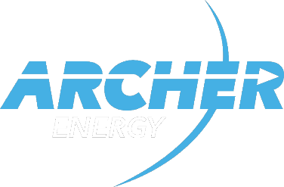
Archer Energy
844-795-7491
Questions:
Clinton County Commissioner’s Office
(937)382-2103

FREQUENTLY ASKED QUESTIONS
How do I sign up?
The aggregation program is an “opt-out” program, meaning customers are automatically enrolled.
Can I opt out of the program at a later date?
Yes, electric customers may cancel service with Energy Harbor without penalty and switch to another provider or return to AES pricing. Natural Gas Customers may terminate with IGS Energy without penalty and return to Centerpoint standard pricing.
What happens when the contract ends?
Prior to the end of the contract, the city/county will ask for bids for a new rate and enter into a contract with the company who will provide the best price for residents.
Is natural gas and electric aggregation right for me?
The Ohio Government implemented a website to compare prices from energy suppliers. This empowers residents to make the best, most effective decision.
(http://www.energychoice.ohio.gov/)
After I am enrolled in the aggregation program, who sends me a bill?
Utility providers continue to provide the bill. AES customers will see a line on the bill indicating the electricity is being provided by Energy Harbor. Centerpoint customers will see a line on the bill indicating the natural gas is being provided by IGS Energy.

