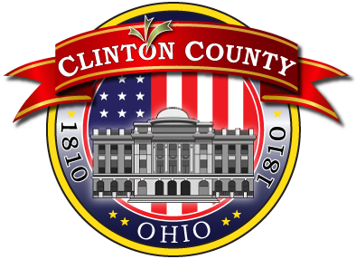

**Governmental aggregation is an easy and effective way for large groups of consumers to save money on their electric and natural gas bills.**

**Ohio law allows for cities and counties to form aggregated buying groups to negotiate rates on behalf of their citizens. The city/county chooses the for all the customer-members in its group.**

**ELECTRIC AGGREGATION PROGRAM**

* Organized by Clinton County
* Available to all Clinton County residents
* Pricing $0.0657/kWh

December 2023- December 2025

Enrollment:

**DYNERGY** 844-351-7691

Questions:

**Clinton County Commissioner’s Office**

(937) 382-2103



**GAS AGGREGATION PROGRAM**

* Organized by the City of Wilmington
* Available to all within City limits
* Pricing: $0.526/Ccf fixed.

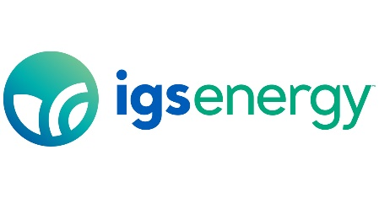November 2024 (Billing) – October 2025 (Billing)

Enrollment:

**IGS Energy**

1-877-353-0162

Questions:

**Tom Bellish, Buckeye Energy Brokers**

1-866-302-2237

**FREQUENTLY ASKED QUESTIONS**

**How do I sign up?**

The aggregation program is an “opt-out” program, meaning customers are automatically enrolled.

**Can I opt out of the program at a later date?**

Yes, electric customers may cancel service with Energy Harbor without penalty and switch to another provider or return to AES pricing. Natural Gas Customers may terminate with IGS Energy without penalty and return to Centerpoint standard pricing.

**What happens when the contract ends?**

Prior to the end of the contract, the city/county will ask for bids for a new rate and enter into a contract with the company who will provide the best price for residents.

**Is natural gas and electric aggregation right for me?**

The Ohio Government implemented a website to compare prices from energy suppliers. This empowers residents to make the best, most effective decision.

**(**[**http://www.energychoice.ohio.gov/**](http://www.energychoice.ohio.gov/)**)**

**After I am enrolled in the aggregation program, who sends me a bill?**

Utility providers continue to provide the bill. AES customers will see a line on the bill indicating the electricity is being provided by Energy Harbor. Centerpoint customers will see a line on the bill indicating the natural gas is being provided by IGS Energy.