WATCH D.O.G.S. PIZZA PARTY KICK OFF

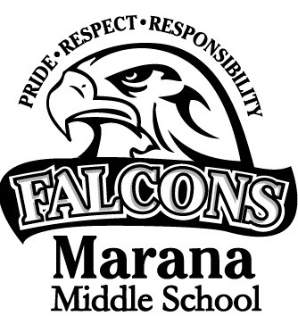 | 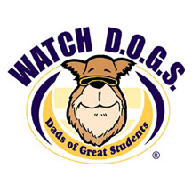
Come join our Watch D.O.G.S. program!

Who: Watch D.O.G.S. are fathers, grandfathers, uncles, and other father-figures or male role models in our community.

What: Our goal is for YOU to spend at least ONE DAY this school year serving as a positive male role model here at Marana Middle School. PIZZA and water will be provided FREE!!
Where: Marana Middle School Cafeteria

When: Tuesday, August 29, 2017 from 6:00pm - 7:30pm.

Who to Contact: If you are interested in volunteering, please contact Matthew Kornacki at 520-682-4730 or emailing at m.j.kornacki@maranamusd.org

