Engineering & Science University Magnet School
We’re selling tote bags, accessories, kitchenware & more through a Mixed Bag Designs fundraiser!

It’s easy to support us – just shop online!
- Go to www.mixedbagdesigns.com/?fundraiserid= 313408
- Make sure our ID# 313408 is at the top of the website before shopping.
- We receive 40% of every online purchase
- Orders ship directly to anyone in the USA that supports our fundraiser
- Shipping is FREE on orders $75 and up!
- Questions? Contact: Anna / Main Office – 203.946.6610

Need more help?

877.520.2247| support@mixedbagdesigns.com
**OR VISIT THE WEBSITE – ENTER YOUR ITEMS ON THE ORDER FORM AND SEND
IT TO SCHOOL W/PAYMENT (NO TAX OR SHIPPING FEES) & We’ll place the order
PROMOTE YOUR FUNDRAISER WITH PERSONALIZED EMAILS, SOCIAL MEDIA & MORE! VISIT WWW.MIXEDBAGDESIGNS.COM/SELLER-TOOLS


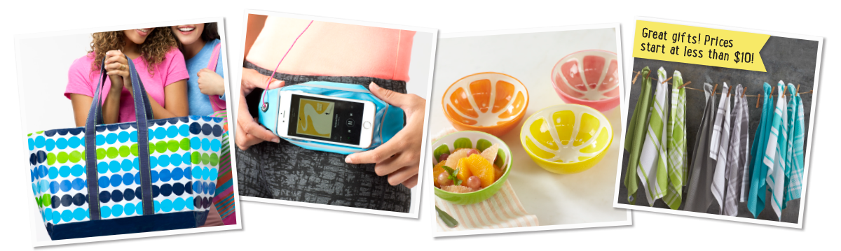

Over 300 products online! Prices start at less than $10!
www.mixedbagdesigns.com/?fundraiserid=313408
~ Or complete the attached order form and send it to school along with payment so you won’t have to pay shipping fees or tax and we will place the order and send
it home with your child when it arrives at school –
Large Orders will have to be picked up by parents/guardians.

