|  |  |
| --- | --- |
| ***Cactus Valley Elementary***  ***School***  CVE Logo copy  **Kelly Detlefsen, Principal**  **222 Grand Ave.**  **Silt, CO 81652**  Phone: 970-665-7850  Fax: 970-665-7884  **CVE Vision**  ***Our vision is to develop happy, high achieving students and staff.***  **Important Dates to Consider:**  5/1-4 Teacher Appreciation  5/4 7:00 Choir Concert  5/6 10:00 Girls on the Run-Fruita  5/10 Bike to School Day  5/11 Kinder Rifle Falls Field Trip  5/11 Choir to Elitches  5/13 3rd Math/Sci Center Field Trip  5/17 11:00 CRHS Senior Walk @ CVE  5/18 2nd Wildlife Field Trip  5/22 1st GWS Caverns Field Trip  5/23 Cougar Day at CVE  5/24 4th Field Trip-Trail of Time  5/25 4th Graduation @ 1:00  5/25 2:45 End of Year Assembly | May 1, 2017  Dear Cactus Valley Families,    As we look to the end of this school year, I do so with mixed emotions. While we wish the best for our 4th graders as they move on to middle school, and to some of our teachers who will be continuing their teaching adventures in new places, we will also be welcoming new Kindergartners and new teachers in the fall. The opportunity to share in the lives of others, and the memories created through those relationships are a few of the many rewarding parts about the teaching profession.    We have had a busy, productive year at CVE! Our newly implemented Math program, Investigations, has provided an opportunity to challenge our students to learn and grow. CVE students have shown growth in reading throughout this year as we increased the text rigor, enhanced vocabulary, and added writing and 6-syllable instruction to SFA. Our school-wide behavior plan, The 3 B’s: Be Kind, Be Safe, Be Responsible, has provided consistency throughout CVE. CVE PTA has been integral in helping promote and sustain our positive culture and climate at CVE with the Box Tops Challenges, the Holiday Fair, the Art Auction, as well as celebrating our staff’s Birthdays and Teacher Appreciation. Finally, we would like to thank all of the volunteers who have helped in various classrooms throughout the year. You truly make a difference in the lives of our students!  Please look for your child’s final report card to come home on the last day of school. In past years, the next year’s teacher has been written on the report card. This year we will be posting class lists on the doors of CVE the first week of August. The first day of school is Monday, August 14, 2017!  **3 ways you can help your child this summer:**  **1. Six books to summer success:** Research shows that reading just six books during the summer may keep a struggling reader from regressing. When choosing the six, be sure that they are just right — not too hard and not too easy. Our local library is a great resource!  **2. Read something every day:** Encourage your child to take advantage of every [opportunity](http://www2.scholastic.com/browse/article.jsp?id=1532) to read.  **3. Keep reading aloud:** Reading aloud benefits all children, especially those who struggle. One benefit is that you can read books your child can't, so he/she will build listening comprehension skills with grade-level and above books. This will increase his/her knowledge and expand experience with text, so that he/she will do better when reading independently.  I am so grateful to the CVE community and for the opportunity to help lead such an amazing school! Take care and I wish you all a safe, fun, & relaxing summer break!  Kelly Detlefsen, Principal  :images.jpg |

**Garfield School District No. Re-2**

Brent Curtice, Superintendent Board of Directors Anne Guettler, Board President

Dave Lindenberg, Asst. Superintenden Jay Rickstrew,Vice President Shirley Parks, Secretary

The Garfield Re-2 School District is committed to providing equal educational opportunities and a safe learning and working environment for all of our students and staff regardless of race, color, gender, sexual orientation, religion, national origin, marital status, or disability. We want our students, families and communities to know that schools and classrooms are safe and inclusive places for all students and all families. To ensure that the Garfield Re-2 schools continue to be safe, inclusive, supportive, and positive environments for all students and their families, we commit to and believe in the following:

* •  Each individual has worth;
* •  Diversity stimulates and can strengthen the community and the educational process;
* •  All students have a legal right to an education, regardless of any differences, including immigration

status. We embrace all students as members of our school community;

* •  Our schools will remain safe and supportive spaces for students and community members, free

from the threat of intimidation, hostility, or violence, including threat of deportation;

* •  We do not collaborate with immigration enforcement agencies or share information that could put

a student’s security at risk;

* •  We will continue to listen to the community and engage in conversations to learn about concerns

throughout our three communities;

* •  We will continue to teach character education, including tolerance and inclusion in our schools, set

clear and high expectations for how we treat one another, and encourage our educators to address

issues around race, discrimination and other challenges with students;

* •  We will not base decisions on speculation or rumor;
* •  We will continue to place the safety of our students and staff as a top priority;
* •  Education is a SHARED responsibility of the student, family, school, and community;
* •  Educated, informed, and involved citizens are the foundation of our democratic society;

The Garfield Re-2 School District will continue to provide equal access to education for all children that come to us. Our vision is to encourage, nurture and challenge every student, every day. We want to make sure every student thrives and we want to ensure that all of our students are safe, honored, and respected while in our care.

If you have questions about any information above, please contact Garfield Re-2 Superintendent Brent

Curtice at 970-665-7600.

Sincerely,

The Garfield Re-2 School Board

Anne Guettler, President Jay Rickstrew, Vice-President

Jacquelyn Johnson – Treasurer

Shirley Parks - Secretary

Brock Hedberg – Member

839 Whiteriver Avenue, Rifle, CO 81650-3500 (970) 665-7600 Fax (970) 665-7623

**Immigration and Discrimination FAQs**

**Q: What impact does my or my child’s immigration status have on my child’s education?**

**A:** None. Children have a constitutional right to have equal access to education regardless of their immigration

status or their parents’ status.

**Q: Does Garfield Re-2 ask for a child’s immigration status when he or she enrolls?**

**A:** No. Public school districts have an obligation to enroll students regardless of their immigration status and

without discrimination on the basis of race, color or national origin.

**Q: Would the school district share our students’ immigration status with the federal immigration officials?**

**A:** No. As mentioned above, we do not ask for students’ immigration status when they enroll.

**Q: What does Garfield Re-2 do to ensure that no student or family is discriminated against or harassed**

**because of their race, ethnicity, religion, sexual orientation or national origin?**

**A:** The Garfield Re-2 School District believes in ensuring equity. We have policies in place that mandate no

discrimination or harassment for our students, families or employees on the base of race, ethnicity, religion,

national origin, sexual orientation, and many other protected classes.

**Q: What should I do if my child feels like he/she has been the victim of discrimination or harassment?**

**A:** Please report the behavior immediately to a teacher, school leader (principal or assistant principal), or the

superintendent’s office. We take these complaints very seriously in order to assure that our schools continue to

be safe spaces.

**Q: What if I am a DACA recipient?**

**A:** Deferred Action for Childhood Arrivals (DACA) is based on an order by the president. The new president could

choose to rescind that order. If you are a recipient of DACA, consider reaching out to an immigration attorney

now in order to determine if you have additional ways to change your immigration status.

**Q: What should I do if I want to understand my immigration rights?**

**A:** Only immigration attorneys can provide you with accurate advice about immigration status and how you can

pursue any legal rights you might have. For your own protection, please do not seek the advice of notarios or

others who are not licensed immigration attorneys. Also, you can seek an immigration attorney from the

American Immigration Lawyers Association at http://www.ailalawyer.org/.  
*\*This FAQs was created by the Denver Public Schools (DPS) and adapted by the Garfield Re-2 School District.*

839 Whiteriver Avenue, Rifle, CO 81650-3500 (970) 665-7600 Fax (970) 665-7623

May 2017

Cactus Valley Elementary

Counselor’s Corner!

In Character Education in April, Kindergarten discussed what bullying looks like and how to be kind to our friends and use our words instead of actions to solve a problem. 1st through 4th grade focused on safety and citizenship. Good citizens make the community a better place to live by helping in the school and town, following rules, picking up trash, recycling, and using kind words and actions. In May, 3rd and 4th grade is reflecting on what empathy means. 1st and 2nd grade will learn to understand what it means to be a caring person and how they can show they care. In Kindergarten, the students will show how they can make good choices on how they act when in school, at home or with friends.



As we wind down the school year and summer thoughts begin to excite the students, continue having conversations with your kids about the importance of good character. Try to use teachable moments to discuss The 3 B’s: Be Kind, Be Safe, Be Responsible. Thanks for sharing your amazing children with us here at CVE. Have a safe and restful Summer! See you in August.

Ms.Chabin, School Counselor. 970-665-7764.

|  |
| --- |
|  |
| **MAY NEWSLETTER** |
|  |

**CVEPTA**

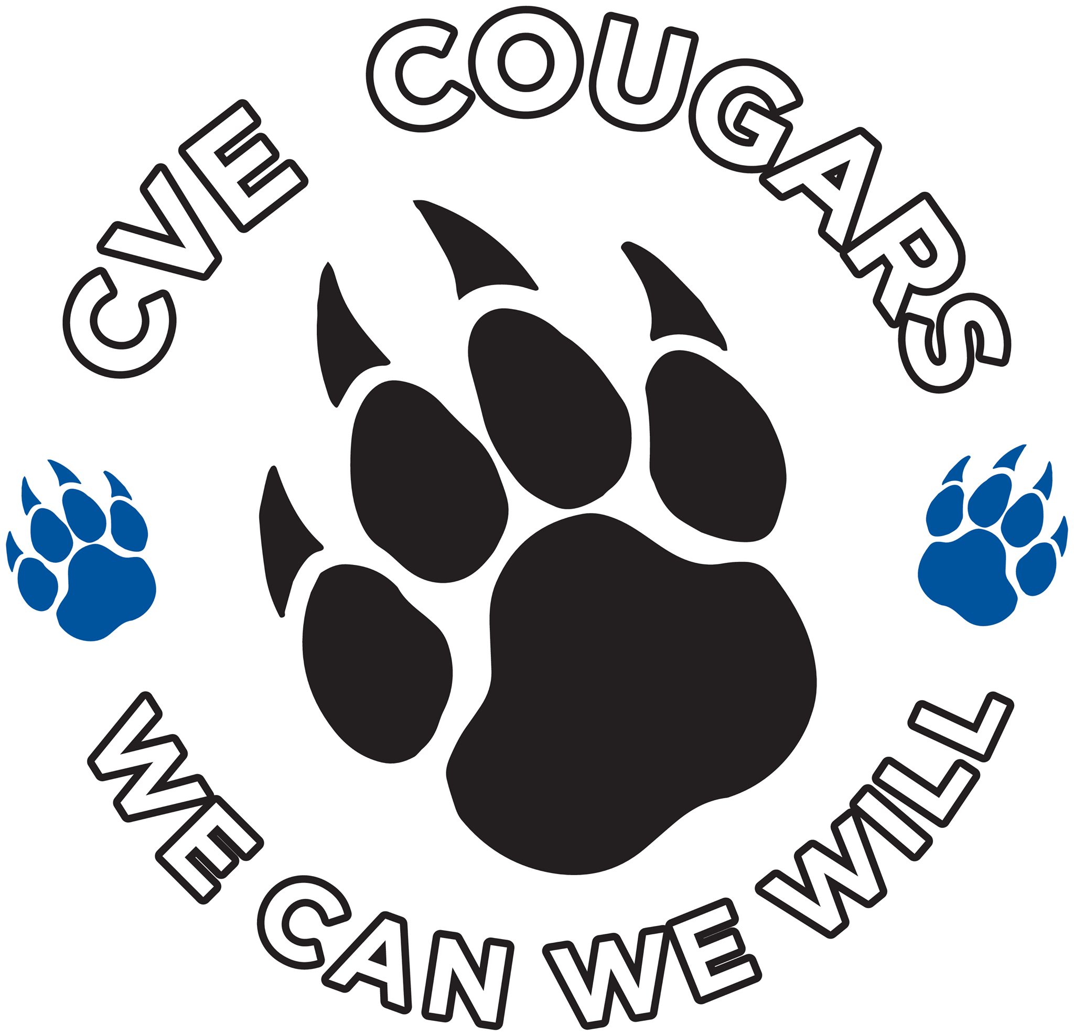

# Upcoming Events

**May 1st-4th**

Teacher & Staff Appreciation Week

**May 4th**

Collecting Box Tops

## May 9th

CVEPTA Meeting at CVE

|  |
| --- |
|  |
| **Questions about the PTA? Please call any one of our Officers!**  Ashlee Taylor 274-1951  Jessica Menu 618-1356  Toni Yorty 948-5831  Michelle Williams 379-7858  Alicia Bartel 366-2950  Meg Ralston 270-6632  Hope Bentzler 239-560-9840 |

NEXT MEETING: Tuesday, May 9th, 2017 @ 2:00 P.M.

LOCATION: Cactus Valley Elementary Conference Room

|  |
| --- |
|  |
| We welcome any CVE parent to any meeting or any event that we host. At our next meeting is May 9th at 2:00 in the CVE Conference Room. Our desire is to build a partnership between all CVE parents and staff so that you, feel empowered in our child’s education. We also have a lot of fun working together and are always looking to include more parents to share in the fun. |
|  |

## What’s Happening in the School:

**April Recap:** Our Annual Art/Silent Auction Fundraiser was a huge success, thanks to all our donors and sponsors. We raised $6,500, which will go towards field trip transportation, supplies needed in the classrooms and a new climbing wall for the gym.

**Box Tops News**: We will be collecting our last and final box top collection on May 4th to finish up the “Giddy Up for Recess”. We will announce the classroom that helped capture all the outlaws on the board. We will do a final collection on the last day of school as well, so keep collecting and don’t forget to collect over the summer too!!!

**THANK YOU TO OUR PTA BUSINESS PARTNERS:**

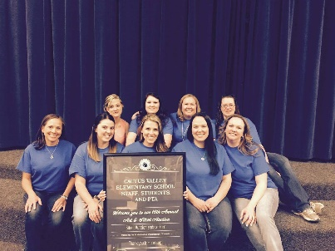Green Zone Metal Recycling, Clark Loter Farmers Insurance Agency, A1 Traffic Control, Miner’s Claim, Hwy-Feed, CT Electric Automation, Rifle Works, Shear Intensity, Timberline Pool and Spa, Dr. Johnson Dentistry, Two Peaks Electrical, Kuyper Foundation Family Gift Program, and Aztlan Tile. We appreciate your support!!

To stay current on all our upcoming events and meetings please “Like” us on Facebook –Cactus Valley Elementary PTA!!





**Music Notes**

“...schools which have instituted an arts base are showing an increase in math and language scores overall and are showing enormous jumps in creativity scores.  Students who are involved in music score an average of 40 points higher on SAT’s that those who are not involved in music.”

*A MacMillian/McGraw-Hill study*

Congratulations first grade on a job well done on their first grade level program!! First grade classes have been working on all kinds of music fundamentals such as: beat and rhythm, form and melody.  Understanding these concepts helps a great deal with appreciating music which is a great part of our everyday life!  We will continue with these fundamentals as well as start to look at instrument families.

2nd grade has been working with Piano Maestro. It is a wonderful application on the iPad mini. We are working with this to tie in beat, rhythm, reading music, reading musical symbols, and learning the basics of the piano. This is something we will build on all the way through 4th grade.

Third and fourth grade are finished working on their recorders.  They did a wonderful job reading the notes both rhythmically and tonally.  We will continue to look at melody and rhythm using Piano Maestro as well as start on a few units about instrument timbre (understanding instruments have their own sound, like recognizing someone on the phone just by his/her own voice).

The beginning choir will have a wonderful performance on Thursday, May 4th, at 7 pm.  I really appreciate all these students do, and all the support the parents give to their students during any performance. The choir and I will be heading to Denver to perform and be adjudicated on May 11th. The bus will leave at 6:30 a.m. from the CVE parking lot.

I would like to take this opportunity to thank all the wonderful parent volunteers who helped with the musicals.  These could not have been done as well as they were without your help.  Thank you all very much!

 

Caring Cougars Coin Competition:

Our coin competition is in full swing so expect a little more chaos each morning as students enjoy giving their silver coins to other classrooms! We have been raising money for River Center as well as supporting two girls in Sierra Leone, Africa so they can attend school. Thank you for helping your child to “change” the world! We will share the amount raised on May 18th.



Girls on the Run:

Third and fourth grade girls on our CVE Girls on the Run team will run their 5K race on Saturday, May 6th in Fruita! We’ve had a great season and are so proud of our girls!

Spanish Class:

The before-school Spanish class finished up with their fiesta on Wednesday, May 3rd. Some 35 students attended class every Wednesday morning since October! Buen trabajo!

 

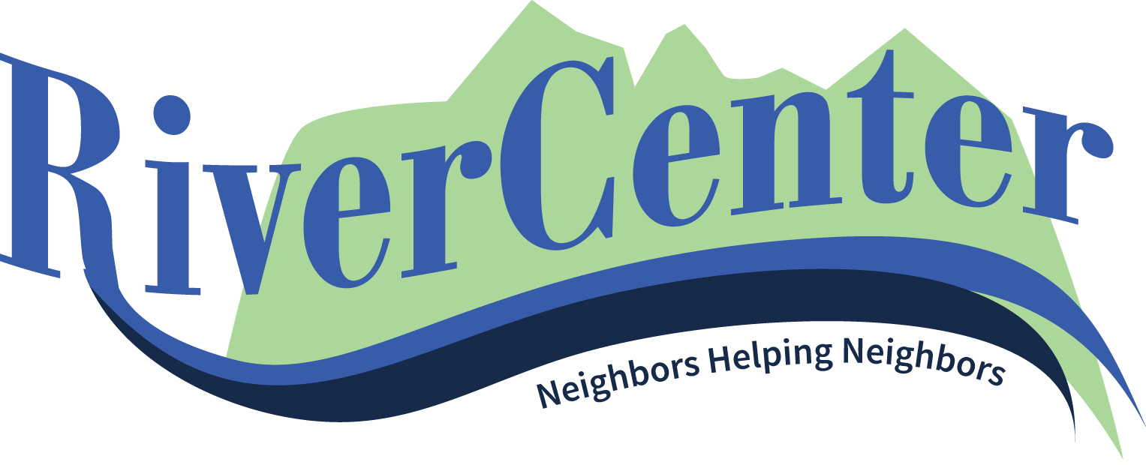

______________May 2017______________

**Spaghetti Fundraiser!**

River Center will be hosting its annual Spaghetti Dinner Fundraiser on Friday, June 9th at Burning Mountain Park. We are always in need of volunteers to help spread the word during the weeks up to the event. If you’re interested in volunteering or eating a delicious spaghetti dinner please visit our website for more details! Or call us at 984-4333.

**Community Enrichment Classes**

Please visit our website at [www.rivercenternewcastle.org](http://www.rivercenternewcastle.org) to sign up!

**Love & Respect**

This marriage class is for anyone looking to better communicate with their spouse and improve their marriage. The class will be taught by Andy & 

Holly Womack each Tuesday in May! There will be no class on May 30th. Please sign up on our website or call with questions: 984-4333.

**Meeting Community Needs**

Meal Monkey: River Center and Lift-Up are partnering to bring the Meal Monkey! This free lunch program is available for children 18 and younger each Friday at noon at Burning Mountain Park in downtown New Castle. If your children, or children you know of could use this, please let them know to stop by the park.

**Meeting Community Needs**

Summer Food Program is a continuation of the Totes of Hope Program. The food is available at the New Castle and Silt Libraries as well as Heron’s Nest during the summer. We still need volunteers to help with this program! Please call with questions or are interested in volunteering!