Korean Language & Culture Classes  at Auburn City Schools  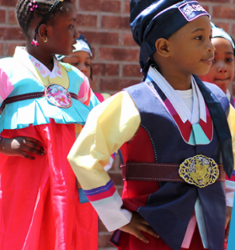 | 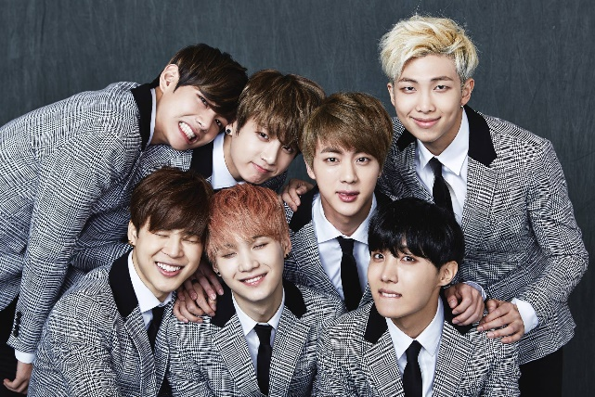  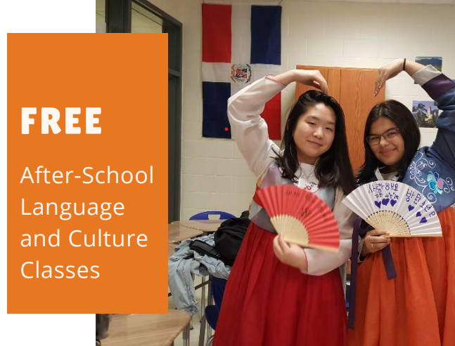
The Korean Language & Culture Classes are designed for beginners who want to learn the Korean language as non-Korean speakers. The focus of the classes will be on developing speaking, listening, reading, and writing skills. Students will acquire knowledge of phonetics, vocabulary, and basic expressions for daily conversation. Students will also learn various aspects of Korean culture through fun activities such as music, dance, games, and special events.
For the 2022 – 2023 school year, four courses will be offered. Programs are only available to students currently enrolled at that school.
School | Day | Time | Eligible Grades
Ogletree Elementary School | Monday & Wednesday esdayWWWWedWednesday | 2:30-3:30 PM | Grades 3-5
Drake Middle School | Tuesday & Thursday | 11:24-11:54 AM | Grades 6
East Samford School | Tuesday & Thursday | 3:00-3:35 PM | Grades 7
Auburn Junior High School | Tuesday & Thursday | 3:50-4:40 PM | Grades 8-9
Register today at: https://www.auburn.edu/outreach/opce/koreacorner/koreanafterschool.htm
For more information, email Dr. Suhyun Suh at suhsuhy@auburn.edu
SPONSORED BY KOREA CORNER, FUNDED BY KOREAN EDUCATION CENTER IN ATLANTA

