**School District of Fort Atkinson**

To: Parents/ Guardians of 4th and 5th grade students at Barrie Elementary School

**Re: National Archery in the Schools Program (NASP)**

Barrie Elementary is proud to introduce an Archery unit to our 4th and 5th grade physical education classes.

**WHAT IS NASP?**

The National Archery in the Schools Program (NASP) brings the sport of archery to millions of students in schools across the United States. Designed to teach international‐style target archery in 4th‐12th grades, the core content covers archery history, safety, technique, equipment, mental concentration, and self‐improvement. The NASP archery curriculum is aligned to National Physical Education Standards and can be run safely in a school gymnasium. No prior archery experience is necessary for students. 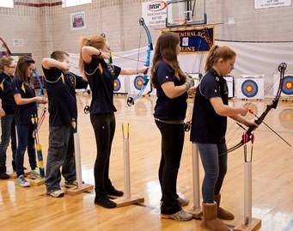

**CHANGING LIVES ONE ARROW AT A TIME…**

Many of the activities in physical education classes favor the strongest, fastest, and most coordinated students. Archery is a life‐long sport that circumvents traditional barriers to engage students of all genders, physical abilities, and backgrounds, even aiding participation in students with disabilities. Archery is a physical activity in which boys and girls can participate together and puts athletes and non‐athletes on a level playing field.

The National Archery in the Schools Program routinely transforms previously unreachable "high risk" students by unlocking self‐esteem and transforming individual lives forever.

**WHY NASP WORKS**

Nearly everyone can succeed at archery. Kids love archery, and archery helps kids excel. Statistics show that school archery programs:

* Improve school attendance • Appeal to all students
* Increase self‐esteem • Get kids out‐of‐doors
* Increase physical activity • Can become an after‐school activity
* Relate to subject matter

**WHO PARTICIPATES IN NASP?**

* In the 2011‐2012 school year, approximately 2,055,000 students participated in NASP throughout the country. That involves more children than Little League baseball and is three times larger than lacrosse! NASP has taught target archery to more than 10 million students in 47 states and continues to grow.
* To date, over 7.5 million youth have participated in nearly 9,000 schools across the United States, Canada, New Zealand, and South Africa.

**IS ARCHERY SAFE?**

* Archery's safety record is better than that of every ball sport taught in schools except table tennis. Equipment used is state‐of‐the‐art and a universal fit so every student can safely use the same bows and arrows.

Please go to the following links for additional information regarding NASP:

WI NASP Promotional Video https://youtu.be/-xyX1vDuZ7A

WI NASP Webpage http://dnr.wi.gov/education/outdoorskills/nasp.html

National NASP Webpage http://www.naspschools.org/

Thank you,

| Meghann Green  greenm@fortschools.org |
| --- |

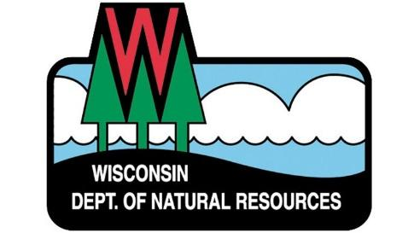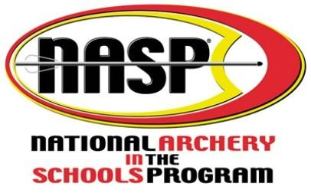

# Parental/Guardian Consent and Release for NASP Program Participation

(To be completed by parent or legal guardian only)

I, ____________________________, do hereby consent to allow ________________________

(Name of Parent/Legal Guardian) (Name of Student)

to participate in the National Archery in the Schools Program, and in the event of injury or accident to my child, do hereby release, discharge, absolve and hold harmless National Archery in the Schools Program, State of Wisconsin, Department of Natural Resources, and Barrie Elementary School, its officers, employees, volunteers, leaders, instructors, teachers and coaches from any and all liability or responsibility thereof, from this date to the end of time.

_______________________________________________ ____________________ (Signature of Parent/Legal Guardian) (Date)

# PLEASE BRING COMPLETED FORM TO THE FIRST CLASS

