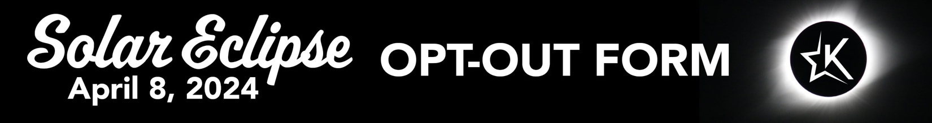

On April 8, 2024, our area will be in “path of totality” for a solar eclipse. In order to allow our students an opportunity to experience this rare event, the Keller ISD Education Foundation has purchased eclipse glasses for all KISD students. These ISO-certified glasses can be used by students to view the eclipse without harming their eyes. Information about how and when each school will make viewing the eclipse available to students will be provided by campuses closer to the date of the event.

While we view this as a tremendous learning opportunity for our students to learn firsthand about the solar eclipse, we understand that some parents may not wish for their child to participate in viewing the eclipse outside in this manner.

If you do not want your child to go outside to view the eclipse, please complete and sign this Opt-Out Form and return it to your school’s principal by April 5, 2024. Students who opt out of viewing the eclipse or whose parents have turned in an Opt-Out Form will remain in the building under supervision of school staff. provided with an alternate activity while the eclipse is viewed by other students.

All students at school on April 8 that have not turned in an Opt-Out Form will be given the opportunity to go outside (weather permitting) to view the eclipse with their classmates and teachers using the ISO-certified eclipse glasses.

ECLIPSE VIEWING OPT-OUT FORM

I do not want my child to go outside to view the eclipse on April 8, 2024. I understand that by returning this completed form by April 5, 2024, my child will stay inside during the eclipse under the supervision of school staff.

Student’s Name: Grade:

Student’s Teacher:

Signature: Date:

