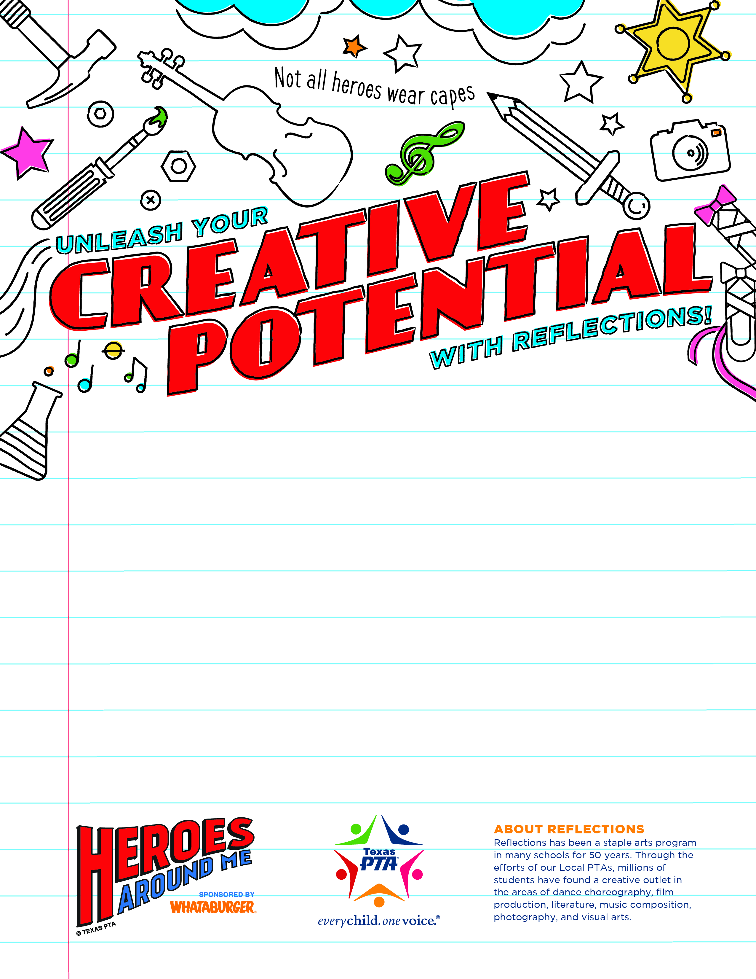
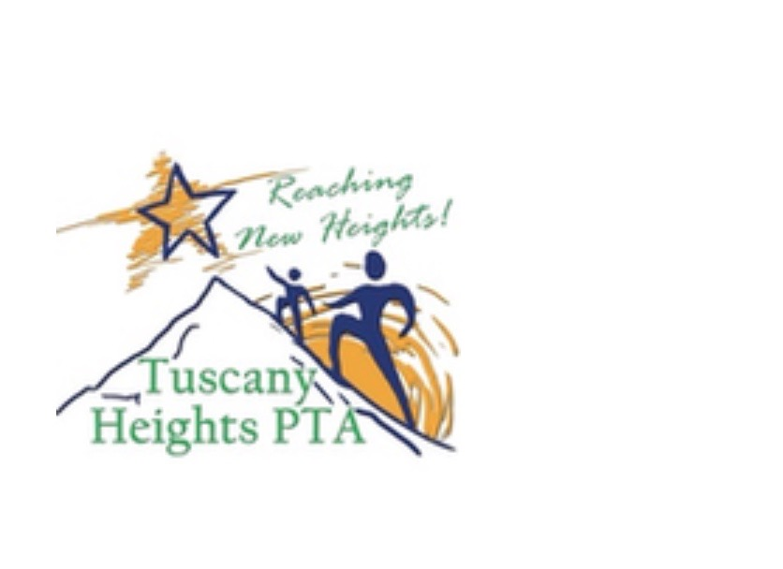
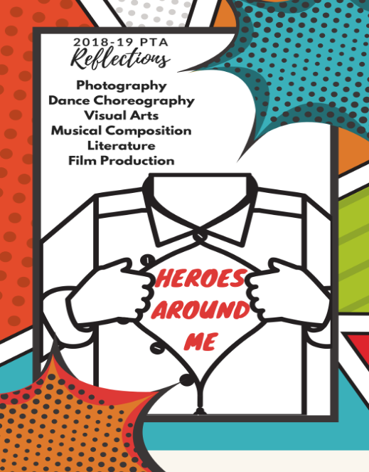

Enter the PTA
Reflections Art Contest!

This year’s theme is “Heroes Around Me.” Students can submit original works of art that reflects this year’s theme along with an entry form (see one on the back of this flyer.)
Enter as many times as you wish in any of six categories: dance choreography, film production, literature, music composition, photography, and visual arts.
Entries will be judged by experienced artists on reflection of the theme, originality and creativity. Winners will go on to compete with winners from other NEISD schools.

See tuscanyheightspta.org for submission guidelines and more information.

All entries must be

turned into the front

office by October 23!

