MacArthur High School Athletic Media Guides
Dear Brahma Supporter,
Booster Club is very proud and appreciative of the strong community that supports our MacArthur Brahmas and would like to share some exciting news with you!
We are thrilled to announce that we are now offering 4 Different Media Guides Featuring and Highlighting All Sports.

The 4 Media Guides will be as followed:
- Football, Cheer, and Dance (Fall Release)
- Volleyball, Tennis, Cross Country (Fall Release)
- Girls/Boys Basketball, Swim/Dive Team, Wrestling (Winter Release)
- Baseball, Softball, Track & Field, Soccer, Golf (Spring Release)

You may now purchase an Ad and be featured in our Winter and Spring Programs. This is a great way to promote your business, wish your student a great year, share how proud you are of their hard work and accomplishments or feature best friends. We invite you to be part of these keepsake programs and honor your child involved in athletics, cheer, dance, band, academic teams, clubs or special groups.

All advertising, camera-ready artwork, and payments must be submitted no later than December 4st, 2020 to be included in the Winter and Spring Sports Program for 2020-2021.
Please submit your camera-ready advertisement and photographs via email to macsportsprogram@gmail.com. If emailing is not an option please mail your information to MABC Sports Program, PO Box 17276, San Antonio, TX 78217-7276 and include a self-addressed stamp envelope if you would like the information returned. Please submit in one of the following formats: PDF, JPG, EPS, AI or TIF files. Microsoft Word, Publisher Excel and Powerpoint files are not acceptable unless properly sized and saved in one of the aforementioned formats.

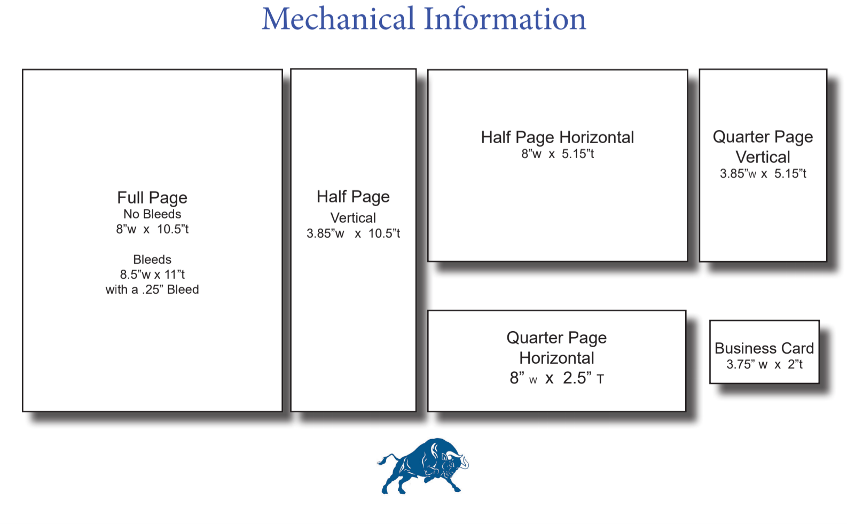
 | Complete and Return this page
Your  Choice | Ad size/Dimension | Business Price | Spirit Price
 | Full Page | $550 | $500
 | ½ Page H | $275 | $250
 | ½ Page V | $275 | $250
 | ¼ Page H | $125 | $100
 | ¼ Page V | $125 | $100
 | ⅛ Page | $50 | $40
PLEASE NOTE ALL ADVERTISING IS IN COLOR

SPIRIT PRICE applies when your advertisement showcases a MAC student, faculty member or staff member
DEADLINE December 4ST, 2020
TURN IN COMPLETED ORDER FORM AND PAYMENT TO:
MABC Sports Program, PO Box 17276, San Antonio, TX 78217-7276
Or scan and E-mail info to: macsportsprogram@gmail.com
Questions call: 580-399-8865

Business Name/Personal Ad:______________________________ ContactPerson:________________________

Email Info:_______________________________________________Phone#_____________________
Ad Sold By:_________________________ Phone# __________________ MAC Organization:________________

Check #__________ Check Amount $_____________________ ( Please make Check payable to MABC)
Credit Card: o Visa o MasterCard o American Express o Discover Amount: $_______________
The information below this line will be destroyed once the card is processed:
Card Number _______________________ Exp. Date_______ Security Code _______ Zip Code______________

Name on Card ______________________________________ Signature _________________________________
Please print clearly to ensure we capture the correct information.

