A How to Guide for Skyward and Launchpad
Parents: How to Make a Skyward Account
Go to www.neisd.net click here
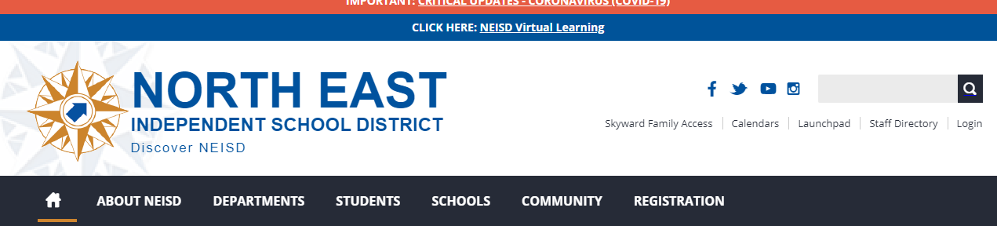
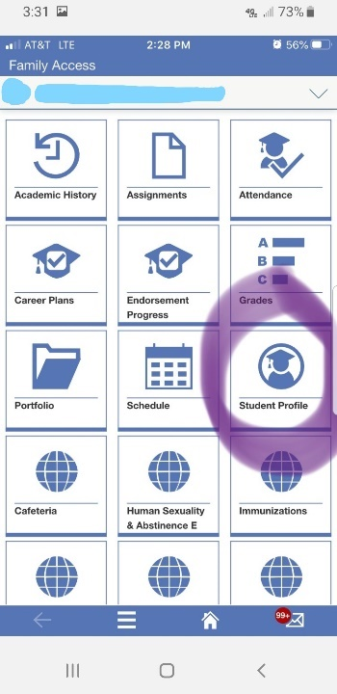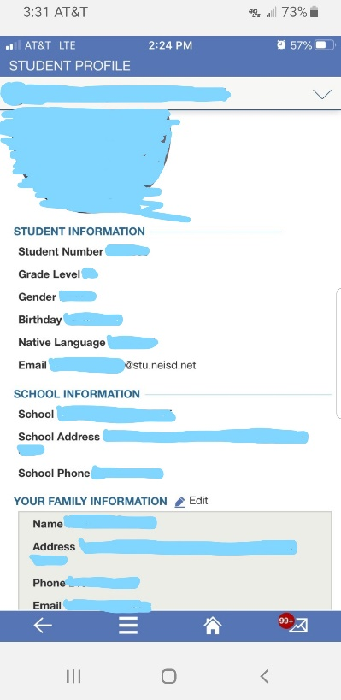
Once you have created an account, you will see tiles with different information. Click on the Student Profile tile. Make sure all the information is filled out and correct.
This is where you can find you student’s email address if they do not know what it is. Typically, their password is their Student Number unless they have changed it.
Make sure you have put in an email so you can receive information from the school and district.

Students How to Access the NEISD Launchpad (Google Classroom, Zoom, Email, etc)
Go to www.neisd.net click here (Launchpad)
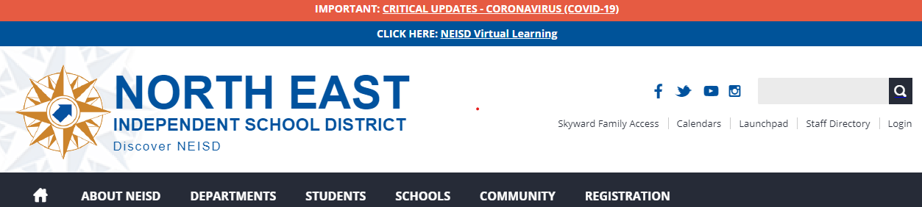
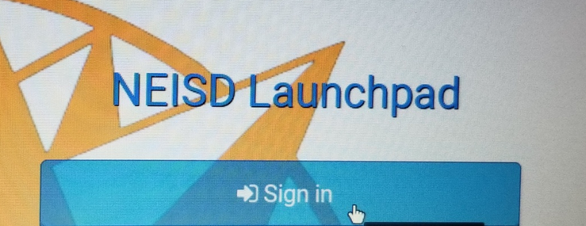
Click Sign in: Username is your school email and the password is your student ID unless you have changed it.

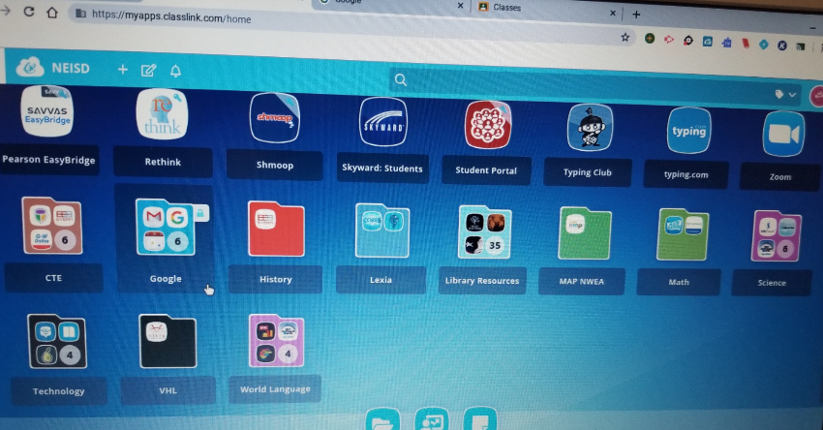
You will see several tiles in your Launchpad.
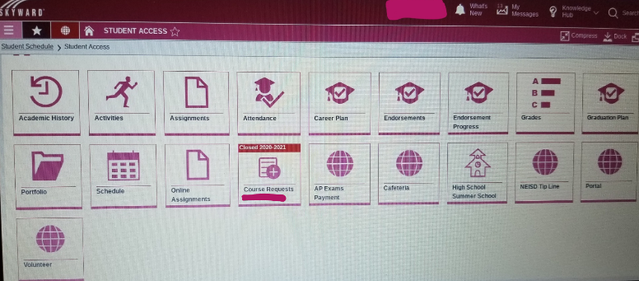
This is what you will see if you click on Skyward: Student. You can see your Schedule and Grades.
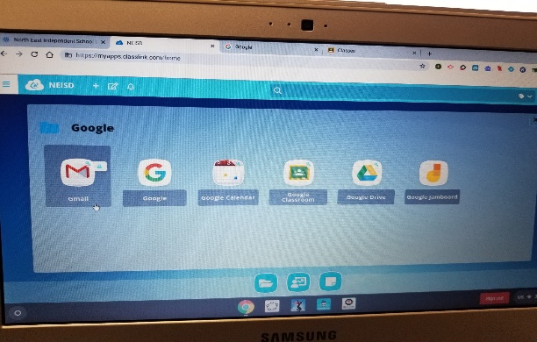
If you click on the Google folder you will see this.
Gmail is where you check your school email. Check this often! Mrs. Deason and teachers will be sending you information. You will get invites to Google Classrooms and Zooms this way.
Google Classroom is where your teachers will have your work. Teachers will be sending you classroom codes – check your email.
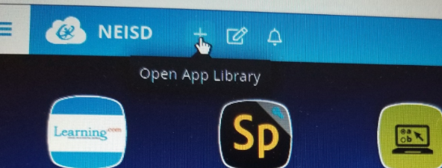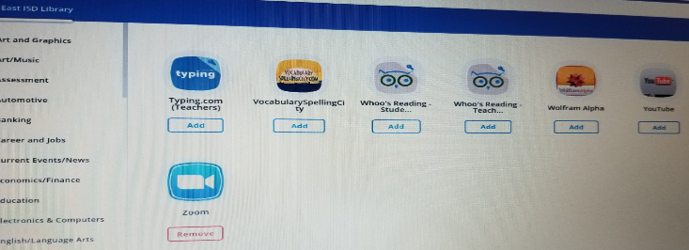
To add a tile to your Launchpad: click on the plus (+) sign, find the tile you need and click Add. It should show up on your Launchpad. Zoom is where you will log in for your live classroom instruction – you will need to add the Zoom tile. Teachers will be sending you the Zoom link to their live classroom.

