September 29, 2025

Dear Almeta Crawford High School Junior and Senior Families,
We are pleased to inform you that students can now access their updated unofficial transcripts and class rank information.
Skyward Q: Unofficial Transcripts
Updated unofficial transcripts, as of September 2025, are now located in Skyward.
Students and Guardians can access the information by logging into their Skyward account, then selecting the "Portfolio" tile.
You may access Skyward at: www.fortbendisd.com/skyward
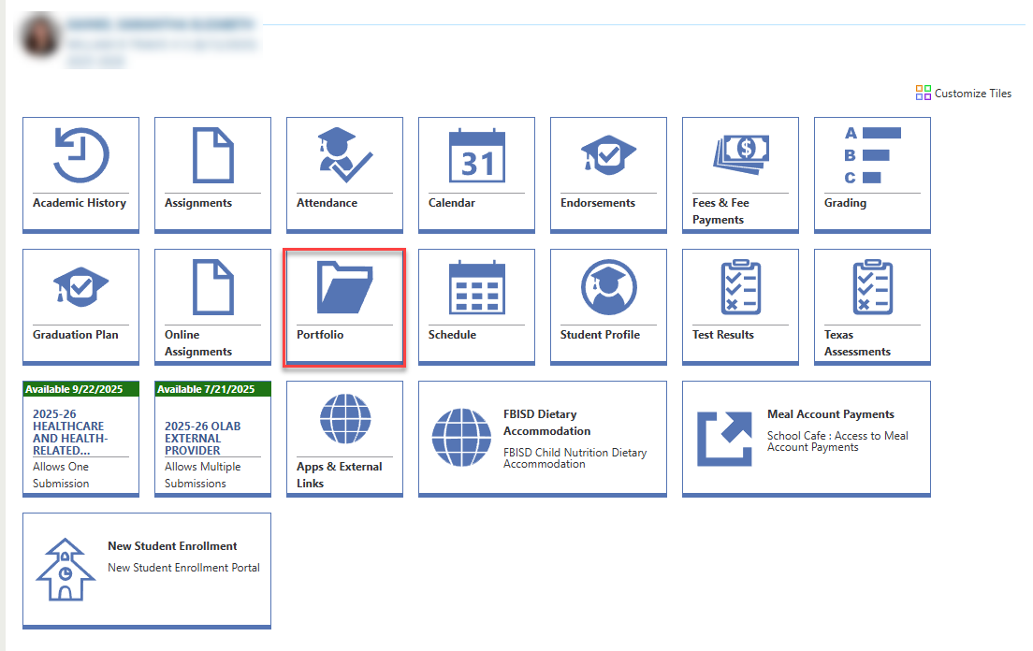

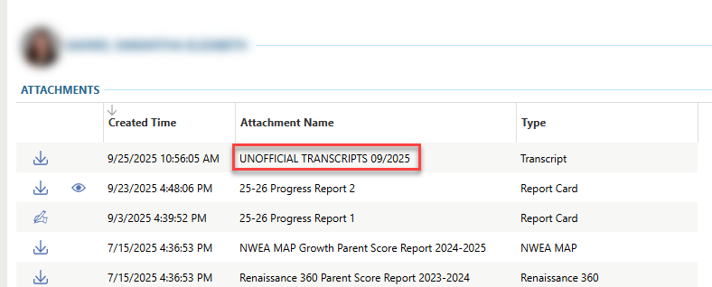
SchooLinks: Class Rank
Additionally, student class rank information is now available in SchooLinks.
Students must log into SchooLinks using their student account, then click on the "Performance" tab to view their current class rank.
From there, they may request that their official transcript and official class rank letter be sent directly to colleges and universities via the Common Application.
***Students will not be able to view the official class rank letter, as these are for college/university reporting purposes, but they can view their official class rank via the Performance Tab.
To access SchooLinks, please visit https://www.fortbendisd.com/1Link , select Clever, then SchooLinks under College Readiness. Log in using the student’s district credentials.

If you have any questions or need assistance, please contact our counseling office.

Sincerely,
Dr. Amber Grady
Almeta Crawford High School

