

Dear Parents:

Our Spring Break begins on Good Friday, April 18, 2025 and runs through April 25, 2025. School resumes on Monday April 28, 2025.

**Ohio State Testing for Math and Science**

|  |  |  |  |
| --- | --- | --- | --- |
| 4/14 | 4/15 | 4/16 | 4/17 |
| Math Part I | Math Part II | Science Part I | Science Part II |
| Grades 3, 4, 5 | Grades 3, 4, 5 | Grade 5 | Grade 5 |
| Make Ups and SPED Testing  4/28-5/9 | Make Ups and SPED Testing  4/28-5/9 | Make Ups and SPED Testing  4/28-5/9 | Make Ups and SPED Testing  4/28-5/9 |

Testing begins at 9:30 each morning.

**Attendance—Every Minute Counts**

Passed by the Ohio General Assembly in December 2016, House Bill 410 (HB410) encourages and supports a preventative approach to excessive absences and truancy. It is important for your child to attend school every day. When your student misses a significant amount of school, even if the absences are excused, the child misses critical instruction time and learning opportunities. This often has long-term, negative effects on a child, such as lower achievement and a greater chance of not graduating on time.

*Excessive Absence:* a student misses 38 or more hours of school in a single month, or 65 or more hours in one school year, with or without a legitimate excuse.

*Truancy:* a student is absent from school without legitimate excuse for 30 or more consecutive hours, 42 or more hours in one school month, or 72 or more hours in a school year.

If your child is going to be absent, call the school or send in a note upon his/her return regarding the absence. This will help to avoid a HB410 attendance meeting where your child will be put on an attendance intervention plan.

**Student Arrival and Dismissal**

Student drop off and pickup, between 8:30-9:00am and 3:15-3:45pm is in the FRONT of the building. All changes to your child’s dismissal routine must be called in to the school office by 2:00pm each day. This will ensure that the office staff has time to notify your child and the teacher. Failure to do so will result in your child being sent home as he/she normally would be. We will not pull students off of loaded buses; you will have to meet your child at his/her stop.

Changes to dismissal cause confusion for your child—changes should be used sparingly for emergency situations.

All students must be picked up prior to 3:45pm. Y**ou must have a back-up plan in case of emergencies—the school cannot be the back- up plan**. We do not have staff on duty after 3:45pm to supervise children.

**Important Dates**

* **April 18-25** Spring Break
* **April 28** School Resumes

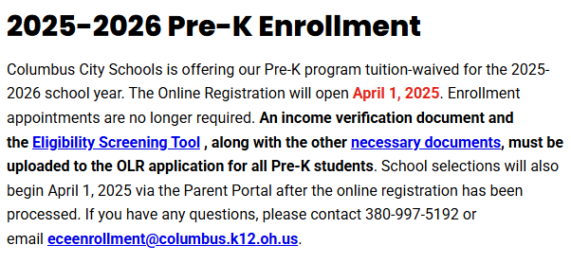

THANK YOU for supporting our school and following the protocols we have in place to keep all students and staff safe. Learning and safety are our top priorities.

Cordially,

Vern R. Miller

Principal