Expanding Universe Investigation - Teacher Answer Key

1. What do you think expansion can reveal about the Universe?

*This is meant to be a reflection/prior knowledge question. Answers will vary.*

1. Click on a point on the image to select the supernova.

Selected Supernova: ZTF19abqmpsr

*This is a guided practice question. Everyone will have the same image and answer.*

1. The photometric redshift technique is used to determine the recessional velocity of a galaxy.
2. Measuring the peak luminosity of a Type Ia supernova allows us to calculate the distance of its host galaxy.

*For questions 5- 8, data are randomized. Missing galaxy distances means they did not read the directions carefully and forgot to click on the galaxy in each image.*

5-8. Identify the supernova by clicking on it. A colored circle should appear when you have

correctly located it. Then identify the center of the galaxy by clicking on it. Another colored circle should appear when you have correctly located it. Your data for galaxy distance and velocity will automatically appear in the table.

9. For each galaxy, click on the plot to add a point with values close to the galaxy’s distance and velocity. You can move a point by clicking and dragging it or by using the keyboard arrows.

*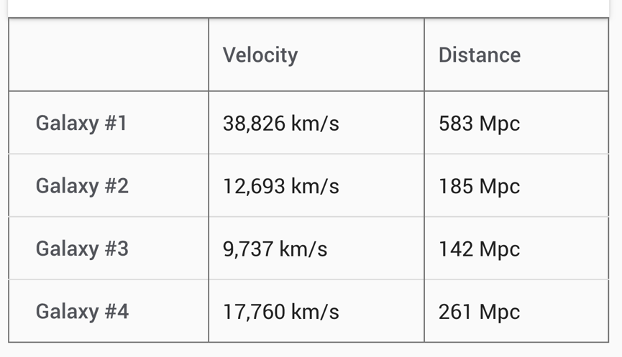*

*Data on the below plot should indicate a roughly linear arrangement of points*

4 points plotted

Hubble Plot

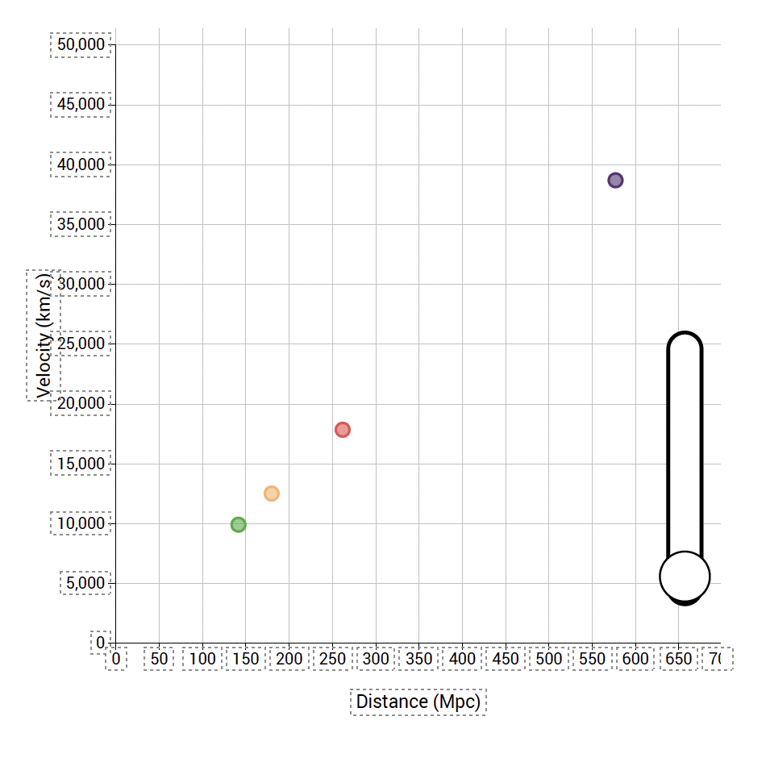

10. We are observing these galaxies from Earth’s location within the Milky Way Galaxy. Where would you put a point on this plot to indicate the location of the Milky Way Galaxy?

At the origin

11. Based on your data, how many of the galaxies appear to be moving away from the Milky Way Galaxy?

All of them

12. Far away galaxies appear to be moving away from the Milky Way Galaxy faster than nearby galaxies.

13. Does this mean that nearby galaxies are going to catch up to farther away galaxies? Explain using the data on your plot.

No, because the farther galaxies will always be moving faster than the closer galaxies.

14. Does this mean that the distance between galaxies is staying the same, getting larger, or getting smaller with time? Explain.

It's getting larger, because over time, the galaxies will seem to move farther away from each other.

15. This means that the Universe is expanding (getting larger).

16. Click and drag anywhere on the Hubble plot to add a trendline.

Hubble Constant: 66.1 km/s/Mpc *(Answers will vary somewhat, see the student plot after Q. 17)*

17. Scientists currently estimate the Hubble Constant to be between 67.7 and 74.0 (km/s)/Mpc. How does your value of the Hubble Constant compare to these values?

Mine seems a little below the range, but not by much.

Hubble Plot

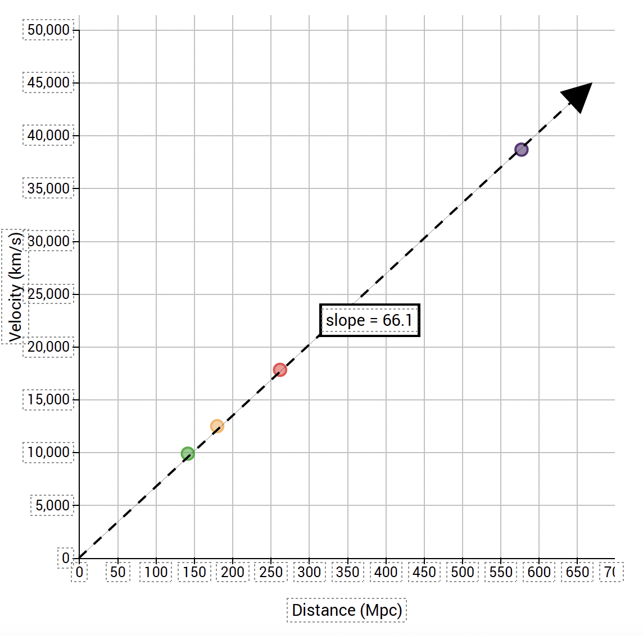

18. If scientists make observations that establish the Hubble Constant to be 57 (km/s)/Mpc, would that indicate the Universe is expanding faster or slower than your data suggest?

It would mean the Universe is expanding slower than my data suggest.

19. In the Hubble plot, the data from galaxy observations all fall along a straight line. Are the galaxies actually positioned in space along a straight line?

no

20. If alien astronomers living in Galaxy #2 were to view a Hubble plot from their position in the Universe, where would their galaxy appear on the plot?

at the origin

21. Is the relationship between the distance of a galaxy and the velocity of a galaxy the same or different than what you observed from the Milky Way Galaxy? Explain.

The relationship is the same, the slope did not change.

22. How does the Hubble Constant for the observations made by the alien astronomers in Galaxy #2 compare to the Hubble Constant you measured from Earth (in the Milky Way Galaxy)?

It's the same value.

23. Does this mean that the alien astronomers and Earth astronomers are observing the Universe expanding at the same rate or at different rates? If different, who observes the Universe expanding faster?

Both astronomers observe the Universe expanding at the same rate.

24. Do your observations suggest that astronomers at all locations in the Universe would observe that all galaxies are moving away from them?

Yes, because everyone would observe the same rate of expansion.

25. What do the above observations imply about the center of the Universe?

All locations observe the Universe to be expanding in the same way and therefore there is no center.

26. Describe a time when you (or someone you know) had an idea or opinion that went against what is commonly accepted by most people. What evidence did you use to try to convince others to consider your idea or opinion?

*Answers will vary based on personal experience.*

27. The galaxy farthest from us provides information from a time that is long ago in the history of the Universe.

28. Was the Universe smaller or larger a long time ago?

smaller

29. Are the galaxies getting closer together or farther apart as the Universe gets older?

farther apart

30. Do your data (colored points) agree with the Rubin Observatory data (grey points) for nearby galaxies regarding the expansion of the Universe? Explain.

Yes, they are in the same area of plot as the grey dots near the origin.

31. For the more distant galaxies, the data do not fit the trendline.

32. The region on the plot where the data do not fit the trendline corresponds to a long time ago in the history of the Universe.

33. The slope of the Hubble plot for galaxies that are far away is flatter than the slope for nearby galaxies.

34. A long time ago, was the Universe expanding faster or slower than it is now? Explain your reasoning.

Slower, because the trendline on the Hubble plot would be flatter (smaller) at far away distances (early times).

Hubble Plot

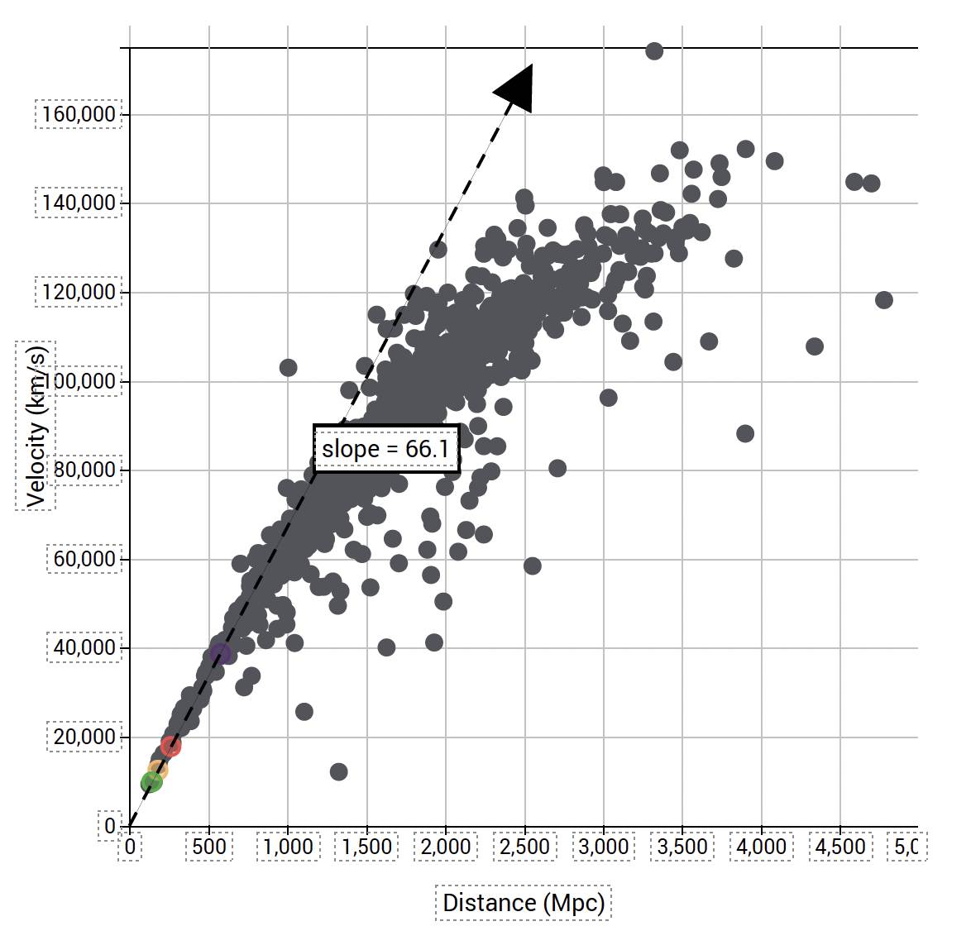

35. Would you have been able to determine that the expansion rate of the Universe is changing with time if you had only your data from nearby galaxies? Explain why or why not.

No, because the data from nearby galaxies all fit along a straight line.

36. How do the data from this investigation provide supporting evidence for the Big Bang Theory? Explain what aspects of the Big Bang Theory are addressed and how they are supported.

The Big Bang Theory suggests that the Universe began “everywhere at once”, and afterwards underwent a period of expansion. Data show that the Universe is expanding, and that there is no center to the Universe, because all galaxies appear to move away from each other over time.

37. At the beginning of the investigation, you were asked to share what you think expansion could reveal about the Universe. Look back to the first page of the investigation to reflect on your initial response. Now that you have explored data for the Universe’s rate of expansion over time and considered the rate of expansion from other galaxies, how would you revise your initial response?

Over time the Universe is getting larger. The changing slope of the Hubble plot shows that expansion is accelerating, so the Universe is getting bigger in a shorter amount of time now, compared to its early history. Expansion also shows that there's no center to the Universe.

38. We observe the light from distant galaxies to be redshifted, indicating that these galaxies are all moving away from us, and that the Universe is expanding.

39. (Choose the two variables that best complete this sentence) To construct a Hubble Plot you need to determine the distance, recessional velocity of galaxies.

40. A Universe that is slowly expanding would have a Hubble plot with a slope that is flatter.

41. The Hubble plot for an observer in a different galaxy would also indicate that all galaxies are moving away from them.

42. Observations of the expansion of the Universe from different locations reveal that the Universe does not have a center.

43. The light we receive from distant objects tells us what the Universe was like a long time ago, while the light we receive from nearby objects tells us what the Universe was like from more recent times.

44. The slope of a Hubble plot is flatter for data from very distant objects compared to nearby objects. Since the expansion rate of the Universe determined by observing distant objects is slower than the expansion rate determined by observing nearby objects, the expansion rate of the Universe is speeding up as time goes on.