Exploding Stars Investigation Answer Key

1. What do you currently know about how distances are measured in space?

Answers will vary. This is a reflection question that is based on prior knowledge and will be asked again at the end for comparison purposes.

*Pages 3 and 4 (Questions 2-4) are the same data for all students.*

1. Select the supernova by clicking on the image.

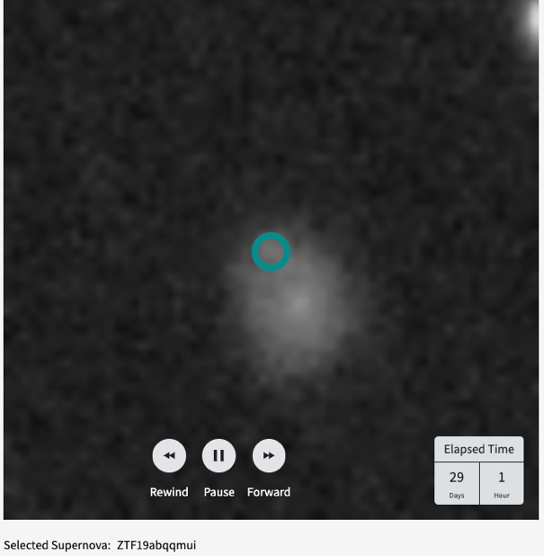

1. Click on the supernova in the image.

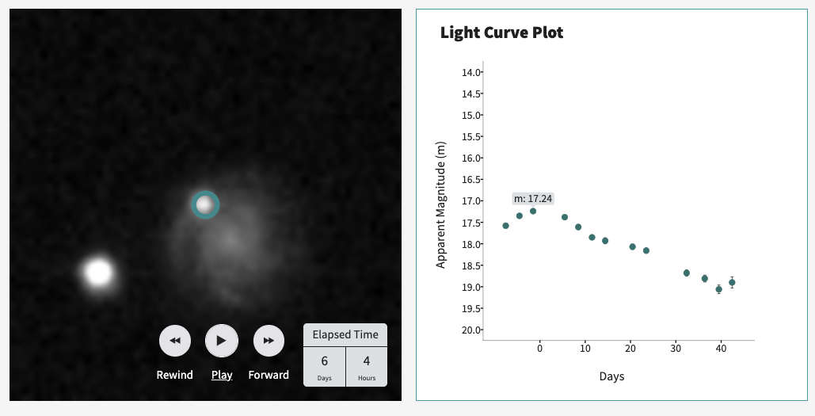

1. What is the best way to describe how the brightness of this supernova changes over time?

It starts out by getting brighter, reaches peak brightness, then gradually gets dimmer.

1. Which type of supernova is the most energetic and intrinsically bright? Ia
2. The peak brightness of a Type IIp supernova depends on the mass of the star that explodes.
3. Which type of supernova remains relatively bright for about 90 days? IIp
4. Which type of supernova always has about the same peak brightness? Ia
5. Which type of supernova arises from stars that are much more massive than the Sun? IIp
6. Which graph shows a supernova that increases until reaching a peak brightness, then its brightness level drops slightly, and its brightness remains approximately the same for several months? Graph 1
7. Which graph shows a supernova that increases to peak brightness and then continues to dim over a period of months? Graph 2
8. Which graph shows a Type Ia supernova? Graph 2

*Pages 9-11 (Questions 13-24) are the same data for all students.*

13. Use the controls to play, pause, and skip between images. Click on the supernova when you find it.

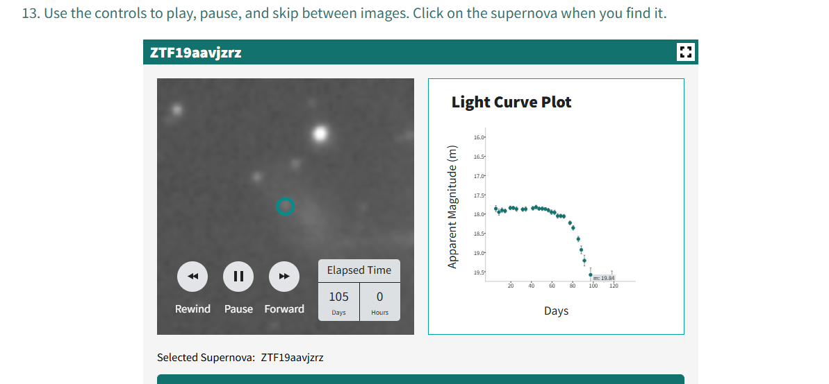

1. What type of supernova is this? Type IIp
2. Explain your answer — which aspects of the light curve caused you to choose this type?

The supernova stays at about the same brightness for about 90 days before dimming.

1. Does the graph show a supernova formed from a white dwarf or a high mass main sequence star? a high mass main sequence star
2. Use the controls to play, pause, and skip between images. Click on the supernova when you find it.

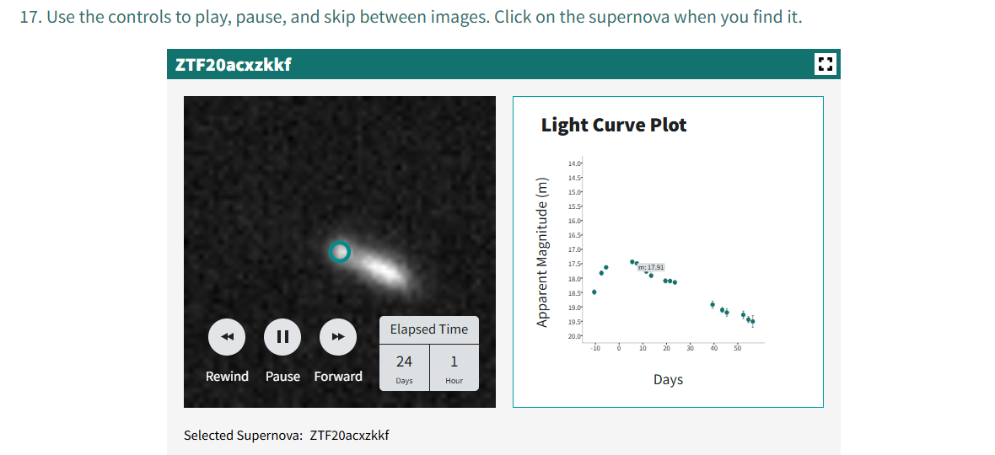

1. What type of supernova is this? Type Ia
2. Explain your answer — which aspects of the light curve caused you to choose this type?

The supernova shows a continual decline in brightness after reaching peak magnitude.

1. Does the graph show a supernova formed from a white dwarf or a high mass main sequence star? a white dwarf
2. Use the controls to play, pause, and skip between images. Click on the supernova when you find it.  
   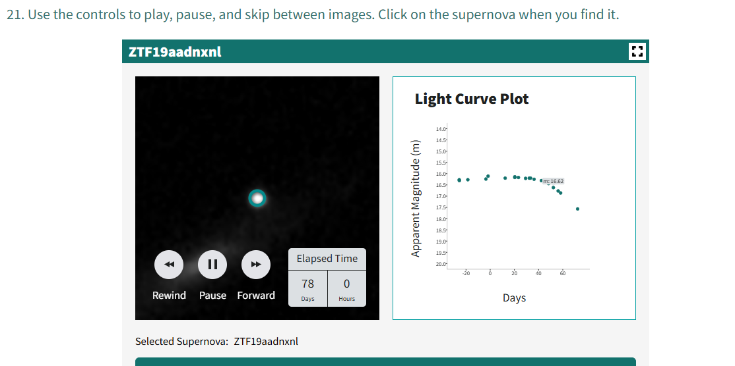
3. What type of supernova is this? Type IIp
4. Explain your answer — which aspects of the light curve caused you to choose this type?

The supernova stays at about the same brightness for about 90 days before dimming

1. Does the graph show a supernova formed from a white dwarf or a high mass main sequence star? a high mass main sequence star
2. Which supernova (A or B) shown in the graph decreases in brightness more rapidly?

Supernova B

1. Does the supernova that decreases in brightness more rapidly have a smaller or larger value for 𝚫m15? Larger
2. Which supernova is more intrinsically bright? Supernova A
3. The supernova that declines more rapidly in brightness will have a larger 𝚫m15, will be less intrinsically bright, and will have a smaller peak absolute magnitude number.
4. Practice fitting the Type Ia supernova model light curve to the sample data.

*Note: this practice light curve is the same for all students. When fitted properly, the approximate curve width is -1.59, and the approximate vertical (y) offset is -1.7. Emphasis is on fitting the 𝚫m15 (shaded grey area) of the curve.*

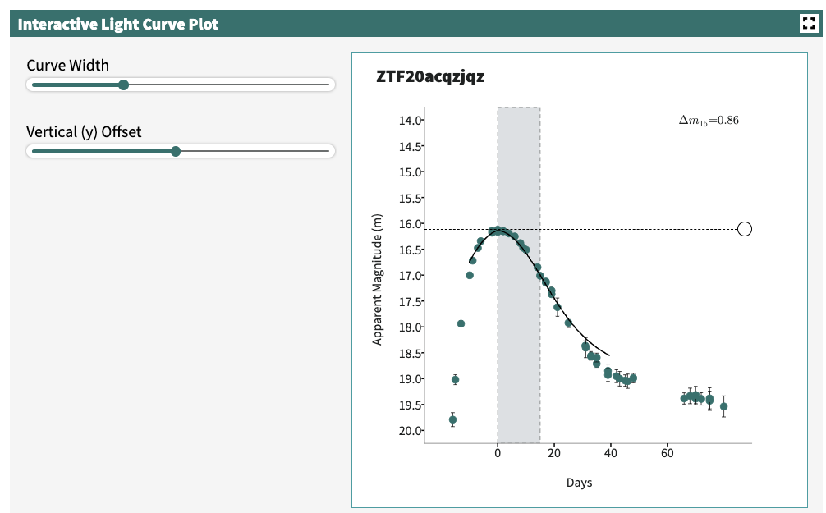

1. Enter the value for your 𝚫m15 to calculate the peak absolute magnitude of the supernova. 0.86
2. Record the values for 𝚫m15, peak apparent magnitude (m), and peak absolute magnitude (M) of the supernova in the table below.

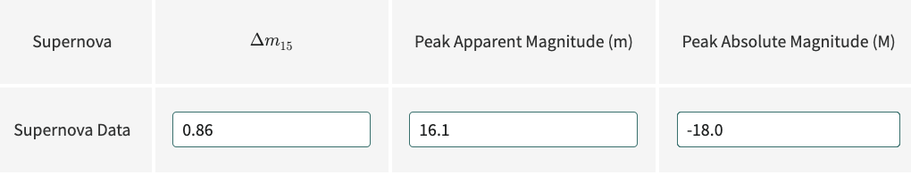

1. Enter the peak apparent magnitude (m) and absolute magnitude (M) for the supernova into the calculator to find its distance from Earth. (Don’t forget to include the negative sign for M.)

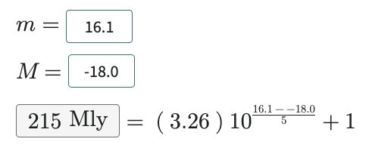

1. Enter the distance for the supernova in Mly. 215 Mly

*Note: in the next section, data for Supernovae A, B and C are randomized. In all cases, Supernova A is the closest of the set. The following cases represent sample data from one randomized set. Student answers for all questions 34-45 will vary.*

1. Fit the model light curve to your data. Then, move the dotted line to the peak of your light curve to determine the peak apparent magnitude.

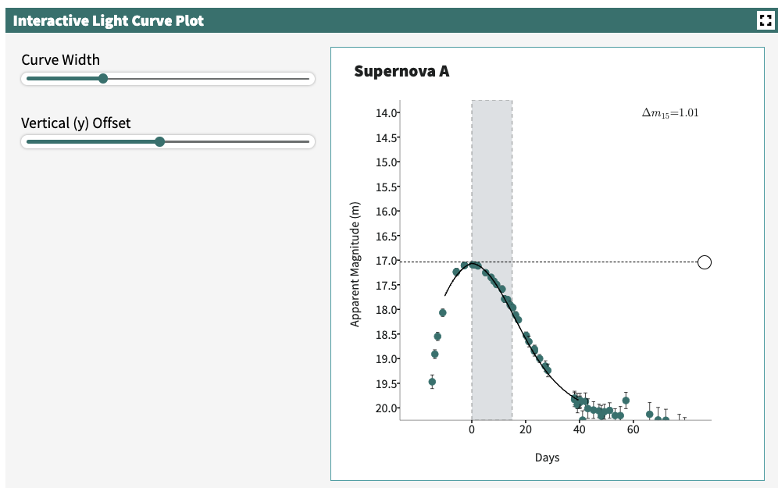

1. Enter the value for your 𝚫m15 to calculate the peak absolute magnitude of Supernova A. In this case 𝚫m15 = 1.01
2. Enter the peak apparent magnitude (m) and absolute magnitude (M) for Supernova A into the calculator to find its distance from Earth. (Don’t forget to include the negative sign for M.) 226 Mly
3. Record the values for 𝚫m15, peak apparent magnitude (m), peak absolute magnitude (M), and distance of Supernova A in the table below.   
   *See completed table for all 3 example supernova at Q 45.*
4. Fit the model light curve to your data. Then, move the dotted line to the peak of your light curve to determine the peak apparent magnitude.

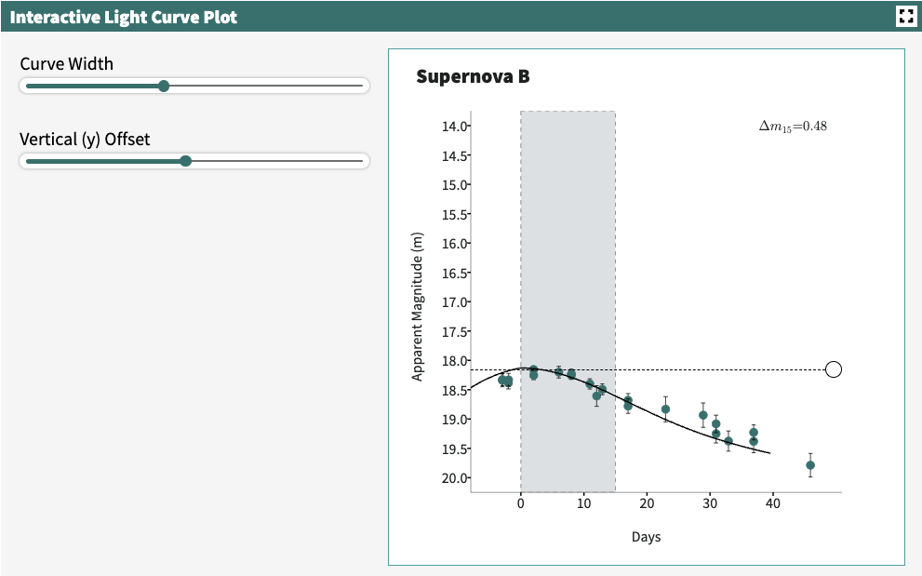

1. Enter the value for your 𝚫m15 to calculate the peak absolute magnitude of Supernova B. In this case 𝚫m15 = 0.48
2. Enter the peak apparent magnitude (m) and absolute magnitude (M) for Supernova B into the calculator to find its distance from Earth. (Don’t forget to include the negative sign for M.) 1790 Mly
3. Record the values for 𝚫m15, peak apparent magnitude (m), peak absolute magnitude (M), and distance of Supernova B in the table below.

*See completed table for all 3 example supernova at Q 45*.

1. Fit the model light curve to your data. Then, move the dotted line to the peak of your light curve to determine the peak apparent magnitude.

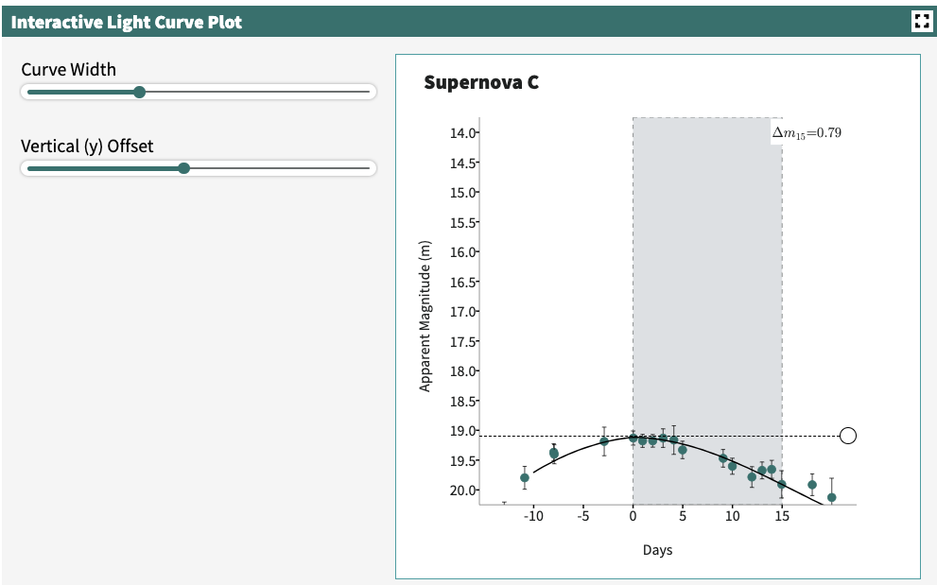

1. Enter the value for your 𝚫m15 to calculate the peak absolute magnitude of Supernova C.

In this case 𝚫m15 = 0.79

1. Enter the peak apparent magnitude (m) and absolute magnitude (M) for Supernova C into the calculator to find its distance from Earth. (Don’t forget to include the negative sign for M.). 1130 Mly
2. Record the values for 𝚫m15, peak apparent magnitude (m), peak absolute magnitude (M), and distance of Supernova C in the table below.

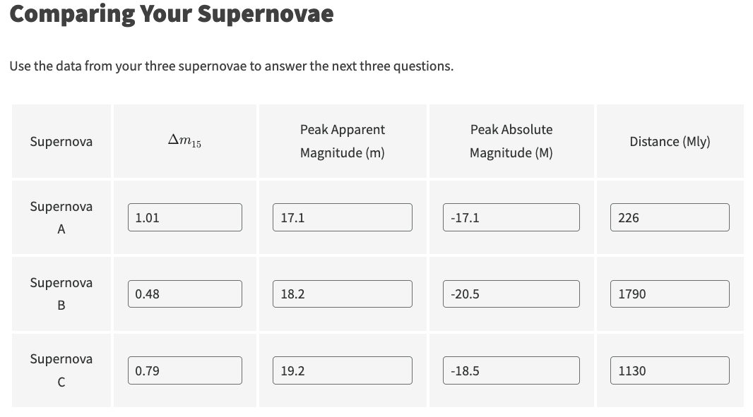

*The answers to Questions 46 and 47 are based on data in the sample table above.*

46. Which of the three Type Ia supernovae appears brightest from Earth? A

47. Supernova B is most intrinsically bright, so its light curve will decrease in brightness

the slowest during the 15 days following its peak apparent brightness.

48. Suppose two Type Ia supernova have the same Δ 𝑚 15. Supernova A has a smaller peak   
 apparent magnitude number than Supernova B. Which supernova is closer to the Milky Way   
 Galaxy?

Supernova A, because a brighter the peak apparent magnitude (m) is a smaller number.

49. Are the locations of supernovae evenly distributed on the map? If not, what patterns do you   
 notice?

Students should note that there is no real pattern to supernova distribution. They seem more or less evenly distributed.

50. Are there equal numbers of supernovae at all distances? If not, at what distance are more supernovae located?

Answers will vary, but should note that the number of supernovae drops significantly at distances greater than ~1500Mlyr (this is due to observational bias–it’s harder to detect supernovae at far distances). The most common distance is at ~800-1200 Mly.

51. Describe where your 3 supernovae are in relation to the Milky Way Galaxy (above, below, close, far, etc.)

Answers will vary. Here’s a sample answer for the distribution on the map shown below:

There are 2 supernovae below the galactic plane and one above it. The one above the plane (Supernova C)is at the farthest distance.

Map using the sample data illustrated in this answer key:  
  
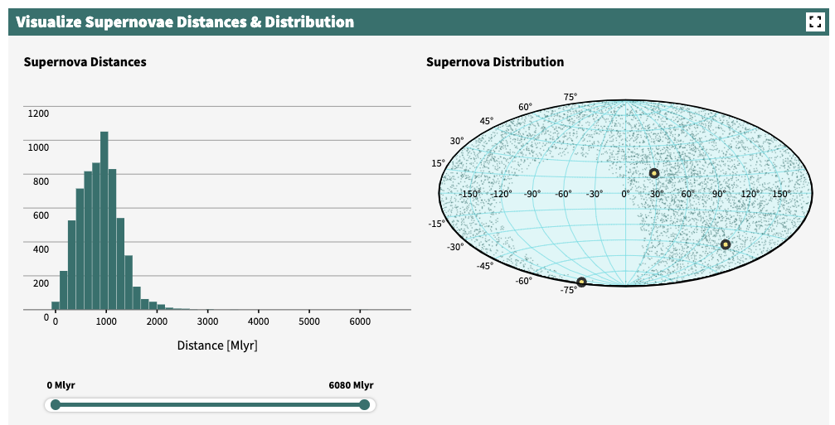

52. In this investigation, you have learned how to classify (categorize) types of supernovae according to the shape of their light curves. Provide an example of how your personal life and/or society have been affected by the use of categories.

Answers will vary. Sample answer: In society we tend to classify people a lot by their appearance, such as the color of their skin, the type of clothes they wear, or by a noticeable disability. These classifications may have personal biases or first impressions attached to them that can be completely misleading.

53. At the beginning of the investigation, you were asked to share what you knew about measuring distances in space. Look back to the first page of the investigation to reflect on your initial response. Now that you have further explored this topic, how would you add to your initial response to explain how supernovae are used to measure distances in space?

Sample answer: One way to measure distances to galaxies is to use Type Ia supernovae. By measuring properties of their light curves, we can calculate a distance to them. Not all types of supernovae can be used to do this, but Type Ia can be used because they act like standard candles.