Stellar Safari Investigation Answer Key

1. Reflect: How are stars different from each other?  
   *This is meant to be a reflection/prior knowledge question. Answers will vary.*
2. A relatively cool star that is intrinsically bright and undergoing more than one type of fusion is a: giant
3. Which stars will have a smaller color index value?  
   the ones that appear brighter in the short wavelength filter
4. Will stars with a larger color index be hotter or cooler? cooler
5. The hottest stars are located at the right of the CMD and the stars that would appear dimmer are located at the bottom of the CMD.
6. Compared to all of the stars on this CMD, a star with a color index of -0.5 and an apparent magnitude of 20 is bluer in color and hotter in temperature, and appears dimmer than most of the stars.
7. What type of star was identified in the previous question? white dwarf
8. What type of star has a color index of 2.0 and an apparent magnitude of 8? Giant
9. Which main sequence stars are brighter and bluer, and therefore more massive?   
   stars near A
10. Stars near A have a faster fusion rate, a shorter main sequence lifetime, a larger surface area, a higher temperature, and a higher luminosity than stars near B.
11. The Sun's mass is closest to the low end of masses.
12. The Sun’s main sequence lifetime is closest to the middle of the range of lifetimes of main sequence stars.
13. The plot demonstrates that more massive main sequence stars will have shorter lifetimes.
14. The plot demonstrates that the relationship between star masses and main sequence lifetimes is non-linear.
15. A main sequence star that is two times more massive than the Sun will have a main sequence lifetime that is less than half as long as the Sun’s lifetime.
16. If you were to think of the Sun’s lifetime as analogous to the 80-year life expectancy for the average human, on this scale, how long (in human years) would a 5 solar mass star live? Choose the best answer. 1.5 years
17. When comparing two clusters, the older cluster will have more stars in the giant branch and will have stars at the turnoff point that are lower mass with main sequence lifetimes that are longer.
18. Which star cluster do you think is older? Explain your reasoning in terms of the stars that are in the giant branch and main sequence stars that are at the turnoff point.  
    Star cluster 2 is older. It has giant stars, and turnoff point around magnitude 14. Star Cluster 1 is so young it does not yet have any giants or a turnoff point.
19. Use the age selector and distance slider to get the best fit of an isochrone to the data. You may need to experiment with different isochrones at several distances to get a best fit.  
      
    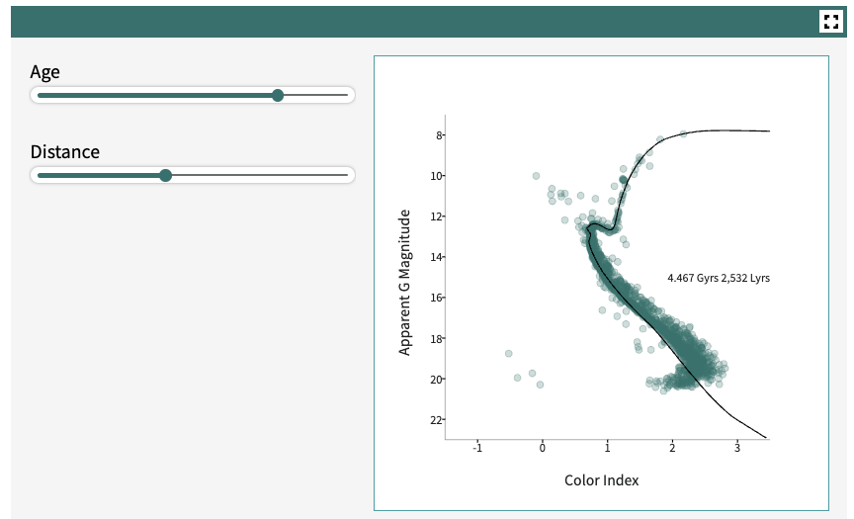
20. The distance to this cluster is __ light-years. 2532
21. The age of this cluster is approximately ___ Gyrs. 4467
22. Look at the stars along the isochrone. Which stars are the oldest in years?  
    all stars are the same age in years

*For Questions 23 & 24 and 27 & 28, star clusters are randomized, so not all answers for age and distance will be the same. The answers to Questions 25 and 28-30 will also be dependent on which star clusters were analyzed. Following are sample answers based on randomized data for star clusters 1 & 2.*

1. Use the age selector and distance slider to get the best fit of an isochrone to the data. You may need to experiment with different isochrones at several distances to get a best fit.  
     
   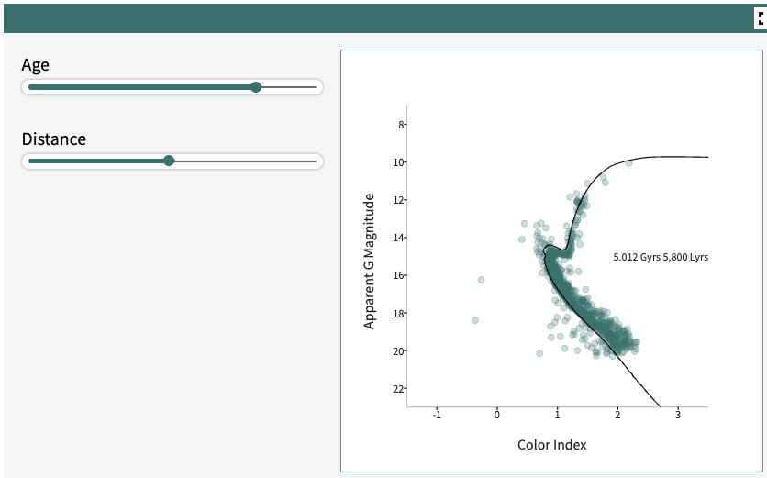
2. Enter the distance and age you determined for Cluster 1 in the table below.  
   Cluster distance 5800 Lyrs Cluster Age 5.012 Gyrs
3. If the Sun were a star member of this cluster, what would its current age be?  
   5.0 Gyrs, since all stars in this cluster are about the same age.
4. If the Sun initially formed in this cluster, based on the age that you just estimated, what kind of star would it be? main sequence
5. Use the age selector and distance slider to get the best fit of an isochrone to the data. You may need to experiment with different isochrones at several distances to get a best fit.

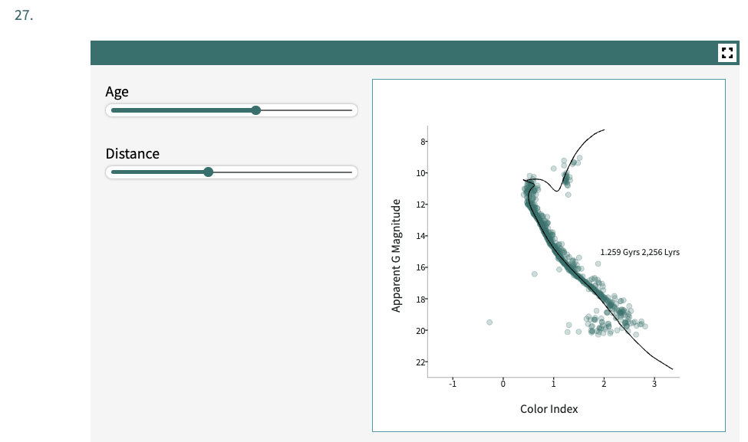

1. Enter the distance and age you determined for Cluster 2 in the table below.

Cluster distance 2256 Lyrs Cluster Age 1.259 Gyrs

1. Which cluster is younger? Cluster 2
2. Which cluster is closer to Earth? Cluster 2
3. Look at the star cluster image below. Based on the kinds of stars that you see, do you think this is a younger or an older cluster? Explain your reasoning.  
   I think this is a younger star cluster because there are still many blue stars in it. Blue stars tend to have very short lifetimes before becoming giants.
4. Stars in the giant branch are higher mass, as they recently evolved from higher mass main sequence stars that had faster fusion rates, and shorter main sequence lifetimes.
5. Describe how star masses are distributed along the main sequence of the CMD of this cluster.  
   The stars highest on the main sequence are the most massive, and the stars lowest on the main sequence (lower right) are the least massive.
6. In this investigation you have explored five different properties of main sequence stars: temperature, luminosity, mass, lifetime, and surface area. Which of these is the property that determines all the others? Explain your answer.  
   The initial mass of the star, once it has begun fusion determines all other properties. More massive stars will have higher surface areas (they have more gas in them) and higher rates of fusion, which will cause higher temperatures and luminosities.
7. At the beginning of the investigation, you were asked how stars are different from each other. Look back to the first page of the investigation to reflect on your initial response. Now that you have further explored this topic, how would you add to your initial response?  
   *This is meant to be a reflection/prior knowledge question. Answers will vary*.   
   Sample answer: Main sequence stars are different from each other in their amount of mass, their size (surface area), their rates of fusion, their temperatures, luminosities, and the amount of time they will be hydrogen-fusing and stay on the main sequence. There are other types of (more evolved) stars, too, such as giants and white dwarfs, that show significantly different sizes, temperatures and luminosities compared to main sequence stars.
8. Stars in a cluster undergo significant changes over their lifetimes. Groups of people undergo changes as well. What are some significant transformations you (or members of a group you are part of) have undergone in your lifetime? How are these transformations similar to or different from the changes that happen in a star cluster?  
   *This is meant to be a reflection question. Answers will vary.*