Best of Butler County is BACK for 2025!

A great way to get exposure for your brand is to be a Best of Butler County finalist or winner! How do you do that? Ask your customers, fans, friends and family to NOMINATE and VOTE for you in our 2025 Best of Butler County contest on Journal-News.com.

Below are sample social media messages you can post, or send in an email, for your bid to be the Best of Butler County. Post the messages with your own photos or use the graphics we made for you! If you use your own photos – you can put our Best of Butler County logo on them to get attention!

URL to post: <https://bit.ly/bestofbutler2025>

**NOMINATION period – January 20 – January 31**

**Facebook posts**

#1 Post

Nominate us to be in the running to be the Best of Butler County (enter category you want to be named in here)!

The more you nominate us, the better. You can nominate us daily through January 31 at https://bit.ly/bestofbutler2025

#2 Post

Hey! We have a favor to ask ... can you help us be named a BEST OF BUTLER COUNTY!? Nominate us today for (enter category you want to be named in here) at

You can nominate us daily now through January 31 at https://bit.ly/bestofbutler2025

#3 Post

Do you think we’re the Best of Butler County? Well, then help us make it official – nominate us today to be named a Journal-News Best of Butler County 2025 (enter category you want to be named in here – example: Best Coffee House)!

Nominate us daily through January 31 at: https://bit.ly/bestofbutler2025

**Instagram**

***Instagram stories***

Adding photos and links to your Instagram stories is the best way to reach your audience. Do you know how to add a link to your Instagram stories? When you’re making a story, hit the smiley face in the upper right corner, and then hit the LINK option.

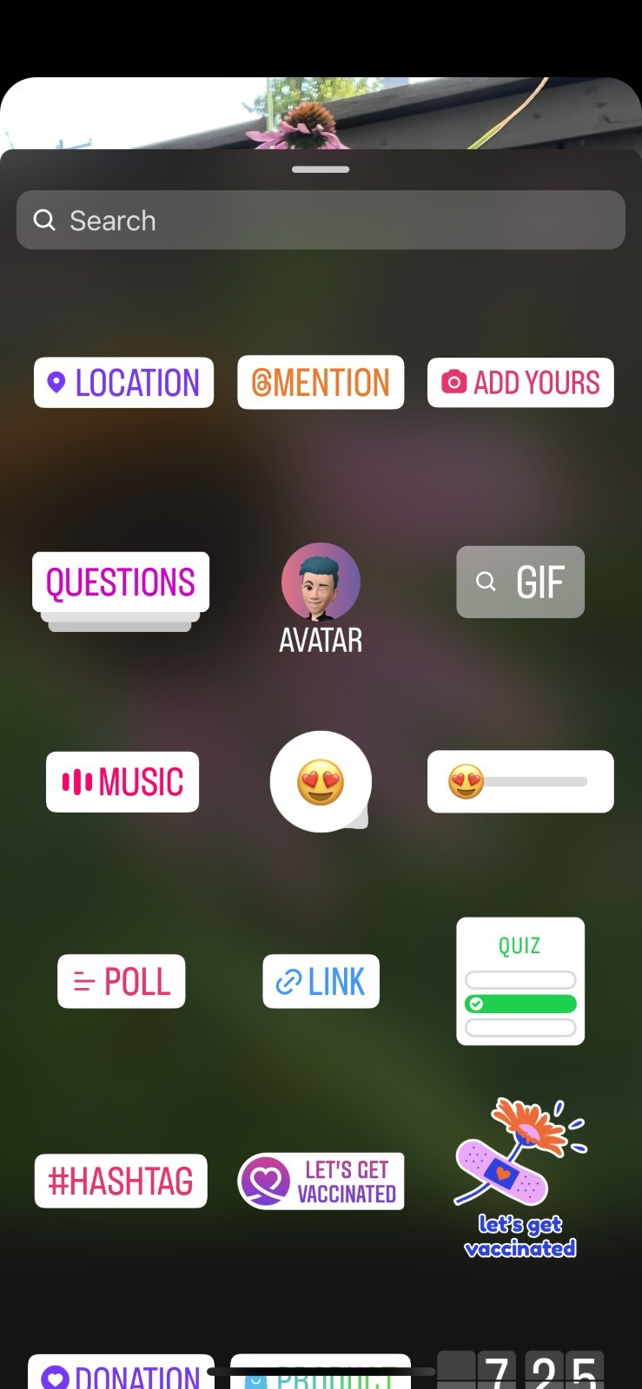  
Paste in this URL to the link generator, and it will add the nominate URL to your story, that your fans can click directly to. URL to use: https://bit.ly/bestofbutler2025

Add our “Nominate us” graphic we provided to your story, with the message “Nominate us for (enter category you want to be named in here – example: Best Coffee House)! And then include the LINK option to your story

***Timeline posts***

#1 Post

HELP US to be named a @JournalNews Best of Butler County 2025! Nominate us today for (enter category you want to be named in here – example: Best Coffee House) on Journal-News.com. #BestofButlerCounty

#2 Post

Do you think we’re the Best of Butler County? Well, then help us make it official – nominate us today to be named a @JournalNews Best of Butler County 2025 (enter category you want to be named in here – example: Best Coffee House)! Nominations are open NOW on Journal-News.com

**Twitter/X**

#1 post

HELP US to be named a @JournalNews Best of Butler County 2025! Nominate us today for (enter category you want to be named in here – example: Best Coffee House) at https://bit.ly/bestofbutler2025 #BestofButler County

#2 post

Do you think we’re the Best of Butler County? Well, then help us make it official – nominate us today to be named a @JournalNews Best of Butler County 2025 (enter category you want to be named in here – example: Best Coffee House)! Nominations are open NOW at https://bit.ly/bestofbutler2025

**Email blast**

Hello friends! We need your help – we're on a mission to be named a Best of Butler County 2025 business, so we need you to nominate us for a Journal-News Best of Butler County 2025 contest in the category:(enter category you want to be named in here – example: Best Coffee House)!

It’s easy – go to https://bit.ly/bestofbutler2025 and nominate us. You can nominate us daily now through January 31!

Thanks for helping us on our quest to be the Best of Butler County!

P.S. - If we get enough nominations, we’ll be named a Finalist in the competition, which the finals voting will start in late February at the same website - https://bit.ly/bestofbutler2025. Stay tuned, and we’ll let you know if we make it to the finals!