Best of Butler County Finalist voting is OPEN NOW!

It’s the home stretch to the finish line – FINALIST VOTING is happening – and you need all the support you can get!

An easy way to get votes is to reach out to your customers, fans, friends and family to VOTE for you in our 2025 Best of Butler County contest, on Journal-News.com.

Below are sample social media messages you can post, or send in an email, for your bid to be the Best of Butler County.

Post the messages below with your own photos or use the graphics we made for you! If you use your own photos – you can put our Best of Butler County logo on them to get attention!

URL to post: <https://bit.ly/bestofbutler2025>

**FINALIST VOTING period – April 22 – March 14**

**Facebook posts**

#1 Post

We made it! We’re a finalist in the 2025 Best of Butler County contest on Journal-News.com.

Now we need you to VOTE for us to WIN the Best of Butler County (enter category you are in here)!

You can vote for us daily until March 14 at https://bit.ly/bestofbutler2025

#2 Post

Can you help us be named a BEST OF BUTLER COUNTY!? We’re a finalist for (enter category you are in) and need you to VOTE for us to win at https://bit.ly/bestofbutler2025

You can vote for us daily until March 14!

#3 Post

Do you think we’re the Best of Butler County? Well, then help us make it official – VOTE for us today to be named a @Journal-News Best of Butler County 2025 (enter category you are in here – example: Best Coffee House)!

Vote for us daily through March 14 at https://bit.ly/bestofbutler2025

**Instagram**

***Instagram stories***

Adding photos and links to your Instagram stories is the best way to reach your audience. Do you know how to add a link to your Instagram stories? When you’re making a story, hit the smiley face in the upper right corner, and then hit the LINK option.

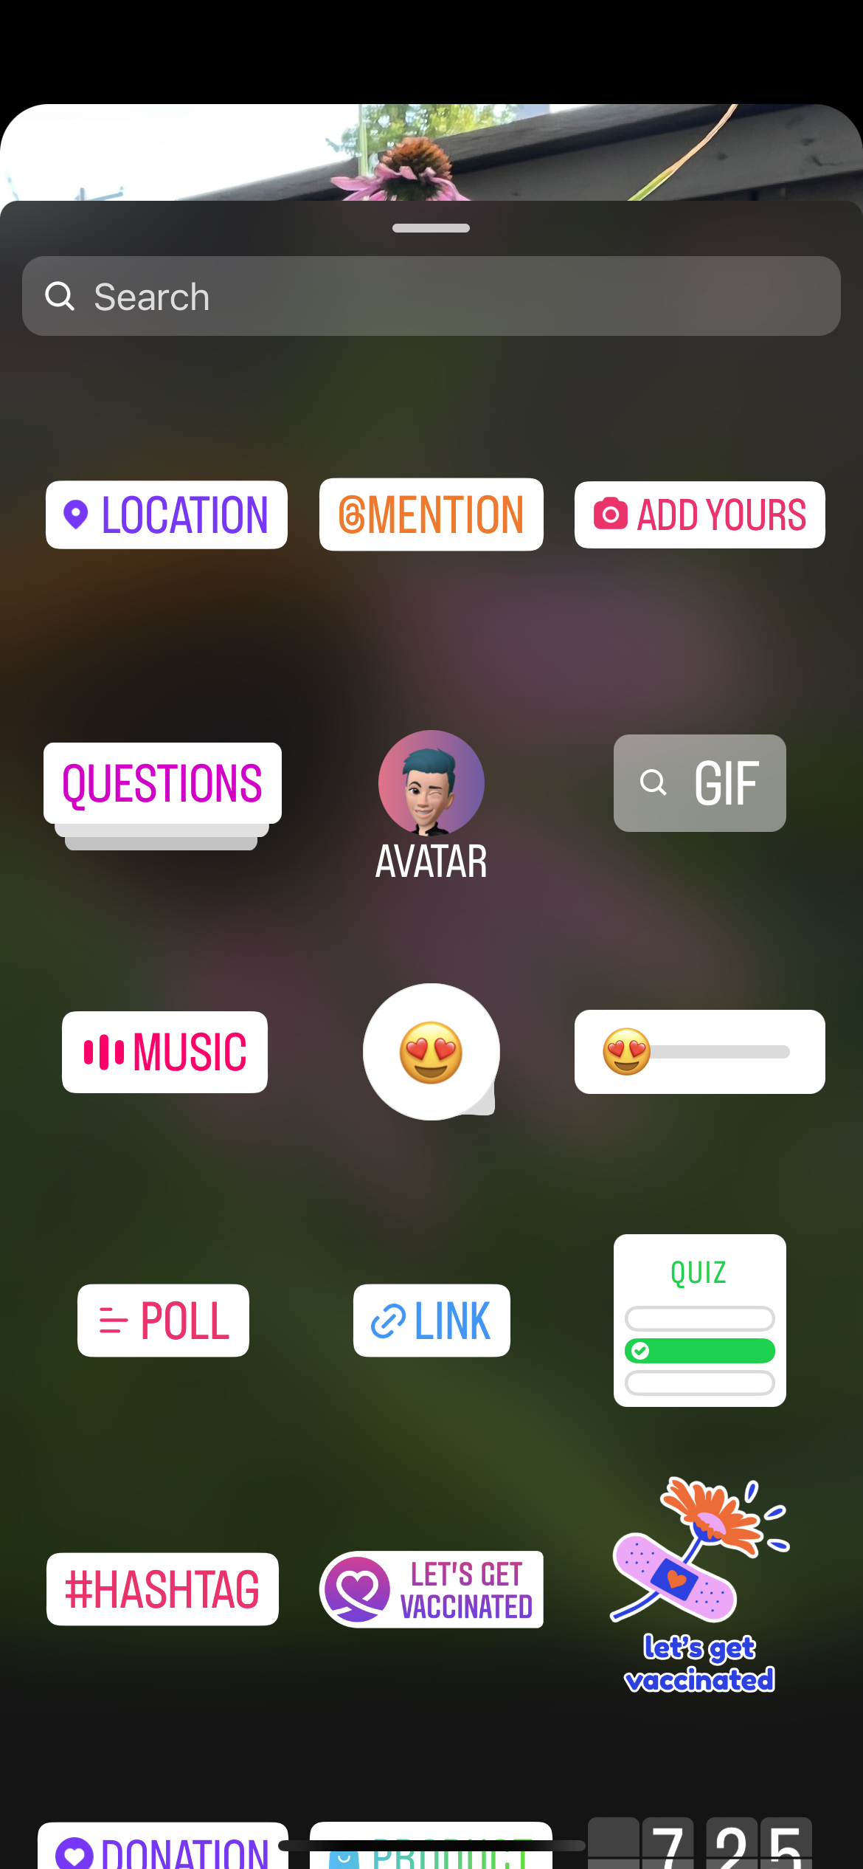

Paste in this URL to the link generator, and it will add the nominate URL to your story, that your fans can click directly to. URL to use: https://bit.ly/bestofbutler2025

Add our “Vote for us” graphic we provided to your story, with the message “Vote for us today for (enter category you are in here – example: Best Coffee House)! And then include the LINK option to your story

***Timeline posts***

#1 Post

HELP US to be named a @JournalNews Best of Butler County 2025! Vote for us today for (enter category you are in here – example: Best Coffee House) on Journal-News.com. #BestofButlerCounty

#2 Post

Do you think we’re the Best of Butler County? Well, then help us make it official – Vote for us as the Journal-News Best of Butler County 2025 (enter category you are in here – example: Best Coffee House)! Voting happening now through March 14 on Journal-News.com #BestofButlerCounty

**Twitter**

#1 post

HELP US to be named a @JournalNews Best of Butler County 2025! Vote for us today for (enter category you are in here – example: Best Coffee House) at https://bit.ly/bestofbutler2025 #BestofButlerCounty

#2 post

Do you think we’re the Best of Butler County? Well, then help us make it official – Vote for us as the @JournalNews Best of Butler County 2025 (enter category you are in here – example: Best Coffee House)! Voting happening now through March 14 at https://bit.ly/bestofbutler2025

**Email blast**

We made it to the FINALS of the Journal-News Best of Butler County 2025 contest – and YOU can help us be named a WINNER!   
All you have to do is go to https://bit.ly/bestofbutler2025 and vote for us in the enter category you are in here – example: Best Coffee House) category! You can vote daily now through March 14!

Thanks for helping us on our quest to be an official Best of Butler County!