Producer: Pre-work | - Slido.com is used for slide 9 audience participation. In ‘present’ mode it will allow users to join at slido.com and enter the code 2131806 to answer the question. Slide 10 will show the answers
 | - There is a breakout room scheduled for slide 14. Facilitator should coordinate with the producer and decide if there are specific groups or chosen at random. Plan for 3-4 minutes depending on size of each group.
 | - Slide 20 requires a poll to be set up ahead of time so the facilitator may see the results and comment as necessary

Facilitator Pre-Work: | - This course was designed to be delivered over any digital platform but could also be used for classroom training as needed. Audience response methods would need to be adjusted. Users will need a device for participation.
 | - Slide 8: Facilitator will decide on adding a desk/chair ergonomics photo or a video on proper ergonomics for facilitating discussion
 | - Slide 9 presents a question for audience participation. Go to slide 10 to show the instructions on how users will log into slido.com, enter code 2131806 to answer. Answers will show on the presentation.
 | - The breakout room on slide 14, you will need to decide the size of each group and the length of their session
 | - Key talking points are added to this facilitator guide but be prepared to add additional information as you feel necessary
 | - The goal is to generate responses from your audience frequently, about every 3-5 minutes and facilitating discussion using their answers to the prompts.
 | - The first reflection question on slide 22 is intended to have them revisit their answer from slide 3. The second question is designed to see what has changed as far as their answer/thinking after this presentation.

Session #1
Slides | Approximate Timing | Topic
1-5 | 5 minutes | Introductions, Value of Remote Employees, Question, Agenda, Learning Objectives
6-8 | 8 minutes | Workspace Tips and Tricks
9-13 | 12 minutes | Time Management
14-19 | 15 minutes | Overcoming Challenges, breakout rooms
20-22 | 5 minutes | Knowledge Check, Summary, Reflection
Total: | 45 – add in a 5-minute break midway as needed

Slide#)  Duration | Slide | Facilitator Notes | Producer Notes
- 1-2 | 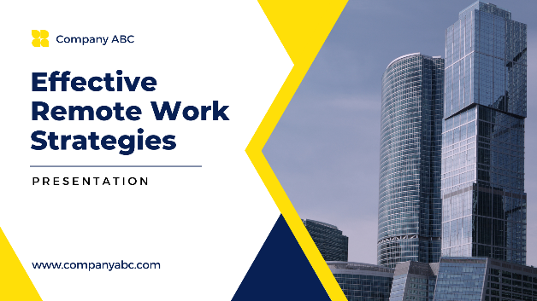 | DO:  -Welcome learners  -Introduce Yourself  -Overview of the Company  -Remind learners of the expectations to  stay on mute and raise hands but questions are  welcomed throughout the presentation | DO:  -Welcome learners as they come on before facilitator is ready  -Remind them to stay muted and raise their hand as they have questions  -The chat will be open for questions throughout
2) | 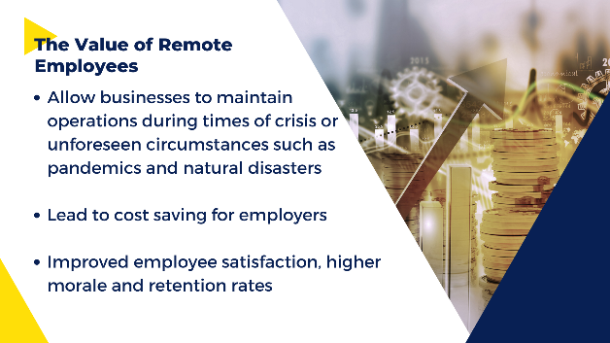 | DO:  -Talk about the value of remote employees, importance of their happiness on the job and success | DO:  Monitor the chat and  waiting room
3) | 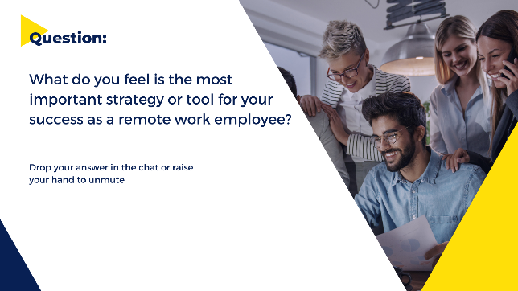 | DO:  - Ask this reflective question and facilitate discussion | DO:  -Moderate questions in the chat, answer any questions.
4) | 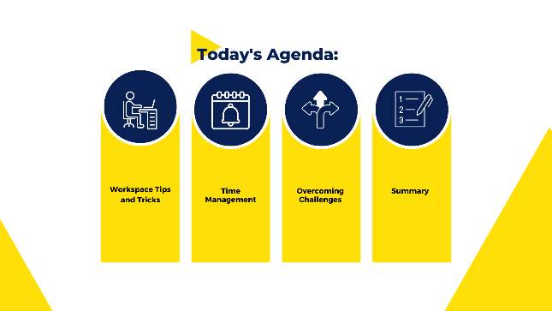 | DO:  -Go over the agenda  -Encourage questions throughout and reminder to use the chat or raise hand sign | DO:  -Moderate questions in the chat, answer any questions.
5) | 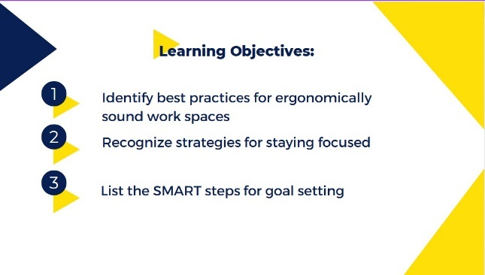 | DO:  -Go over the learning objectives | DO:  -Moderate questions in the chat, answer any questions.
6) | 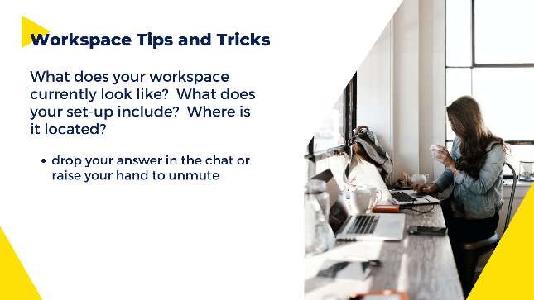 | DO:  -Start the first topic by asking a question and having them answer. | DO:  -Moderate questions in the chat, answer any questions.
7)) | 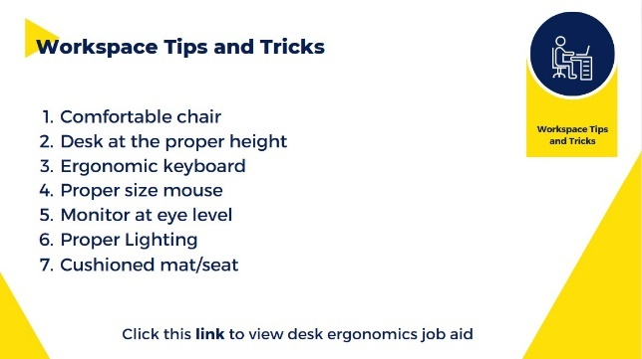 | DO:  -Talk about each item in more detail  -Point out the link to the job aid | DO:  -Moderate questions in the chat, answer any questions.
8) | 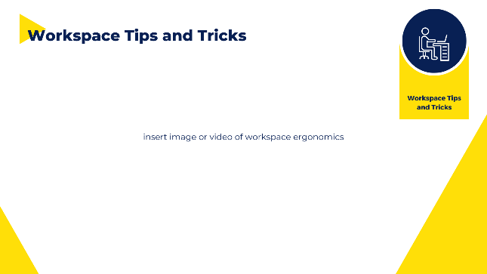 | DO:  -Tell them this is an example of an ergonomically sound workspace.  -Point out the positive aspects | DO:  -Moderate questions in the chat, answer any questions.
9) |  | DO:  Start the second topic by asking this reflective question and having them answer  Use Slido on slide 10 to have them add their answers | DO:  Participants can join at  slido.com with #2131806.
10) | 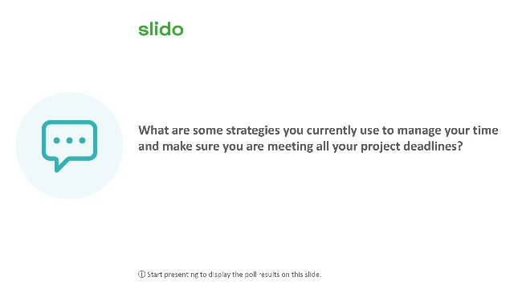 | DO:  -Instruct participants to join on their device at slido.com with #2131806 | DO:  -Moderate questions in the chat, answer any questions.
11) | 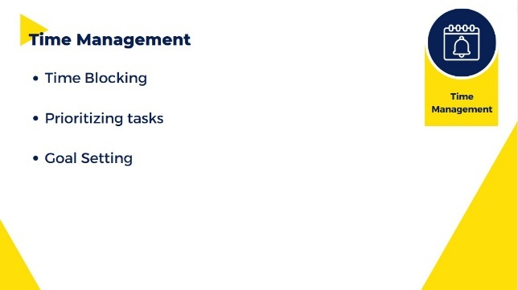 | DO:  -Talk about the time management items listed. Each one is further detailed on the 3 slides that follow | DO:  -Moderate questions in the chat, answer any questions.
12) | 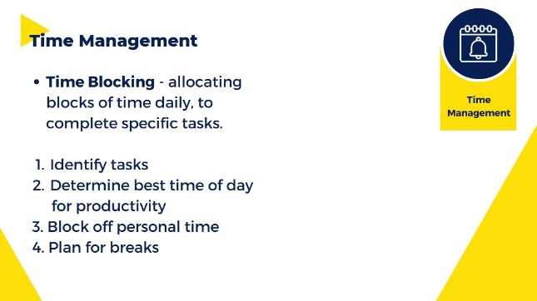 | DO:  -Say “Time blocking is allocating blocks of time daily to complete specific tasks. This allows you to divide your workday into manageable pieces and keep you better focused on your tasks. Estimate how long each task will take in order to help decide on the block of time needed.” | DO:  -Moderate questions in the chat, answer any questions.
13) | 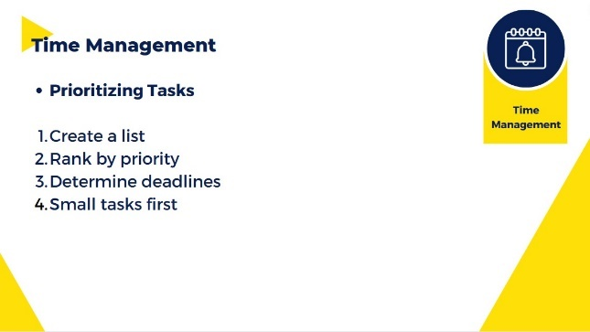 | DO:  -Say “Have you ever audited yourself to see how much time you waste on tasks not related to the job at hand? Checking your texts, personal emails, maybe a quick glance to a social media site?”  -Go through each point…then say “Reward yourself after completing a set amount of tasks before you dive back into your work for the day.” | DO:  -Moderate questions in the chat, answer any questions.
14) | 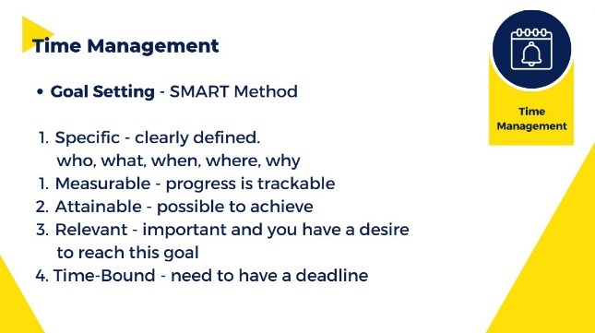 | DO:  -Say “ The SMART method of goal setting is an acronym for specific, measurable, achievable, relevant and timely. It was first created to enable workers to write manageable goals and improve the overall performance of the business through time-based measurable goals.”  -Talk about each part in more detail | DO:  -Moderate questions in the chat, answer any questions.
15) | 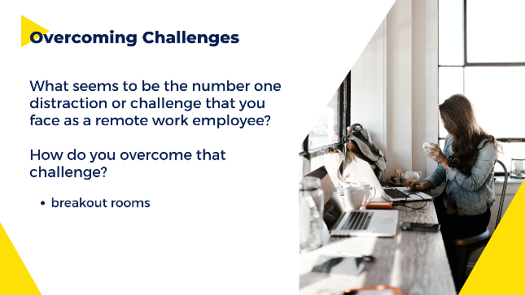 | DO:  -Start this topic by asking this reflective question and having them discuss it with others in breakout rooms.  -Tell them they will have 3 minutes to discuss before coming back to share their insight.  -Let them know you will be popping into the rooms to answer any questions they may have while discussing | DO:  -Have the breakout rooms set up ahead of time  -Put ‘x’ number of participants in each room.
16) | 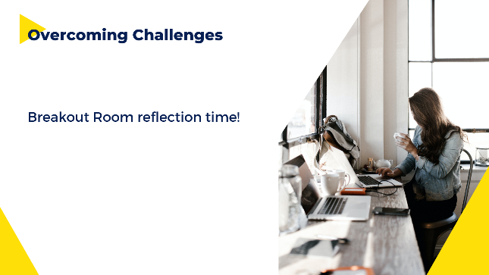 | DO:  -Ask the question again to encourage discussion of what they feel is the biggest challenge or distraction they face as a remote work employee. How do they overcome those challenges. What things came up in the breakout rooms? | DO:  -Moderate questions in the chat, answer any questions.
17) | 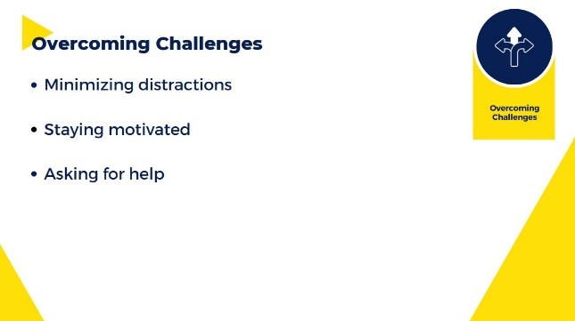 | DO:  -List the topics covered in this section. Each one is discussed in more detail on the following 3 slides | DO:  -Moderate questions in the chat, answer any questions.
18) | 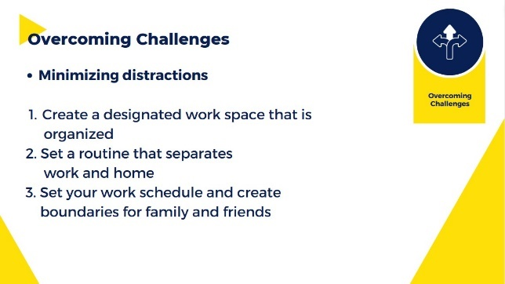 | DO:  -Say “Working from home presents a different set of challenges than a normal office environment, as we just touched on in our breakout rooms.”  -Add others that may have come up from the reflection question. | DO:  -Moderate questions in the chat, answer any questions.
19) | 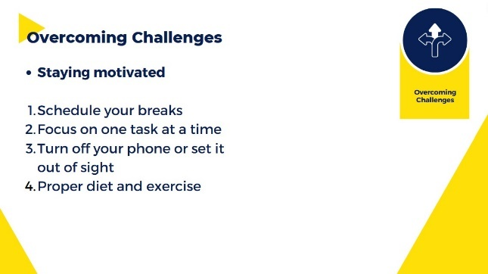 | DO:  -Say “At home it’s easy to become distracted by tasks you feel pressing in your home environment. We have to find ways to make sure we are balancing our tasks and completing projects.”  -Add others that may have come up from the reflective question | DO:  -Moderate questions in the chat, answer any questions.
20) | 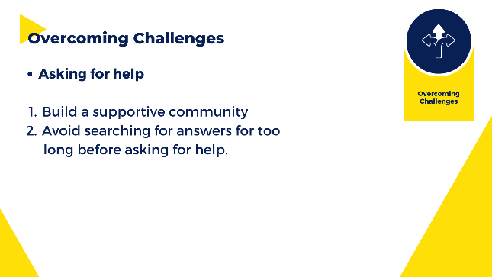 | DO:  -Talk about how NOT asking for help is a barrier for remote work employees.  -Say “ Often people spend way too much time searching for an answer when they could rely on colleagues to help them through their difficulties.”  -Add any other insight that might have come up from the reflective question | DO:  -Moderate questions in the chat, answer any questions.
21) | 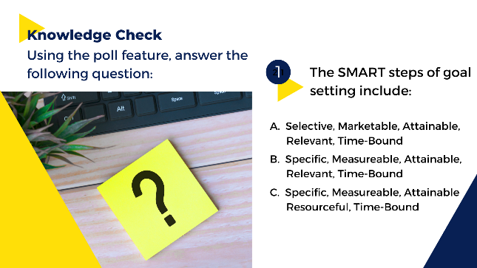 | DO:  -Tell them let’s take a moment to see if you remember what SMART goals means.  -Read the question and choices  -Moderator will show the poll | DO:  Have the poll feature ready to be shown with the question and answer choices showing
22) | 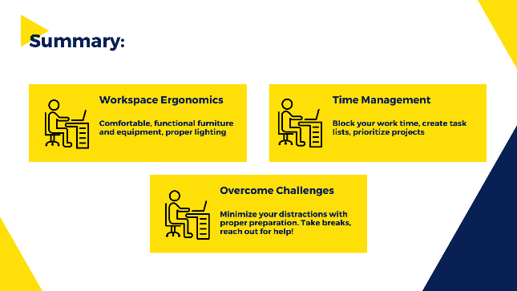 | DO:  Summarize the key points of the presentation | DO:  -Moderate answers in the chat, answer any questions.
23) | 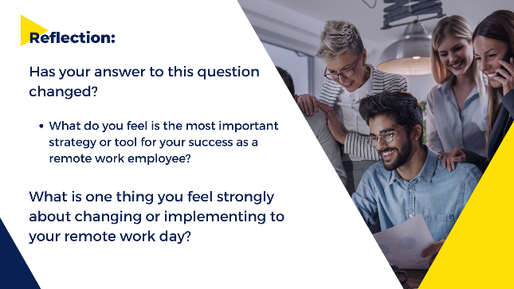 | DO:  -Ask the reflective question. Has your answer changed from the beginning of this presentation?  -Discuss  -Ask the final question – can be done as introspective or ask a few to share. | DO:  -Moderate answers in the chat, answer any questions.
24) |  | DO:  -Say “from Company ABC we thank you for your dedication to our company and hope you gained some valuable insight so you may continue to be a happy, cohesive part of our team.”  -Remind them they will get a copy of the presentation and access to the job aid. | DO:

