The following template shows off all the fields available in the 4.99 release of Quick Bid. You can use any of the fields below shown in brackets. There are also many flexible parameters available for some of the fields (these are separated from the fields with a colon [:] inside the brackets).
For additional information regarding creating and editing templates, see:
https://kbase.oncenter.com/article/AA-04014

Contents
INSTRUCTIONS 2
PROPOSAL CUSTOM FIELDS 2
Cover Sheet Fields 2
Contact Fields 4
Proposal Details 5
Bid Totals Fields 6
Conditions Tab Fields 7
Equip, Other, and Subs Tab Fields 9
Markups Tab 10
Alternates and Change Orders 11

INSTRUCTIONS
To use any of these fields in another Microsoft Word Template, just type them as shown below or you can copy and paste them into the appropriate DOT file.

PROPOSAL CUSTOM FIELDS

Cover Sheet Fields
These fields correspond to fields on the Cover Sheet including the Job Site/Contacts and Notes sub tabs.
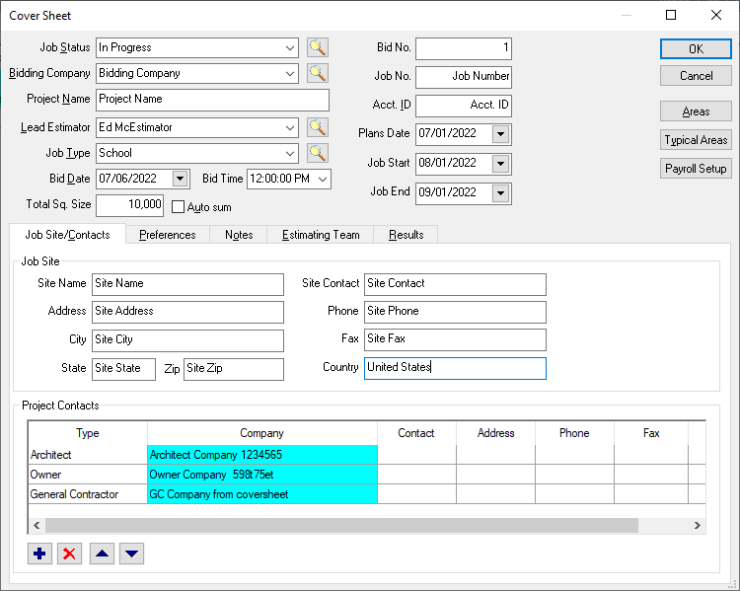
Job No. (old): [Bids.JobID]
Job No. (new): [Bids.JobNo]
Job Status: [Bids.JobStatus]
Bidding Company: [Bids.BiddingCompany]
Project Name: [Bids.ProjectName]
Bid No.: [Bids.BidNo]
Acct. ID: [Bids.AcctID]
Job Type: [Bids.JobType]
Bid Date (default=long): [Bids.BidDate]
Bid Date (short): [Bids.BidDate:short]
Bid Time: [Bids.BidTime]
Plans Date (default = long): [Bids.PlansDate]
Plans Date (short): [Bids.PlansDate:short]
Job Start (default = long): [Bids.JobStart]
Job Start (short): [Bids.JobStart:short]
Job End (default = long): [Bids.JobEnd]
Job End (short): [Bids.JobEnd:short]
Total Sq. Size: [Bids.TotalSqSize]
Site Name: [Bids.JobSiteName]
Address: [Bids.JobSiteStreet]
City: [Bids.JobSiteCity]
State: [Bids.JobSiteState]
Zip: [Bids.JobSiteZip]

Cover Sheet, cont’d

Site Contact: [Bids.JobSiteContact]
Phone: [Bids.JobSitePhone]
Fax: [Bids.JobSiteFax]
Notes (from the Notes tab): [Bids.Notes]
These three fields are set on the Cover Sheet – Project Contacts grid:
Architect Company: [Companies.Name:type=Architect]
Owner Company: [Companies.Name:type=Owner]
General Contractor Company: [Companies.Name:type=General Contractor]

Proposal - Contact Fields
These are fields associated with the person for whom you are generating this proposal.
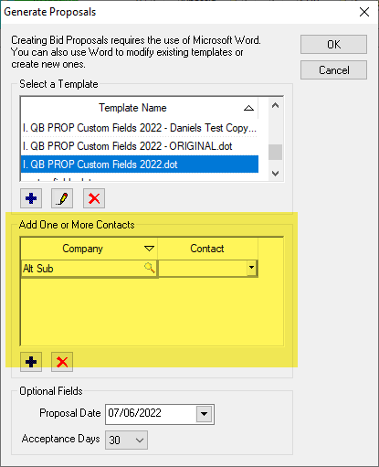
Selected Contact Company: [Companies.Name]
Selected Contact First Name: [Contacts.FirstName]
Selected Contact Last Name: [Contacts.LastName]
Selected Contact’s Email: [Contacts.Email]
Selected Contact Address: [Companies.Address1]
Selected Contact City: [Companies.City]
Selected Contact State: [Companies.State]
Selected Contact Zip: [Companies.Zip]
Selected Contact Phone: [Companies.Phone]
Selected Contact Fax: [Companies.Fax]

Proposal – Details
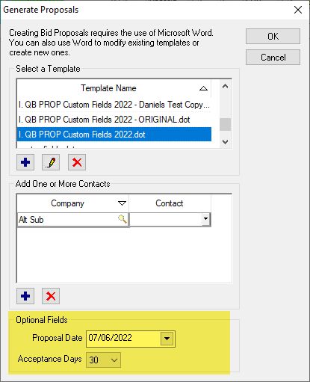
Proposal Date (default = long): [ProposalDate]
Proposal Date (short): [ProposalDate:short]
Acceptance Days: [AcceptanceDays]

Bid Totals Fields
These are calculated Bid Totals.
Total Bid: [Bids.Total]
Total Bid w/Acc. Alt.: [Bids.Total:accAlts]
Total Bid w/All Alt.: [Bids.Total:allAlts]
Total Bid w/Acc. CO’s: [Bids.Total:accCOs]
Total Bid w/All CO’s: [Bids.Total:allCOs]
Net Bid Total no decimals: [Bids.Total:net:decimals=0]
Sale Bid Total no decimals: [Bids.Total:sale:decimals=0]

Conditions Tab/List Fields
(Bid.Conditions:decimals=x)– adds the Conditions list with specified decimal places to Proposal (default is “2” decimals)
These next two “fields” modify the Conditions list inserted into your proposal and are added after the first field ( “Bid.Conditions:decimals=X” ) they cannot be used alone:
(Bid.ConditionUnitPrice:show=X) – shows (X=”1”) or hides (X=”0”) the Unit Price column
(Bid.ConditionGroupbyArea:show=X) – Turns on (X=”1”) or off (X=”0”) Bid Area Grouping
(The above fields have their brackets [ ] replaced with parentheses ( ), if you copy/paste them into your template, be sure to change the parentheses ( ) back to brackets [ ].)
Examples
To use the GroupbyArea and UnitPrice options, you add all three to your proposal, like this:
Bid Conditions list, 2 decimals, Not grouped by Area, Showing Unit Cost:
[Bid.Conditions:decimals=2][Bid.ConditionGroupbyArea:show=0][Bid.ConditionUnitPrice:show=1]
This inserts the Conditions list into your proposal, showing 2 decimals for each Condition's Total Cost, disabling Area Grouping, and showing the Unit Price column.
Bid Conditions list, 0 decimals, grouped by Area, hiding Unit Cost:
[Bid.Conditions:decimals=0][Bid.ConditionGroupbyArea:show=1][Bid.ConditionUnitPrice:show=0]
This inserts the Conditions list into your proposal, showing no decimals for each Condition's Total Cost, Grouping by Area, and hiding the Unit Price column.

Equip, Other, and Subs Tab Fields
Equipment Tab: [Bid.Equipments:decimals=2]
Other Tab: [Bid.Others:decimals=2]
Subs Tab (default :accepted): [Bids.Subs]
Subs Tab (all): [Bids.Subs:all]
Subs Tab (only show sections for Accepted Subs with rounded totals and no currency symbol): [Bids.Subs:onlySections:decimals=0:noCurrency]
Bid Subs Tab (Accepted Subs, no totals): [Bids.Subs:noTotal]

Markups Tab
When you generate a Proposal for a Base Bid, just like on the Markups Tab, Sections used exclusively in an Alternate (accepted or not) are shown in the Base Bid (with “0” costs).
Markups with Notes & Totals: [Bids.Markups]
Markups with Notes: [Bids.Markups:noTotal]
Markups with Total no decimals: [Bids.Markups:noNotes:decimals=0]

Alternates and Change Orders
NOTE: to generate a proposal for just an Alternate or Change Order, make sure that Alternate or Change Order is selected, and generate a Bid proposal using the normal Bid fields above. These Alternate and Change Order fields are used when you are running a proposal on the Base Bid and want to include Alternate and/or Change Order information.
Alternates (accepted only): [Bids.Alternates]
Alternates (all): [Bids.Alternates:all]
Alternates (not accepted): [Bids.Alternates:pending]
Alternates (accepted - no total no decimal):
[Bids.Alternates:noTotal:decimals=0]
Change Orders (accepted only): [Bids.ChangeOrders]
Change Orders (all): [Bids.ChangeOrders:all]
Change Orders (not accepted): [Bids.ChangeOrders:pending]
Change Orders (accepted - no total no decimal):
[Bids.ChangeOrders:noTotal:decimals=0]

