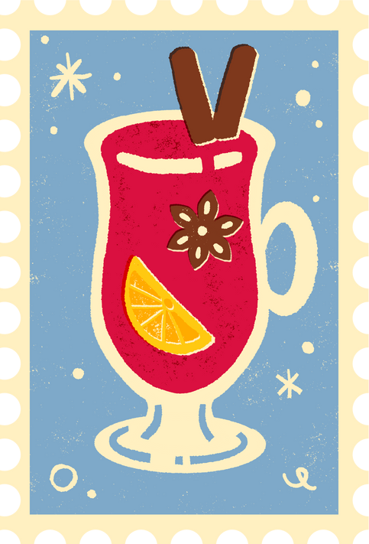
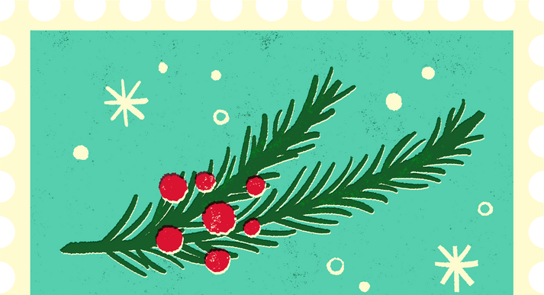
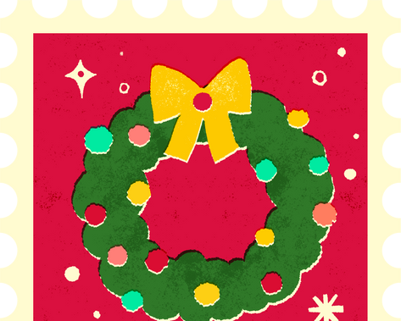
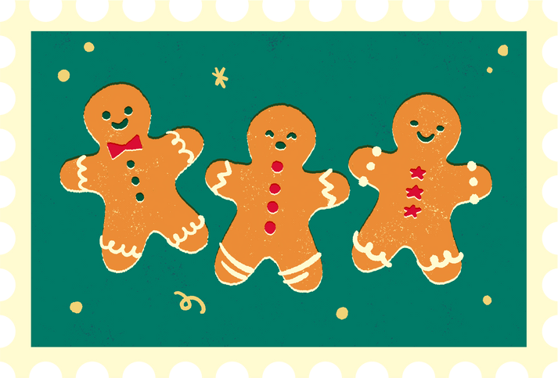
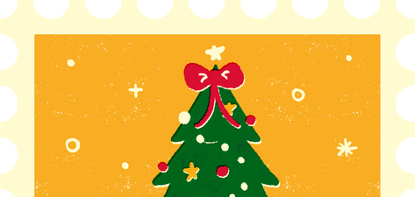
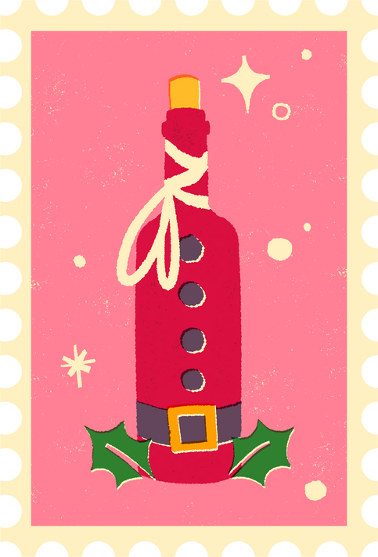
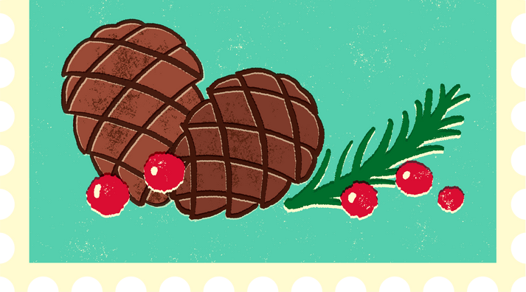
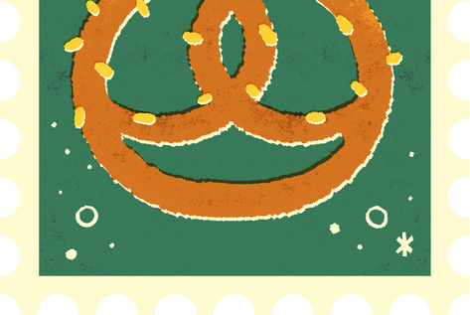

Dear Santa,
Letter to Santa
123 Reindeer Lane North Pole, Arctic Circle

How’s the North Pole? I hope you and the reindeer are doing well. I’ve been (mostly) good this year. For Christmas, I’d love:

Gift | Image | Link
A cozy blanket | 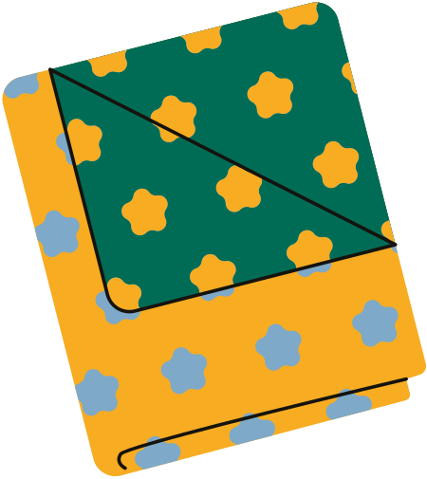 | www.reallygreatsite.com
A second gift |  | Link here
Another gift |  | Link here

If you can’t ﬁt it all on the sleigh, surprises are always welcome.

Love,

Your Name Here



Credits
This template is free for everyone to use, thanks to the following:

for the template

Pexels, Pixabay
for the photos

