

CONFERENCE DOC

PARENT-TEACHER

|  |  |  |
| --- | --- | --- |
| **Student’s Name** | | Margot Elsher |
| **Grade Level** | | Grade 4 |
| **Teacher’s Name** | | Ms. Irena Kim |
| **Date** | | Sep 10, 2030 |
| c18c08a9-509e-4024-86c5-c240fdc1f003.png | **Canva tip:** Select **Actions** to add date pills and drop-downs, and unlock more features! | |



|  |
| --- |
| Academic Progress |

Share student strengths and areas for growth with the parent or guardian.

|  |  |
| --- | --- |
| **Strengths** | List areas where the student excels, such as reading, math, creativity, or extracurricular work. |
| **Areas for growth** | Mention subjects or skills where improvement is needed and provide specific examples. |
| **Recent achievements and sample works** | Highlight notable accomplishments, such as projects or test scores.  Attach sample works here, if there are any:   * Sample work 1 * Sample work 2 |
| **Existing support** | Include any in-class interventions or accommodations that support student learning. |

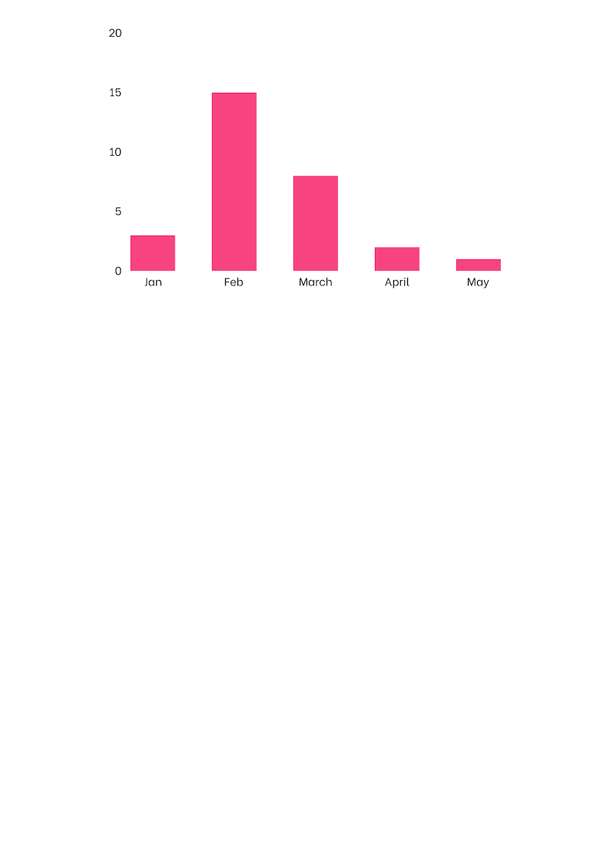

**Chart title:** Add a chart title or description here to support your report on student progress.

|  |
| --- |
| Student Habits and Behavior |

Track students and behavior inside and outside the classroom

|  |  |  |
| --- | --- | --- |
| **Habits and behavior** | **Status** | **Notes** |
| Follows classroom rules and procedures | 🟢 Doing great | Specify any behavioral concerns and possible solutions. |
| Pays attention during lessons | 🟢 Doing great | Add more notes here. |
| Accepts responsibility | 🟢 Doing great | Add more notes here. |
| Asks for help when needed | 🟠 Getting there | Add more notes here. |
| Respects teachers, peers, and school staff | 🟠 Getting there | Add more notes here. |
| Works well with others | 🟠 Getting there | Add more notes here. |
| Completes schoolwork independently | 🟠 Getting there | Add more notes here. |
| Participates during class discussions | 🟠 Getting there | Add more notes here. |
| Add more items here. | 🔴 Still working on it | Add more notes here. |

|  |
| --- |
| Parent Concerns and Questions |

Provide space for parents or guardians to share concerns, ask questions, or provide insights about their child.

|  |  |
| --- | --- |
| **Concerns and questions** | **Teacher notes** |
| Margot gets frustrated with math homework and often refuses to finish it. | * In class, she responds well to visual aids like number lines and hands-on activities. * We can provide real-life objects as examples and more guided practice sheets. * If this continues, we can explore small-group math support. |
| Write a question from the parent or guardian. | Add notes based on the teacher's observations and initial ideas for addressing the concern. |
| Write a question from the parent or guardian. | Keep this section objective and clear. |

|  |
| --- |
| Next Steps |

Organize goals and action steps for both teachers and parents.

|  |  |  |  |  |  |
| --- | --- | --- | --- | --- | --- |
| **Focus area** | **Teacher actions** | **Parent actions** | **Timeline** | **Status** | **Notes** |
| Reading fluency | Provide additional in-class reading time. | Read with child for 15 minutes daily | Review progress in 4 weeks | ✏️ In progress | * Margot loves to read books about animals. * Can read more complex words in the second week |
| Specify the focus area. | Write teacher recommendations. | Outline how parents can support their child’s learning at home. | Specify the target timeline or date range. | ⏳ Not started | Add notes here. |

**Additional Notes:**

* Use this space for any extra details or important reminders.
* Let parents know if a follow-up meeting is needed.
* Keep this section clear and concise.

|  |  |
| --- | --- |
| **Teacher’s Signature:** | **Parent/Guardian’s Signature:** |
| Signature | Signature |

Date: **Sep 10, 2030**

|  |  |  |
| --- | --- | --- |
| **Credits** This template is free for everyone to use, thanks to the following: | 954064b5-9873-4fd6-8584-082ed3fd3695.png  for the template | **Pexels, Pixabay, Sketchify**  for the photos and elements |