Learning from Maps
DAILY LESSON PLAN

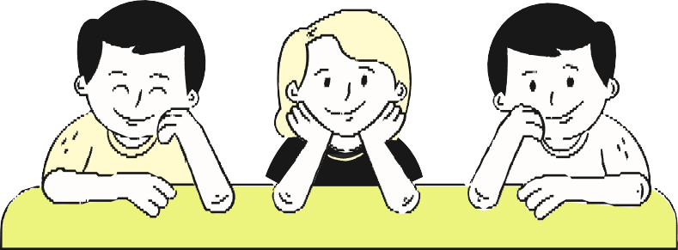

Grade/Subject: Add grade or subject here. Date: Add date here.

LESSON OBJECTIVES
At the end of the lesson, students will:
- Add a speciﬁc learning outcome or skill here.
- Include another relevant outcome or skill.
- Add a third outcome or skill if needed.

MATERIALS

  - List required materials here.
  - Include a link to the lesson deck.
  - Mention any other needed resources.

LESSON PROPER

Introduction/Hook
Start by capturing students’ interest and connecting the topic to what they already know. You can use a question, an image, or an activity to get them thinking. Help students understand why this topic is important and how it relates to their world.
In this section, you might also include:
  - a warm-up or quick review
  - a question tied to the learning goal
  - a clear explanation of today’s objective

Discussion
This is the part of the lesson where you introduce and explore new ideas. Explain the key concepts and model them using real-life examples or visuals. Structure this section in the way that works best for your class.
If relevant, you can note the method you’re using (direct instruction, guided practice, or independent work). Feel free to use bullet points if it helps map out the steps or key moments in your delivery.

Closure and Assessment
Wrap up the lesson by reviewing the most important takeaways and checking for understanding. This could include a summary, an exit ticket, or a preview of what’s coming next. This is also a good time to give students space to ask ﬁnal questions or share insights.

NOTES
Use this section for reminders or strategies. You might:
  - Note how you’ll support diﬀerent learning styles or abilities.
  - Add teaching techniques or accommodations.
  - Include any personal reﬂections or prep tips.

PREPARED BY

Your name hello@reallygreatsite.com Room no. 1 | +123-456-7890

