Patient Information

Patient Name: Patient name here

Date of Birth January 30, 2030

Gender: Details here

Address: 123 Anywhere St., Any City, ST

Contact Information
Phone Number: 123-456-7890

Email: hello@reallygreatsite.com



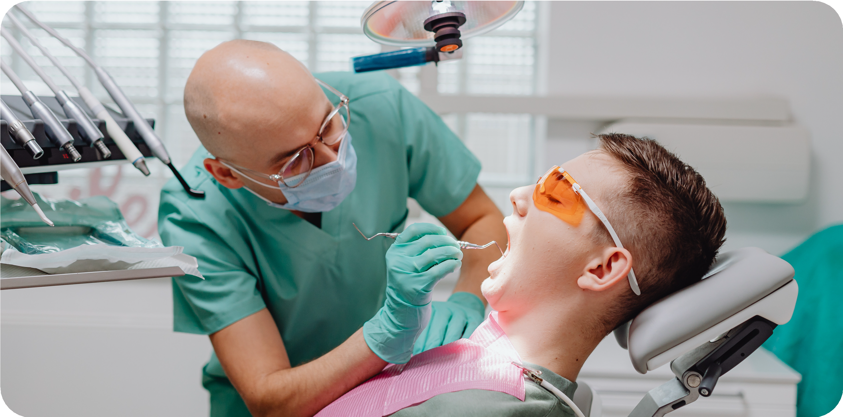

Dental Treatment Consent Form
Record patient agreement for dental procedures, risks, and after-care instructions

Emergency Contact Emergency contact name here

Relationship to Patient Relationship here

Dental Treatment
Ask the patient to review each section, initial where required, and sign at the end to conﬁrm their consent. Remove all instructional notes before ﬁnalizing this form.

Work to be done
Describe the proposed treatment(s), including speciﬁc procedures such as:

- Fillings
- Bridges
- Crowns
- Extractions
- Add other procedures as needed
- Add other procedures as needed
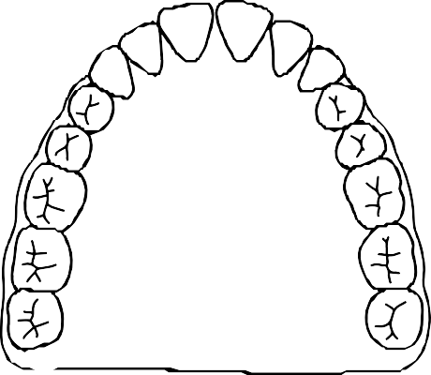
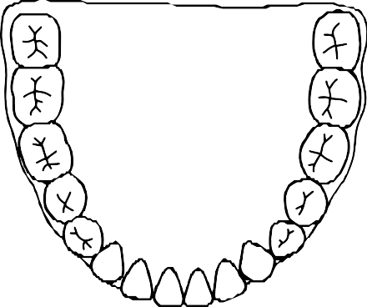
Add a dental numbering chart here.
7
8 9
10
6
11
32
17
5
4
3
12
13

14
31
18
2
19

20
15
30

29
28
21
1
16
27
22
26
25
24 23
TIP: Double-click to edit this section.

Initial here:

Drugs and medications

Summarize any risks or effects of antibiotics, anesthetics, or other medications, including but not limited to itching, vomiting, redness, etc.

Initial here:

Changes in treatment plan

Explain that unforeseen conditions may require changes to the proposed treatment. Highlight that patients will be informed before proceeding.

Initial here:

Tooth removal

Mention possible alternatives (e.g., root canals). List also the risks involved and conﬁrm that the patient authorizes the removal if agreed upon.

Initial here:

Crown, bridges, and veneers

Explain color-matching limitations and the use of temporary ﬁttings. Include a statement that patients are responsible for reviewing the ﬁnal ﬁt, color, and appearance before the ﬁnal placement.

Initial here:

Note potential post-procedure sensitivity, the risk of further decay, and chewing precautions. Initial here:
Fillings and restorations

Include an acknowledgment that outcomes may vary and follow-up treatments may be required. Initial here:
Root canal therapy

Dentures (full or partial)

Describe potential challenges such as soreness or looseness. Specify when design adjustments can be made.

Initial here:

Periodontal treatment

Explain the condition and treatment options here. Outline what the patient needs to do to maintain results.

Initial here:

Acknowledgment and consent
Add your clinic’s ﬁnal acknowledgement statement here. Conﬁrm that the patient: Understands the procedure
Has been informed of the risks and beneﬁts Accepts that results are not guaranteed
Has had the opportunity to ask questions

Signatures:
Patient signature: Date:

Parent/guardian signature (if applicable): Date:


Credits
This template is free for everyone to use, thanks to the following:

for the template
Pexels, Pixabay
for the photos

