EU Citizens Welcome – A Third Sector Response

Introduction
An exodus of EU migrants from Scotland would pose a threat to the economy, third sector organisations (as employers) and the many individuals who rely on EU migrants for – amongst other things – care, support and education.

While there is rarely a legal requirement for them to do so, many EU migrants living in the Scotland are choosing to leave the country – primarily due to uncertainty about their future immigration status and rights protections. It is also a sad reality that there is a tangible sense of hostility in the press, our politics, communities and workplaces which has a demoralising effect on EU nationals who have chosen Scotland as their home.

SCVO’s engagement work with our members has seen this raised as a major fear for many – including those with an interest in human rights, as well as those organisations who rely on and value the EU work force. The demographic challenge faced by Scotland, and the role EU migrants play in addressing this, is also of crucial importance to many.

With negotiations progressing slowly and immigration policy reserved, there is little that the Scottish Government – never mind the third sector – can do to directly influence the law in this area. However, as an employer of some 138,000 people, the third sector can play a role as a responsible employer, helping to make EU nationals feel welcome in Scotland and to offer the information and support they need to make the decision to remain in Scotland.

Challenges for EU Migrants

Settled Status
Following Brexit (under proposed plans) EU nationals, who have spent five years or less in the UK, will have to apply through the Home Office for a residency document over a two-year window. For those arriving after the cut-off period, everything will hinge on future immigration rules.

Confusion
Even those who currently have documentation certifying permanent residence will still be required to apply for the new settled status document. The Home Office claims that the application process for people who need to do this will be as streamlined as possible.

It is not clear whether those who successfully apply will be required to carry an ID card, or whether details will simply be held as an entry in a Home Office database. Given rhetoric regarding employers holding databases of all foreign workers, this will be of significant concern to many EU nationals.

Clarity is also lacking about existing and future rights, including the ability to bring family to the UK and whether salary expectations will be put in pace – as exists currently for non-EU migrants.

Settled status will be lost if an individual leaves the UK for a continuous period of two years. Many EU nationals will not be aware of this (having never been required to abide by these rules). It is also no immediately clear if the two year period is continuous or cumulative.

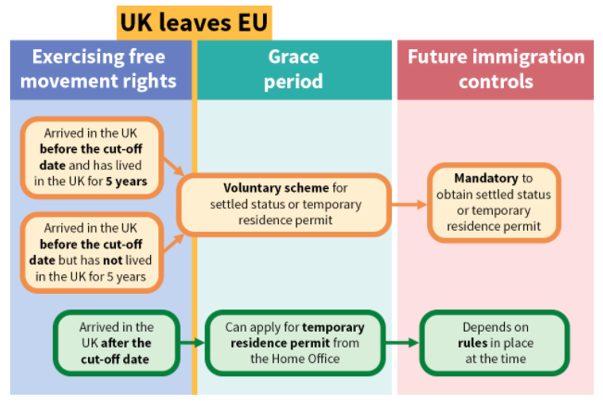

Cost
It has been estimated that the cost of new documentation will be £65 – generating a gross amount of £195million were all three million EU nationals living in the UK to successfully apply. As explained in the diagram above, this decision is ‘voluntary’, but essentially mandatory if EU nationals wish to enjoy even some of the rights they currently do.

Feeling unwelcome
Press coverage before, during and since the EU referendum has – from some quarters – been highly critical towards the very concept of immigration and the presence of EU nationals in this country. In many cases, this coverage has been irresponsible and inflammatory and created a deeply hostile environment for EU citizens living in the UK. Unsurprisingly, this unrelenting attack on immigrants to this country has seeped in to public consciousness and now manifests itself in both our politics and in our communities, where hate crime is on the rise.

As outlined above, the policy positioning of UK Government departments will be translated as cold, unwelcoming and deliberately confusing. That the future rights of EU have not been more clearly outlined has led many EU migrants to read between the lines and draw conclusions that they are not valued.

Even from perhaps unexpected sections of society (business and trade unions) the economic impact of migration is regularly attacked. EU migrants are often criticised as being the primary cause of unemployment, poor wages and working conditions. Unquestionably this causes tensions within many workplaces.

Challenges for Scotland

Demographics
In Scotland it is projected that the number of people aged 65 and over will increase by 53% between 2014 and 2039. This poses multiple challenges for Scotland. With more tax powers now devolved to Scotland, a significant working age population is more important to ensure the sustainability of public spending. Furthermore, as the population ages, greater resource (both in terms of finance and workforce) will be required to tackle the challenges associated with ageing.
With Scotland’s birth rate having recently fallen to a 14-year low, it is clear that continued immigration from the EU and beyond will be important to addressing this situation - particularly when it is considered that half of the net increase in the Scottish population between 2000 and 2015 came from people born in EU countries and that 80% of EU nationals in Scotland are of working age, compared to 65% of the Scottish population as a whole.

Key industries
In the region of 4% of Scotland’s health and social care workforce comprises non-UK EU citizens. Representing approximately 12,000 personnel, losses in this sector would have a significant negative impact on already overstretched health and social care services.

In NHS England, the number of EU nationals registering as nurses has dropped by 96% since the EU referendum in June. At the same time, a compilation of Freedom of Information requests (from 80 of the 136 NHS acute trusts in England) has shown that 2,700 EU nurses left the health service in 2016, compared to 1,600 EU nurses in 2014 – a 68% increase.

Camphill Scotland support more than 500 people with learning disabilities and other support needs, ranging from children to older people. Their survey found that 68% of the 251 short-term co-workers currently living and working in Camphill communities in Scotland are from other EU countries. Of the 165 people working as long term co-workers, 53% are from other EU countries.

British Heart Foundation, pointed to the £63 million worth of research they carry out in Scotland and warned that withdrawal from the EU may see an exodus of Principal Investigators (PIs) – individuals who leverage funding, administer grants and lead research projects. It was pointed out that within six months of Switzerland’s referendum rejecting freedom of movement, the number of PIs dropped from 21 to 2.

Alzheimer's Scotland conducted a poll of 70 top dementia researchers and found that 76% said they knew of someone leaving the UK or considering leaving the country as a result of Brexit. 51% said the vote had led to increased problems recruiting researchers or students from other European countries.

Third Sector Role

Solidarity
With little influence over the Home Office or future immigration policy, the sector must attempt to find other means to stem the flow of crucial EU migrants from Scotland. As employers, third sector organisations can help EU nationals better understand the situation unfolding and offer support, assistance, solidarity and reassurance where possible. In some cases, this may be enough to encourage people to take the decision to stay in the UK.

SCVO
For many third sector employers, capacity and understanding of the situation are clear barriers to fulfilling this role. As the umbrella body for the sector, SCVO can encourage our members to take up the mantle and provide the necessary tools and understanding to be successful. This could include:

- How to broach the subject
- Help cutting through jargon
- Up to date information
- How to challenge hateful behaviour
- Assistance with application costs (match funding with Scottish Government)
- Establishing a supporting campaign (poster in office)
- Providing case studies
- Email sign up to latest updates

Conclusion
An exodus of EU migrants from Scotland would pose a threat to the economy, third sector organisations (as employers) and the many individuals who rely on EU migrants for care, support and education.

Using our position, SCVO has the opportunity to stress the importance of this to our members and provide them with the tools to support, assist and show solidarity with their EU national colleagues – with the hopeful aim that they will feel confident enough to make a decision to stay in Scotland.

