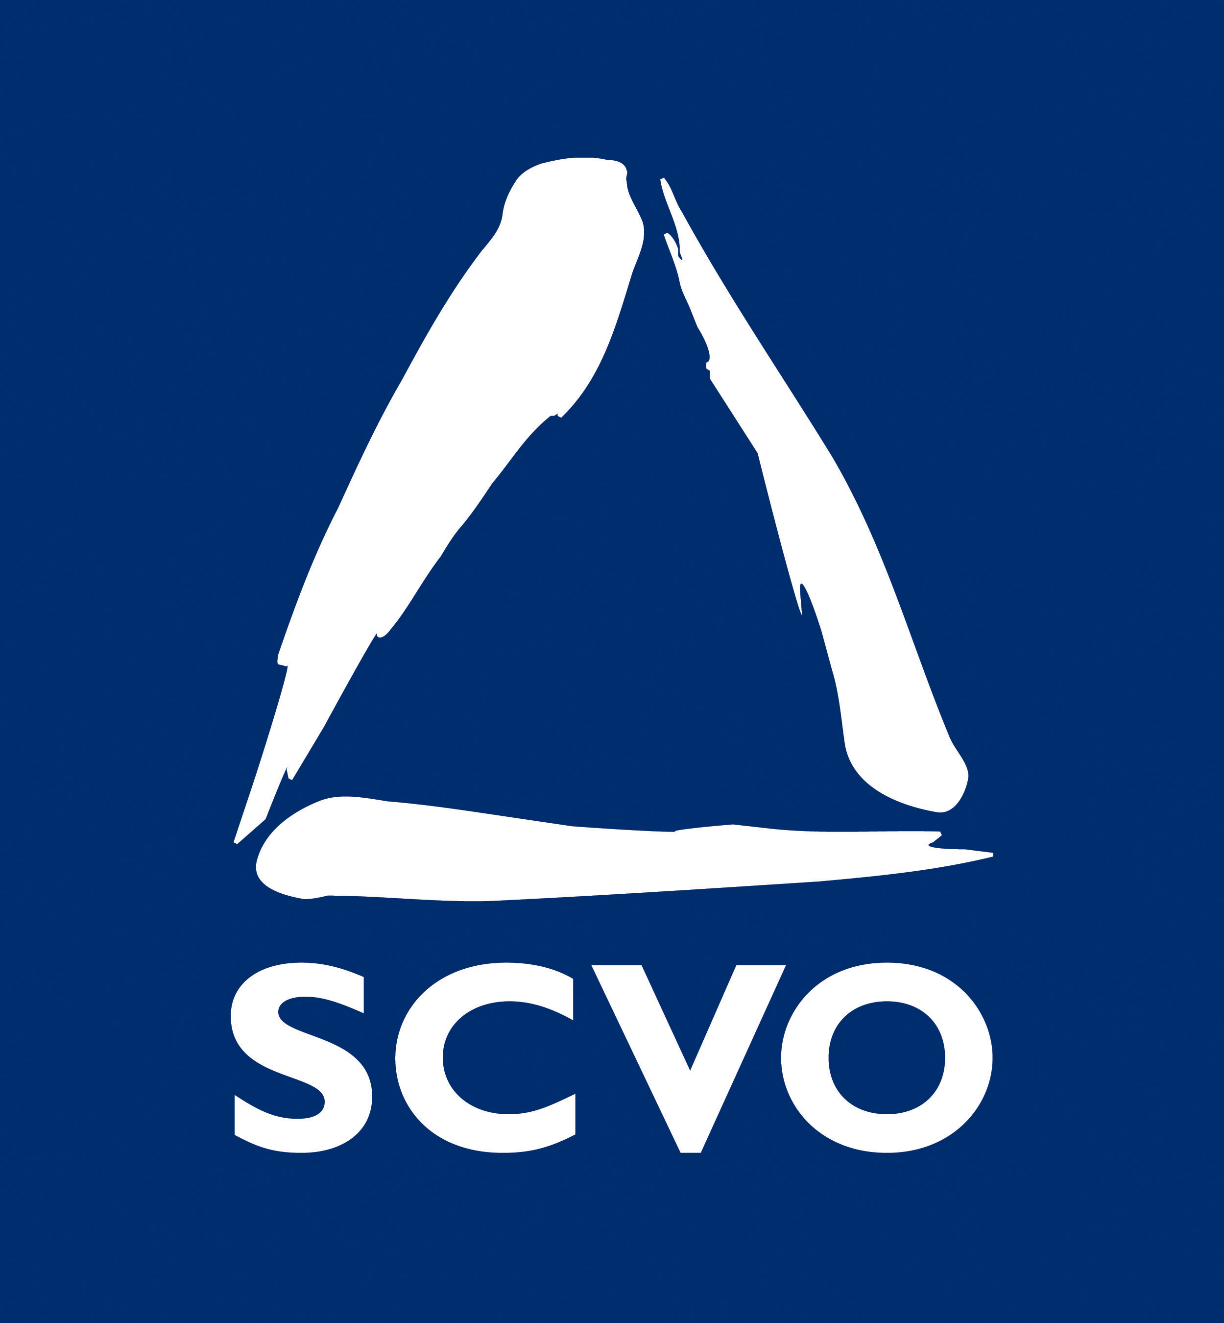
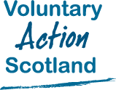

Government and the Third Sector: relationships at local level
Summary of Survey Responses

January 2010

Context
The Cabinet Secretary for Finance and Sustainable Growth met with a delegation from Scotland’s third sector on the 14th of December 2009 to discuss the Scottish budget. At the meeting, the Cabinet Secretary requested an analysis of the funding situation and relationships between government and the third sector at a local level.
In January 2010, the Scottish Council for Voluntary Organisations (SCVO) and Voluntary Action Scotland (VAS) surveyed all 56 Chief Officers of Scotland’s third sector local infrastructure organisations as well as representatives from Scotland’s National Intermediary Network. A total of 47 responses was received, 39 of which were from Chief Officers across all 32 local authority areas, and 8 from National Intermediary representatives.
Introduction
The development of third sector Interfaces is an important change in the local landscape for the voluntary sector. The Interfaces, created by the bringing together of Volunteer Centres, Social Enterprise Networks and Councils for Voluntary Service, signal a more efficient approach to engagement with Community Planning Partnerships (CPPs).
They present opportunities to reinforce the third sector’s role at the heart of community planning, particularly during this difficult financial period in which we find ourselves. These new combined structures will be seeking to influence how the public sector relates to and works with the third sector at the local level.
In response to the challenges we all face, the third sector is looking at opportunities to work more creatively and innovatively to achieve its aims in an effective and efficient manner. Voluntary organisations are keen to explore different ways of working with public sector partners, as well as with each other.
Ongoing monitoring of the relationships at local level will tell us how successful various initiatives have been and where there are examples of good practice that can be shared across the country.
Summary
The survey findings show a mixed picture. There are some very encouraging signs, such as the near universal representation of the third sector at community planning Board level. Other findings reflect the prevailing economic climate, such as the widespread pessimism about the future of grant funding.
These findings are an initial baseline for monitoring the agreements in the Joint Task Group Statementon the relationship between the third sector and government at a local level. However, it is difficult to know from the results of this survey, which factors are most influential in ensuring good relations at a local level and which factors are influencing how the principles of the Joint Statement are being implemented.
This survey clearly identifies the need for further in depth research into good practice of cross sector collaboration in service delivery. SCVO will undertake this with partners over the coming months.

Key observations
- Good relationships at community planning partnership level do not guarantee good funding practice with the local authority
- There is a clear move towards competitive tendering. This is to the detriment of a wider approach to a commissioning strategy which is more user-focused and includes assessment of needs and service design
- Funding is becoming very tight in almost all areas, with very little optimism about future funding opportunities, especially grants
- Three year funding is acknowledged as a policy position, but the implementation does not match this.

Findings
- In most areas, the third sector is represented at the top table of Community Planning Partnerships. But there is still no top table representation in Glasgow, Highland, North Ayrshire and Stirling
- Representation at the CPP top table does not guarantee good involvement in the community planning process. This is notably the case in Inverclyde, South Lanarkshire and West Dunbartonshire
- Local authorities failing to undertake tendering as part of a broader commissioning process i.e. one that includes needs assessment and consideration of the requirement to re-tender, include Aberdeenshire, Argyll & Bute, Clackmannanshire, City of Edinburgh, Eilean Siar, Glasgow City, North Ayrshire, Orkney Isles, Renfrewshire and West Dunbartonshire.
- Interestingly, five of these (Aberdeenshire, City of Edinburgh, Eilean Siar, Orkney Isles and Renfrewshire) rate their satisfaction with CPP representation arrangements as high.
- Involvement in CPP structures below the top board level are generally felt to be adequate in 24 authority areas (and for 65% of overall survey respondents)
- In a majority (25) of authority areas (and for 78% of respondents), grant funding opportunities in their area are ‘becoming less frequent’.
- One third (10) of local authorities continue to claw back surpluses from projects delivered by the third sector. These authorities (Aberdeen, Dundee, Glasgow, Highland, Inverclyde, Midlothian, Renfrewshire, Scottish Borders, Shetland Islands and South Lanarkshire) were also considered not to be awarding 3-year funding as standard practice
- 17 local authorities do not consider inflationary uplifts in pay for workers in the third sector. Of these, a number were also not considered to be awarding three year funding as standard practice; Clackmannanshire, East Lothian, City of Edinburgh, Glasgow City, Highland, Perth & Kinross, Scottish Borders, Shetland Isles and South Lanarkshire.
- However, some longer-term funding relationships (over three years) do appear to be in place in at least nine authority areas; i.e. Aberdeen, Angus, East Lothian, City of Edinburgh, Eilean Siar, Falkirk, Highland, Inverclyde and Shetland Isles.

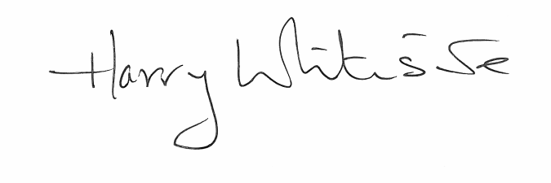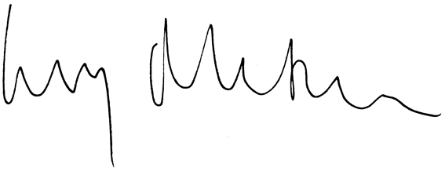

Harry Whiteside Lucy McTernan
Convener, Voluntary Action Scotland Deputy Chief Executive, SCVO

The Joint Third Sector Task Group Statement was published on 24 September 2009 and is an agreement between CoSLA, SCVO, the Scottish Government and SOLACE.

