**Pre-assignement IP-Belgium**

**Introduction**



Today already, we globally face several challenges caused by global warming and other environmental issues. If we don’t act now, these problems will only get worse and will take uncontrollable dimensions.

To step up to these challenges, there are worldwide tons of initiatives to bring down our global footprint with a focus on CO2-emissions in particular.  
  
By participating this IP-week, you’re also contributing to one of these projects. The goal of our project is to generate an online course that will contribute to the general knowledge of the transport sector and the awareness of urgency in moving towards a more sustainable eco-system.

As the transport sector is an important contributor to these emissions, it must be transformed drastically to bring down its negative impact on the environment.

**Sustainable energy use for transportation - Electricity**

Electric energy, it’s the current go-to alternative for conventional fueled passenger vehicles. Electric machines have been used in stationary applications for decades in factories and houses. The recent developments in battery technology have allowed the electric machines to be used in non-stationary applications: electric vehicles.

These electric vehicles have no emissions when driving around. However, because electricity is a secondary energy source it needs to be generated with a primary energy source. During the generation of electricity there might be emissions depending on the generation types which makes driving your EV is essentially still polluting.  
If you would switch to renewable electric energy sources like solar and wind you should take into account that theses sources are not always available.

During this *IP – Sustainable Transportation,* you will be working on several topics to identify how polluting EV are if the electricity is generated with emissions. How efficient are EV’s in converting the electricity to motion. What can we do to make sure we recharge vehicles in the most sustainable way, only using renewable energy sources.

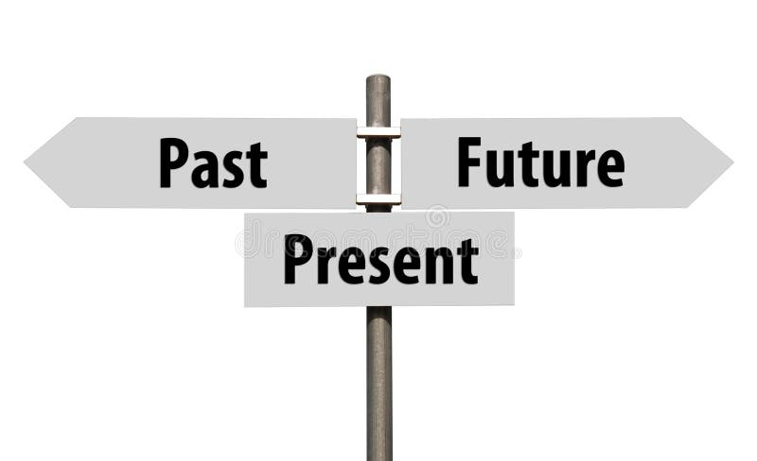  
We would like you for each item to look some years back, to look at the current situation and make a prediction of the future developments.  
During the pre-assignment you will be focusing on the (recent) past & present, during the IP-week and the post-assignment you will focus on the future situation.

**Outcome of the assignment**

Always keep in mind that the outcome of your assignment should be material that can be bundled to an interactive online course for other students.  
So make sure that you provide the right type of information like graphs, numbers, pictures, little films, ….



***Sources***

List very detailed the sources of the information you’ve used.

The downloadable documents you store in the Teams-folder.

**Your Assignement**

**Total cost of ownership (Leon)**

Today there are many different types of financial aid for electric vehicles. Some countries have lower taxes for zero emission vehicles, some countries give out a fixed fee when buying a new or second hand electric car. This implies the total cost of ownership for an electric passenger vehicle is higher compared to a petrol fueled car.

What costs does a TCO of a passenger vehicle contain? Compare the TCO for comparable size vehicles, one propelled by petrol, one propelled by electricity.

**Life cycle CO2 emissions of passenger vehicles (Nabil)**

EV’s don’t have any emissions when driving. When charging the electricity taken from the grid might have emissions being generated. And what about the emission from producing these green vehicles which contain totally different parts and materials ?   
Compare the total emissions (production + use) of two similar vehicles with an electric and conventional ICE drive train.

**Price of public charging (Pavla)**

Just like refueling a diesel or petrol car at the pump might cost a bit more or less, depending on the location, the price of charging an EV also differs from location to location. However at the same location there can be a significant (up to 300%) depending on type of chargers.   
Research the evolution of the price of mode 3 charging (ac slow) and mode 4 charging (dc fast) over the past 5 years.

**Drive train efficiency (Tuomas)**

Electric drive trains are technically more suitable for propulsion of a vehicle. There is no need for multiple gears, no need to idle the motor when standing still,…  
Compare the efficiency of a passenger vehicle with a petrol drive train to the efficiency of an electric drive train.

**Charging efficiency (Tuomas)**

While refueling a gasoline car, practically no energy is lost. This differs a bit for electric vehicles. The AC from the grid needs to be converted to DC to charge the battery. How much is energy is lost during mode 3 charging (ac slow) and mode 4 charging (dc fast).