Paul Kelly – Seapoint Rugby Club

Paul Kelly, also known as PK, is a well-known and popular rugby player with Seapoint Rugby Club who started his playing career in the 1980s at youth’s level in Seapoint. In 1983 he moved to Pres Glasthule and following in his father's footsteps, he joined the front row.
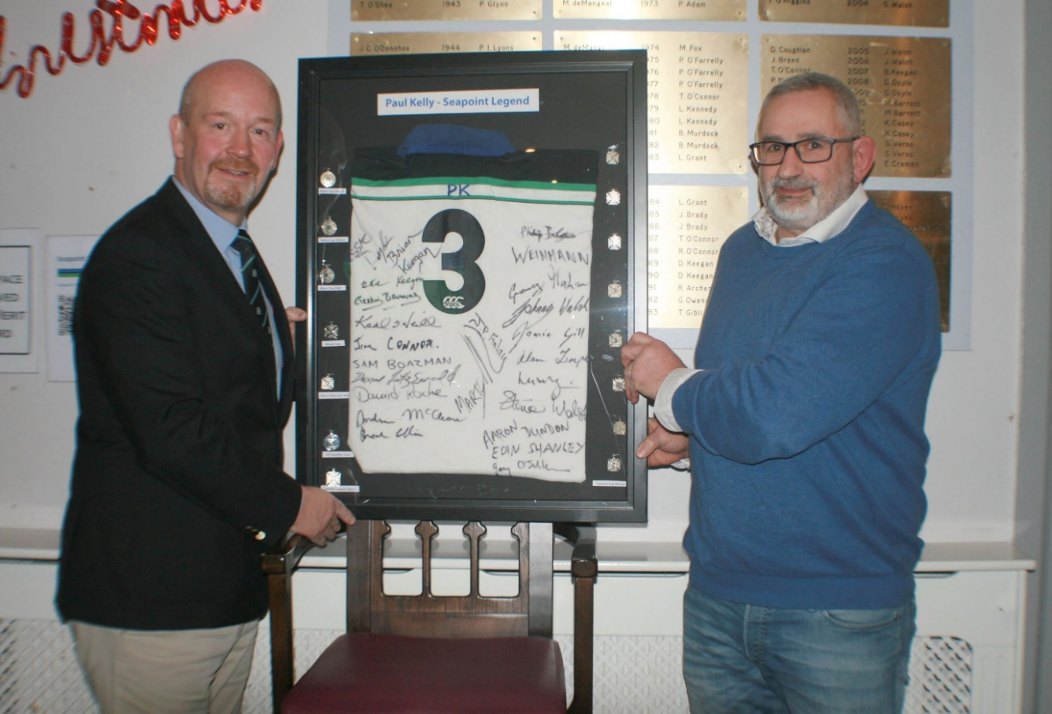
Following school, he returned to Seapoint and played on the U19 teams that we beaten finalist in the Harry Gale Cup in 1985/86, going one better the following year winning the cup in the 1986/87 season. PK joined the Seapoint 1st XV for the remainder of the 1986/87 season along two of his u19 teammates, out-half Mick McDonagh & full back John Ledwitch.
PK presenting his jersey & career medals to Seapoint President Barry Chadwick
In 1991 PK joined Wanderers, playing his first AIL game on the main pitch in the old Lansdowne Road in October that year against Bangor, propping down against Irish International Jim McCoy, and playing along-side ex-Ireland captain Phillip Matthews and Irish International & Leinster captain Kelvin Leahy. After 3-years with Wanderers, PK moved to Bective to seek a new challenge. He honed his front-row skills and played against some of Ireland's top forwards, including Reggie Corrigan the week Reggie received his first Irish contract. Among his teammates in Bective was the up-and-coming backrow player by the name of Trevor Brennan, to whom PK was appointed “minder” for a season to try keep Trevor focused and on the pitch. During his 7-seasons at Bective PK won the Metropolitan Cup with the club in 1995.
In 2000, PK was told by the Bective coach he was too old to play senior rugby and should return to Seapoint, which he did. In his first season back Seapoint won the 3rd Division of the Leinster League and the Spencer Cup. The noughties proved very successful for Seapoint & PK, winning 3 Metropolitan Cups (2005, 2006 & 2008) 5 Spencer Cups (2001, 2003, 2004, 2007, & 2009), Leinster League Division 2 in 2003, Leainster League Division 1 in 2004 & 2009, the All-Ireland Junior Cup in 2007, and the provincial round robin & promotion to the AIL in 2009.
After “retiring” from senior rugby with Bective in 2000, PK was to play numerous AIL matches with Seapoint through the noughties. PK started his last AIL game for Seapoint 1sts in 2018 at the age of 50, against Midleton for an AIL career spanning 26 years and four decades of first team rugby for Seapoint covering the 1980’s 1990’s 2000’s & 2010’s.
PK last competitive game for Seapoint was in February 2020, for the seconds against his old club Bective in the Leinster League Division 1a Seconds League, which Seapoint won.
PK's playing career is an excellent example of his dedication and passion for rugby. His son, Darragh, is currently playing for the club’s Under 15 team and is showing great promise. Seapoint Rugby Club, its members, and friends congratulate PK on his great achievements in the sport of rugby and wish him all the best for the future.
