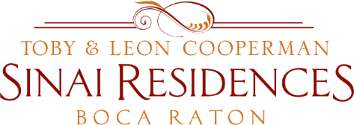
IL Live Broadcast Minutes
December 28, 2020

Update on Community COVID-19 Updates: 2 positive employees in SNF and 1 employee in AL.
Vaccines were administered today, December 28th to Skilled Nursing Residents and employees. We do not have a date yet for IL Residents to receive the vaccine yet. We are working closely with Walgreens to determine when they will administer to IL Residents.
In the meantime we will distribute a packet today with information to complete if you are interested in receiving the vaccine. In the packet, we will provide a consent form, an information form and a “how to complete” document. Please complete and return the information and return in the envelope provided for privacy to the Concierge Desk.
Visitation Policy Update: please wear a mask at all times when you have visitors even when outside. All visits will continue in the outdoor spaces. Visitors must comply with this policy for the wellness of the community. The addendum to the Visitation Policy was distributed on Saturday.
Anyone who is under quarantine will get tested this week by the Residential Health Services team.
If you are under quarantine, please take it seriously and quarantine in your apartment. If you need assistance with your mail or anything else please reach out to the Concierge Desk at 561-609-4020 for assistance.
Additional pull cords are available for installation in your apartments. The cost is $125.
The JFS Food Pantry Pick-Up is Friday, January 8th from 1:30pm - 2:30pm. Please leave non-perishable items outside of your apartment.
If you have specific medical questions about taking the vaccine please reach out to your physician.
Special events scheduled for New Year’s Eve. Happy Healthy New Year.

