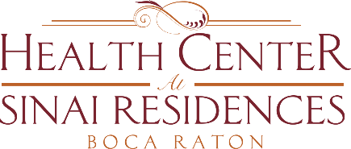

Health Center Broadcast Minutes
July 30, 2020
Welcome Sasha Arreguin & Pierce Carey, Administrators in Training
Partnered with JFS and providing emotional support “Spice Your Mood” new offering. Beginning August 27th: Every 4th Thursday at 11:30am on Channel 909.
Pierce Carey, Administrator in Training. Helping in the interim of recruiting the Associate Executive Director. Please reach out if you need anything ext. 4041.
COVID Updates:
0 positive cases in AL/MC Residents. Waiting on testing results in Skilled Nursing.
0 positive case with IL Residents.
Update on positive employees in the community. Positive employees are removed the schedule.
Residents are doing a great job! Continue washing your hands, social distancing and wearing a mask at all times. Wear a mask at all times when individuals are in your apartment.
Mandatory Employee and HC PSP mandatory testing begins this Sunday, Monday and Tuesday.
Visitation Stations will continue this Tuesday. Cases are looking good! Please call to make your reservation.
Campus decals expire August 31st. We will provide information on how to renew your decals.
Exercise today 1:30pm with Ruth! Channel 909

