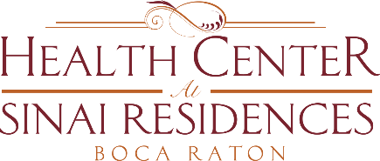

Health Center Broadcast Minutes
August 10, 2020

Update on Community COVID Cases
Private Aid (PSPs) proof of testing and results. Take individual responsibility of providing proof of testing and results and send directly to PSPtestingreporting@sinairesidences.com. Recommended to private aids to take a picture of the form that you complete and sign when you are tested to use as proof of test.
Continuing to recruit for the Administrator position in the Health Center. Pierce Carey and Sasha Arreguin are continuing to support in the interim and available to you.
Visitation Stations are scheduled for this tomorrow, Tuesday. If you are considered a PUI – Person Under Investigation, you may not be able to participate.
Congratulations to Nicole Forbes-Maximin as the new Director of Residential Health Services and Assisted Living. Please call her at ext. 4140 if you need anything.
Exercise today at 1:30pm on Channel 909!

