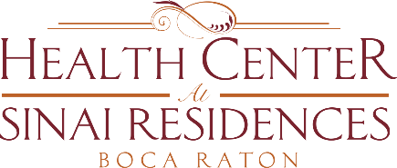

**Health Center Broadcast Minutes**

**November 16, 2020**

Review of COVID-19 community updates. We do not have any positive residents. There are currently two employees that tested positive.

The number of COVID-19 cases are continuing to rise in PBC. Masks should be worn at all times. Anyone near you or in your apartment should always wear a mask. Please wash your hands and use hand sanitizer often. Reduce the amount of interactions that you have with others.

We are continuing to track the vaccine response. Walgreens will administer once details finalized.

Reminder: The Employee Appreciation Gift Fund is still open. Make your contribution or connect with loved ones who may handle your account.