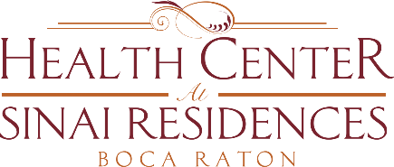

Health Center Broadcast Minutes
October 5, 2020

Community COVID-19 updates: 0 confirmed cases in the community.
Today, October 5th is the last day to vote. If you need assistance with voting, please contact the Resident Life Services Team – Patti is available to help with registration.
Communal dining opens today! Social distanced dining will begin today in Assisted Living and Memory Care. Lunch will begin in Memory Care and Dinner will begin in Assisted Living. Please continue to follow CDC guidelines. Wear a mask at all times, social distance appropriately, only two individuals should use the elevator at once, use hand sanitizer often. Use hand sanitizer before going into the Dining Room and after your meal. We will continue to move slowly and cautiously.
Today starts Active Aging Week. A Hydration Station will come around with a hydrating drink at 2:30pm to your home.
The activities team is planning small group activities. Stay tuned for more activities.
We are continuing to move slowly and cautiously when making decisions. COVID-19 cases have diminished but it is still very present. We want to continue to keep everyone safe.
The Outpatient Clinic is available to everyone. Please reach out to the Nicole or the nurses to get scheduled for Outpatient Therapy – Occupational, Speech and Physical Therapy is available.
Congratulations to Nicole on passing her RN boards!

