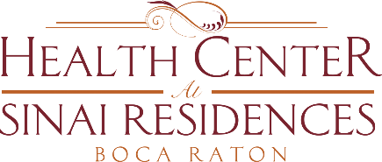
Health Center Broadcast Minutes
Monday, July 27, 2020

Zero residents in house that have tested positive for COVID-19.
14 total employees (out of total of 330 employees) who have tested positive for COVID-19 – 8 employees in SNF; 5 employees in AL; 1 employee in IL
Continue to educate employees on how to stay safe.
PSP Testing – Encouraged to test here at Sinai – through our schedule. Schedule available at screening table. Everyone tested during three-day period, easier to keep track of. If employed by agency, please work it out with them. If testing at a location outside of Sinai, you are responsible for communicating test results to your agency. Agency will then provide Sinai with a list. If you are a “private, private”, please utilize email address provided to you to send results in.
Resident testing – weekly testing this week – may go to every two weeks following that.
Dining Room and Salon remain closed. If second week of zero residents testing positive, salon will open Monday. Will have update Thursday in order for you to make appointment for next Monday or Tuesday.
No Visitation Stations this week for Health Center. May resume next week.
Under social distancing guidelines, Dining Room may reopen once numbers in Florida decreased.
Any questions or concerns, please reach out to Pierce at extension 4041. Sasha and Nicole can be reached at extension 4140 and Jay can be reached at extension 4040.

