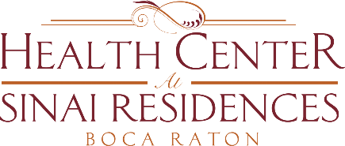

**Health Center Broadcast Minutes**

**December 28, 2020**

Update on Community COVID-19 Updates: 2 positive employees in SNF and 1 employee in AL.

Vaccine administered today, December 28th, to Skilled Nursing Residents and employees across the campus. There is a second dose that will be administered in 3 weeks.

We are waiting on confirmation from Walgreens to administer the vaccine to residents of Assisted Living. We are continuing to wait and work very closely with Walgreens.

Continue to wash your hands, wear your mask and social distance. This applies to outdoor visits as well. Masks must be worn at all times even during outdoor visits.

Happy New Year.