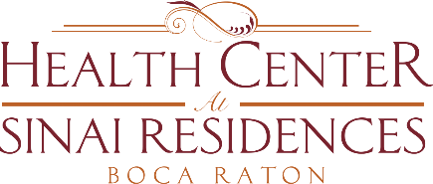

**Health Center Broadcast Minutes**

**November 23, 2020**

Happy Thanksgiving!

If you go out for Thanksgiving we ask that you quarantine for 14 days upon returning to the community.

Please remember to Social distance, wear your mask at all times, clean hands often and gather outdoors.

There is still time for the Employee Appreciation Gift Fund. The employees really appreciate your support.

COVID-19 Update: 1 employee and 1 resident tested positive in Skilled Nursing. The resident and employee are currently not in the community.

We do not have any employees or residents that tested positive in Memory Care or Assisted Living. There are 3 employees in Independent Living that tested positive.

Please check your SinaiDaily for current activities. If you have not set up FaceTime please set up with the Activities team.