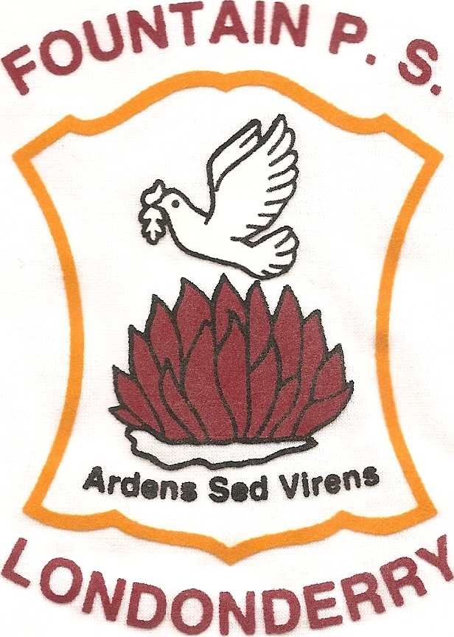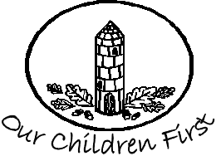

Fountain Primary School Longtower Primary School

Dear Parent/Guardian

We are delighted to inform our school communities that together Fountain and Longtower Primary Schools are working to become Rights Respecting Schools.
This means that we are working to embed in our whole school practice the articles of United Nations Convention on the Rights of the Child (UNCRC). At present both school communities already do a lot to recognise these rights and are now looking to gain accreditation for the work they do.
Initial training for teachers, assistants and governors has taken place which has helped us to realise that although we are on the right road more work needs to take place. This is a long term process, lasting up to 5 years for full accreditation, and asking at this initial stage a commitment from all staff to work together.
Children will be made aware of some of the articles in their classroom and their responsibilities towards them. This will also spill into other areas of school life such as playground, canteen, visitors and outings. Children will also be aware the lives of children in the wider world who do not have all the rights available to them. Regular assemblies will take place around Rights Respecting themes.

We hope to have your support as we begin this journey together and should you have any questions feel free to contact your child’s teacher.

Thank you

Cathy Arthur Joyce Logue

