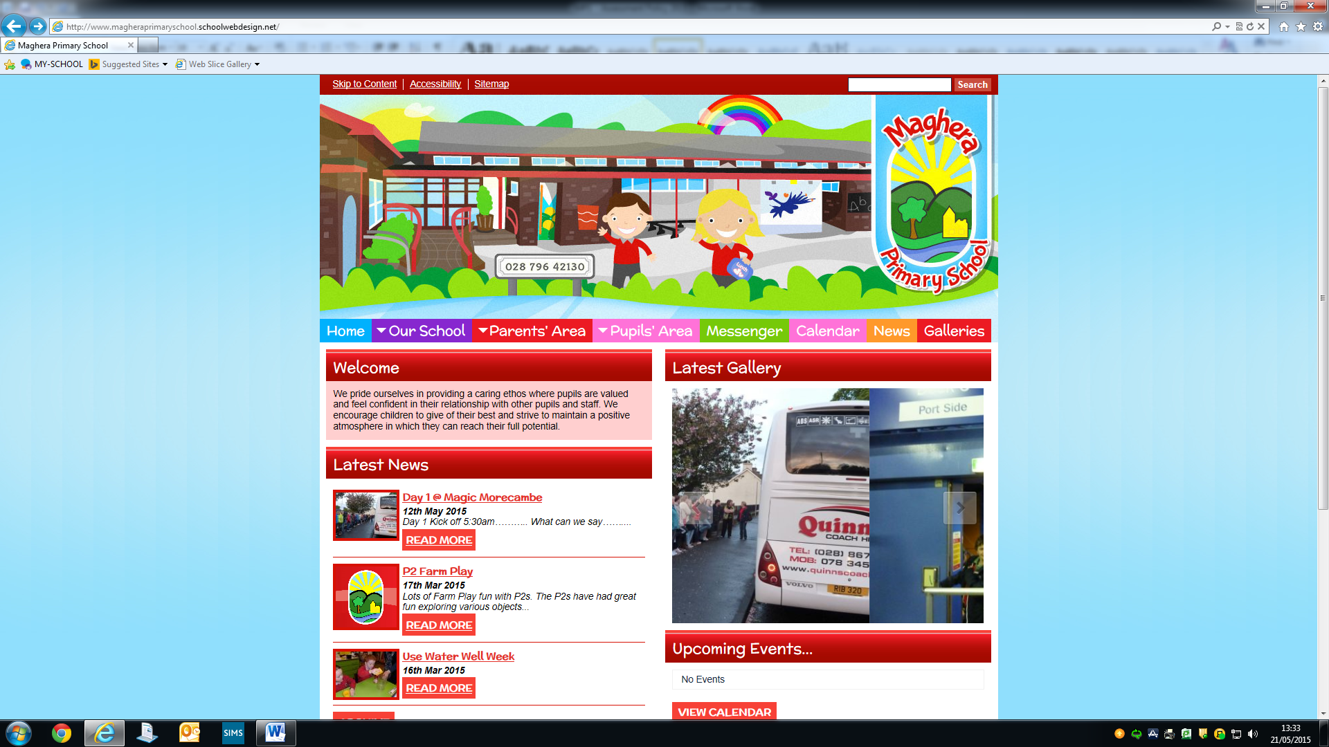

MAGHERA PRIMARY SCHOOL
15 Station Road, Maghera, Co Londonderry, BT46 5BS

E-mail: info@magheraps.maghera.ni.sch.uk
Website:www.magheraprimaryschool.com

Principal: Mrs L Mawhinney Tel: 028 796 42130

27th February 2023
Guidance on Social Media Posting

We tend to forget that almost anybody can see what we are posting online and comments that may have been made in the heat of the moment can easily be copied and then shared by others, even after the original post has been deleted. We wish to urge our school communities to work together, communicate properly and remember at all times that parents/carers are representatives of their school. Inappropriate actions on social media can impact negatively on the life and welfare of those connected with the school.

The partnership of parents and school is central to achieving the best pastoral and educational outcomes for all our pupils.

- All parents have a responsibility in role-modelling effective, appropriate and safe communication on social media
- Parents/Guardians should be aware of their responsibilities regarding their use of social networking by accessing their own school’s social media policy.

Methods of proper school communication with parents/carers include:

- School prospectus, school website, newsletters, texting service, emails, letters and face to face meetings.
- Pictures taken of school members be confined to the school’s website.
- Parents should be aware that primary aged children should not be on any social media platforms. It is the parents’ duty to protect their children from unhelpful social media contact. It is also not the school’s responsibility to deal with any social media issues which have taken place outside school.
- Parents should not share complaints about a child, teacher or school through social medias such action, and subsequent comments by others, may cause significant emotional distress to those persons referenced and/or the school community as a whole. Every school has a published Complaints Procedure which should be adhered to by both parents and the school.

Please remember that perceived complaints written in the heat of the moment and posted on social media may have personal bias and not necessarily reflect the whole truth about a situation or incident to viewers. We therefore advise parents not to be drawn into liking or commenting on such postings if they see them on social media.

Complaints to do with in-school incidents, should they arise, should be pursued through the appropriate channels by:

- Making contact with the class teacher or Principal
- A meeting can then be arranged at a mutually convenient time to try and bring about a resolution to the issue.
- All schools have a complaints procedure that should be followed.

Parents/Carers should also be aware that defamatory/unhelpful comments made online will naturally be viewed negatively by the school as the parent/carer has chosen to disregard the schools Complaint Policy. The parent may have to be asked to come in and speak to Senior Management and Principal about this breach in policy and the matter dealt with face to face, which would have been the preferred method of dealing with the initial complaint.

THANK YOU TO ALL OUR PARENTS WHO PARTNER WITH US WITH FRIENDSHIP AND UNDERSTANDING

