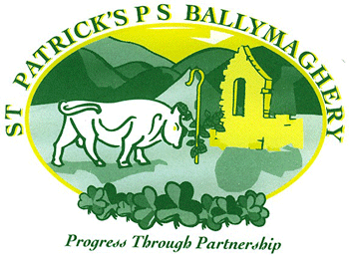
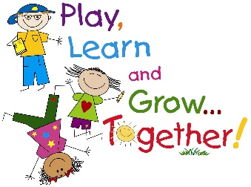
Weekly P2 Activities for Home Learning 18th – 22nd May
- This is the outline for our weekly home learning activities, which you can complete in your own time.
- Remember this is only a guide .You do what is best for your child.
- Remember every week there will be 6 See Saw activities posted along with other activities from the Home Learning Page.
- Don’t forget to use the spelling list for writing sentences and to help you create dictation sentences.
- IXL English is an excellent resource along with IXL Maths.
- Grow in Love – This week we teach the children about John the Baptist. See activity on Seesaw.

Monday
Spellings – See spellings dated for this week.
Mental Maths – See Mental Maths on Home Learning under P2. Go to Number 12. Attached on Seesaw. Continue to revise last week’s activities.
Literacy - Complete Literacy worksheets linked to ‘er’ sound uploaded on Seesaw – if it is easier please write answers on a page, as handwriting practice is still important. You tube video clips to help.
https://youtu.be/Taa3ANEyN_Y https://youtu.be/XUCUhHUDZIY (This link goes through all the Jolly Phonics sounds)
Numeracy – Place Value. Please watch this clip. https://youtu.be/9XCJFP0zPfY https://youtu.be/1F3AycEDksY
Maths Challenge – See on Seesaw
Reading – Big Cat Reading Scheme (see link on the website) Oxford Reading Tree. Serial Mash also with lots of quizzes etc. Diamond level.
IXL Numeracy – Complete some of the IXL targets for numeracy.
Tuesday
Spellings – See spellings dated for this week.
Mental Maths - See Mental Maths on Home Learning. See Number 12 attached on Seesaw.
Literacy - Complete Literacy when to use ‘a’ or ‘an’. Grammar activity. https://youtu.be/lFmPNuR6gxY There are a number of pages attached. Do as many as you want uploaded on Seesaw – if it is easier please write answers on a page, as handwriting practice is still important.
Numeracy –Place value. https://youtu.be/1F3AycEDksY https://youtu.be/k01vawgpSI4
IXL Literacy – Complete some of the IXL targets for Literacy.
Wednesday
Spellings - See spellings dated for this week.
Mental Maths - See Mental Maths on Home Learning. See Number 12 attached on Seesaw.
Literacy – Story about Formidable Sid. Report writing. See worksheets added on Seesaw – if it is easier please write work on a page.
Numeracy – Place Value
Maths Challenge – See on Seesaw
Reading – Big Cat Reading Scheme (see link on the website) Oxford Reading Tree. Serial Mash also with lots of quizzes etc. Diamond level.
IXL Numeracy – Complete some of the IXL targets for Numeracy.
Thursday
Spellings – See spellings dated for this week.
Mental Maths - See Mental Maths on Home Learning. See Number 12 attached on Seesaw.
Numeracy – Odd and even numbers. https://www.bbc.co.uk/bitesize/topics/zknsgk7/articles/zt4jj6f https://youtu.be/JY_DRcnkbmc https://youtu.be/oesINcpSuZc
Literacy – Story about Formidable Sid. Report writing. See worksheets added on Seesaw – if it is easier please write work on a page.
ICT – Following on from last week’s online safety activity we have another one for this week. As your child is now using computers, laptops, iPads etc. more than ever due to school closure, another online safety activity has been attached to Seesaw. Please take pictures and upload them onto Seesaw. We can share your child’s work on our school website.
IXL Literacy – Complete some of the IXL targets for Literacy.
Friday
Spellings – Spelling test
Maths Challenge – See on Seesaw
Numeracy – Odd and even numbers. https://www.bbc.co.uk/bitesize/topics/zknsgk7/articles/zt4jj6f
Literacy – Write your own report about a pet you would like to have. You may have alittle research to do. See Seesaw for activity.
Reading – Big Cat Reading Scheme (see link on the website). Oxford Reading Tree. Serial Mash also with lots of quizzes etc. Diamond level.

 Iced Fairy Cake Challenge!

- This week your challenge is to make and decorate some Fairy Cakes.
- Let your creativity run wild when decorating!
- See challenge on Seesaw

