
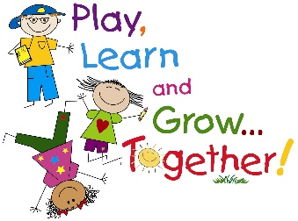
Weekly P2 Activities for Home Learning 27th – 29th May
- This is the outline for our weekly home learning activities, which you can complete in your own time.
- Remember this is only a guide .You do what is best for your child.
- Remember there will be See Saw activities posted along with other activities from the Home Learning Page.
- Don’t forget to use the spelling list for writing sentences and to help you create dictation sentences.
- IXL English is an excellent resource along with IXL Maths.
- Grow in Love – This week we talk to the children about how they can make good choices. When we make good choices we live as Jesus taught us. Chat together with your child about times when they made good choices, and how it made them feel.
Monday
Mid-Term Break

Tuesday
Mid-Term Break

Wednesday
NO SPELLINGS THIS WEEK
Mental Maths - See Mental Maths on Home Learning. Go to Number 13 It is also uploaded onto Seesaw.
Literacy – Write a recount about what you did over the long weekend. Template and instructions on Seesaw.
Numeracy – Money – Create your own shop. Practical activity. See activity on Seesaw. https://youtu.be/oYr0eq8M9nI (Really worthwhile watching)
Reading – Big Cat Reading Scheme (see link on the website)
IXL Numeracy – Complete some of the IXL targets outlined for Numeracy
Thursday
NO SPELLINGS THIS WEEK
Mental Maths - See Mental Maths on Home Learning. Go to Number 13. It is also uploaded onto Seesaw.
Literacy – Grammar activity – nouns. https://youtu.be/tquecIG-Pws https://youtu.be/c292_2_W-hc
Numeracy – Money – Create your own shop. Practical activity. See activity on Seesaw. https://youtu.be/oYr0eq8M9nI (Really worthwhile watching)
ICT – Continuing on from last week’s online safety activity we have another one for this week. As your child is now using computers, laptops, iPads etc. more than ever due to school closure, another online safety activity has been attached to Seesaw. Please take pictures and upload them onto Seesaw. We can share your child’s work on our school website.
IXL Literacy – Complete some of the IXL targets outlined for Literacy
Friday
See activity on Seesaw
Virtual Sports Day

 Create your own Sports Day Medal Challenge!

- Use any recycled items you may have to create your own medal.
- Materials such as,
card
paper - gold/silver/bronze
aluminimum foil and
gold paper
ribbon
string
- Be creative and decorate your medal anyway you want
- Please share your medals on Seesaw

