Thursday 7th January Answers
Maths –
Page 1 -Writing 3 digit numbers in words

- 101- one hundred and one
- 633- six hundred and thirty three
- 987 – nine hundred and eighty seven
- 542 – five hundred and forty two
- 218 – two hundred and eighteen
- 369 - three hundred and sixty nine
- 444 - four hundred and forty four
Page 2 - Writing numbers in words
Ensure your child has spelt the words correctly as they have the guide to help them.

Mental Maths C
- 42
- 58
- 22
- 4
- 10
- 7
- 0
- 5
- 11
- 0
- 8
- 70
- 780
- -3
- 780

Cinderella Answers 7th January
- Cinderella found the pumpkin in the garden
- When her godmother touched the pumpkin with the wand, it was changed into a fine coach.
- The mice changed into horses once she touched them.
- Another word for rind is the outer peeling/skin
- Dappled means b. having spots and patches of a different colour.

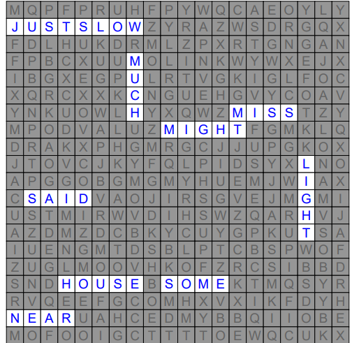
Wordsearch answers for Spellings 7/01/21

