Thursday 14th January answers

**Wordsearch answers**

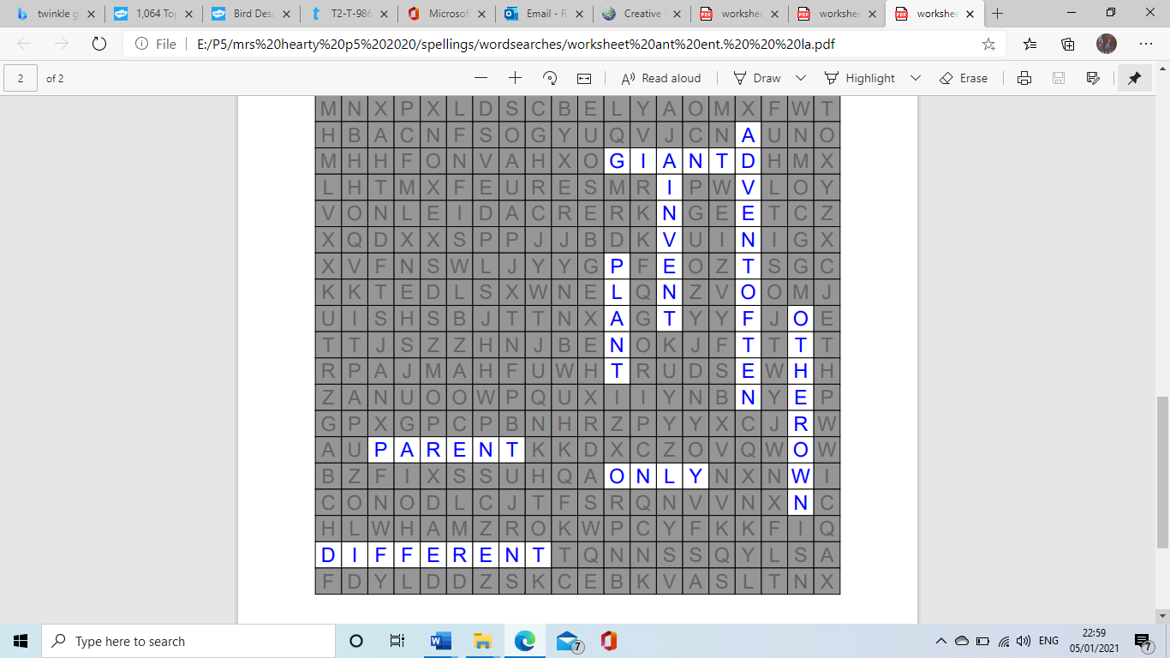

**Plurals (6) answers**

1. dollies
2. windows
3. bunches
4. pigs
5. ticks
6. tries
7. lips
8. wolves
9. boxes
10. brollies
11. class
12. tax
13. friend
14. jelly
15. punch
16. school
17. mouse
18. triangle

**Missing number problems answers**

1. **3**
2. **5**
3. **2**
4. **4**
5. **9**
6. **2**
7. **6**
8. **9**
9. **10**
10. **7**
11. **0**

**Next page of missing answers**

1. **11**
2. **12**
3. **54**
4. **49**
5. **35**
6. **34**
7. **10**