**Thursday 14th January - Answers**

**Wordsearch**

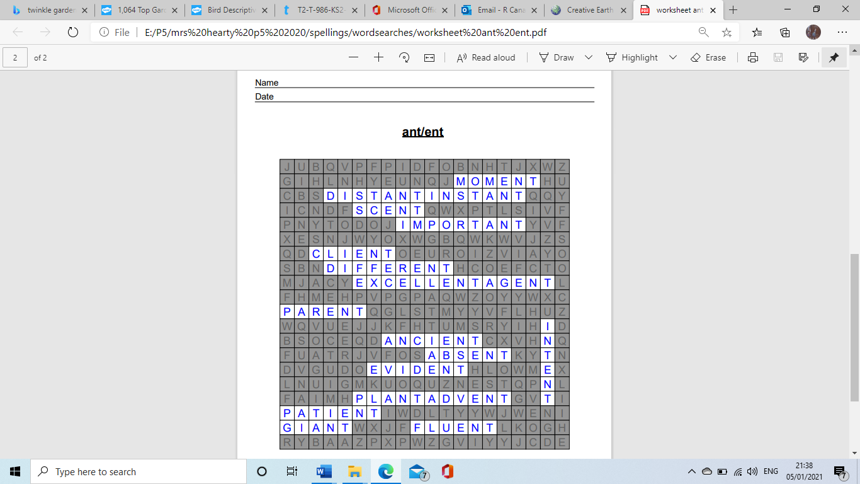

**Plurals (5) answers**

1. **people**
2. **children**
3. **men**
4. **women**
5. **teeth**
6. **geese**
7. **feet**

**Extension Task - children could have the following**

* More than one louse = lice
* More than one cactus = cacti
* More than one appendix = appendices
* More than one ox =oxen

**Plurals (6) answers**

1. dollies
2. windows
3. bunches
4. pigs
5. ticks
6. tries
7. lips
8. wolves
9. boxes
10. brollies
11. class
12. tax
13. friend
14. jelly
15. punch
16. school
17. mouse
18. triangle

**Maths Page 21 answers**

1. **a. 30**

**b. 60**

**c. 35**

**d. 28**

**e. 16**

**f. 91**

**2a. 74 b. 38**

**3a. 25 b.42 c. 93 d.88**

**4a. 90**

**b. 40**

**c. 81**

**d. 32**

**e. 79**

**f. 15**