**How to Help My Children Learn Spelling at Home**

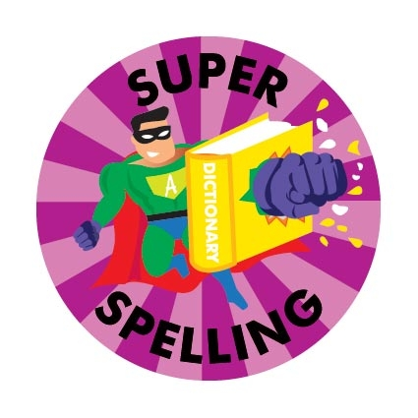

**Helping with spelling at home**

* Help your children hear sounds in words by encouraging them to say each word slowly, stretching out the vowel sounds so that they can be heard clearly, e.g. m-a-n, h-ou-se, kn-igh-t

s-t-a-m-p

Help your child to write simple words by asking your child what sound s/he can hear, moving left to right across the word. If s/he can hear the sound but does not know how to write it, simply show how to do it. “This is ‘m’ , e.g. m-a-n.



**In Key Stage Two we aim to help your child understand how words are spelt (Stage 5-6)**

At stage 5 children learn that:

The same sound can be represented in different ways e.g. s**ee** w**e** **ea**t

The same spelling can represent different sounds

e.g. w**e** g**e**t

At stage 6 children explore multi-syllable words that contain stage 5 information. E.g. ‘happ**y**’ ‘happ**i**ness’

They also discover words with special endings e.g.

‘sta**tion**’, ‘spe**cial**’, ‘trea**sure**’

**Word Investigation**

You child will be given home a list of words to investigate.

* Encourage your child to identify the target sounds e.g. **ea**t s**ee**
* Help your child to sort the words according to how the target sounds are spelt.
* e.g.

|  |  |  |  |
| --- | --- | --- | --- |
| ea | e | y | ee |
| eat  teach  stream | we  me  be | happy  mummy  lovely | street  green  feel |

* Look for words containing the target words in text e.g. “Ton**y** s**ee**s a gr**ee**n frog in the f**ie**ld.”

Children will begin to learn how to spell **important, high-frequency words.** They will do this as they investigate each target sound.

Help your child to identify parts of words that are tricky to remember e.g. which ‘ee’ is in ‘feed’?

He/she may like to:

* make a word-puzzle, putting each sound on paper squares
* underline the tricky part in a different colour of ink
* think of other words containing the same spelling and link them together in a silly phrase or sentence e.g. ‘feed green trees’
* write the word several times to make a pattern
* To help learn spellings children can use the Look, Say, Cover, Write and Check rule.

**Remember!**

It is important to let children learn though investigation and discovery. Give your child plenty of praise when he/she attempts something new and join in the discovery too! Point out things you are noticing for the first time and help your child to make connections e.g.

Look Tony! The ‘ee’ in your name is ‘y’ but it is ‘i’ in Toni’s name!