An Seomra Nuachta

An Seomra Nuachta is a news website aimed at children attending Irish-medium schools. This is a fantastic resource which can make a huge impact on children’s vocabulary and fluency in Irish as it exposes them to terminology beyond everyday school life. An Seomra Nuachta is updated daily with articles suitable for primary school pupils. We use this resource regularly in school not only to keep up to date with the latest articles, but also to carry out research using their fact files, and even enter competitions.

To access Seomra Nuachta from home follow the steps below:

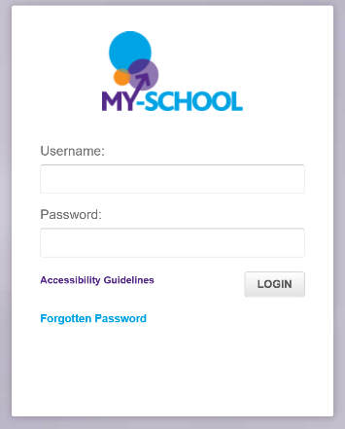
1. Go to www.c2kschools.net and enter the username and password you use when logging into the computers at school.
eg. jsmith123
Password4

2. Select ‘Links’.
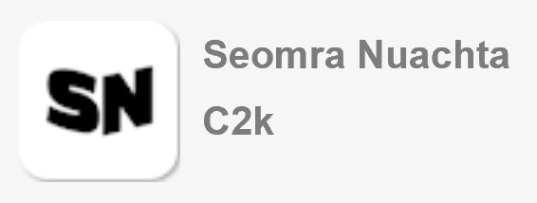
3. Click on An Seomra Nuachta (SN).

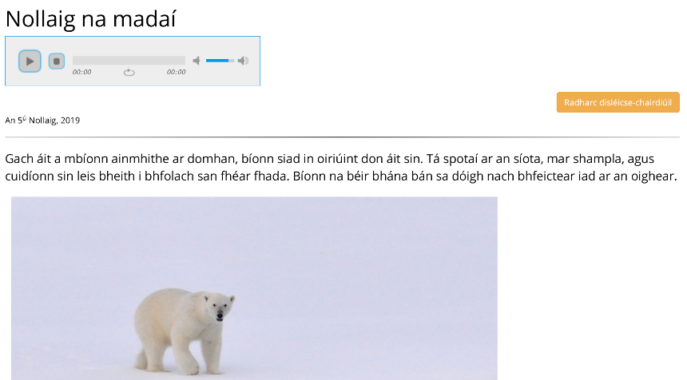
Each article can be played aloud by using the toolbar under the title. Children can also ‘like’ or ‘comment’ on the article at the bottom of the page.


Fact files on a range of topics can be found by clicking on ‘Fillteáin Fíricí’ on the toolbar at the top of the page. Simply search for whatever topic you would like to research using the search bar.

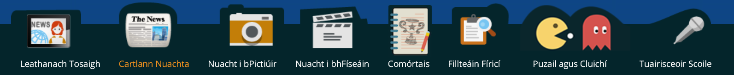

There are a range of puzzles and games available through An Seomra Nuachta also, which children may like to play at home. Maths and literacy games can be found, in addition to some which are just for fun!
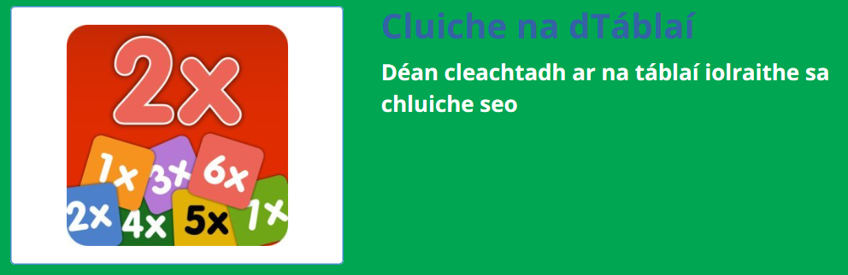

*Please note that the English version of Seomra Nuachta, Newsdesk can also be accessed by using the same steps as above. *


