A thuismitheora,

As you may be aware, the Accelerated Reader programme is usually only accessible in school. We don’t normally encourage quizzing at home as improper quiz practice can affect test fidelity and impact upon the data we receive as teachers. However, due to the exceptional circumstances of school closures, we have decided to allow students to quiz at home for the duration of the closure, as daily reading is crucial in developing students’ reading ages.

ACCESSING ACCELERATED READER AT HOME
- Head to our school website www.gaelscoilaodharua.com and select the ‘Links’ tab. Under ‘Pupil Links’ you will see the Renaissance (Accelerated Reader) icon.

- Choose ‘I am a student’ and enter username and password as prompted.

e.g.
username: j.smith
password: RANG5

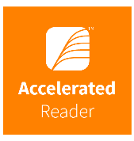

- Click on the ‘Accelerated Reader’ tab and search for the quiz you would like to complete.

*Pupils should know their username and password, but if you are experiencing any difficulty logging in from home please contact me at mfox444@c2kni.net and I can email your child’s personal login details.

We advise students to complete the quizzes unaided. If you wish to support your child you can do so in the following ways:
- Discuss the book with your child as the book is being read
- Ask your child to read the quiz questions aloud
- Re-word questions for your child, if necessary
- Ask your child which answers are not correct

Each child in Rang 5-7 was asked to take home 2 Accelerated Reader books before the St. Patrick’s day break, however we understand that some children may have finished these already. Many books that you will have at home will be on the AR programme. To check whether they are, head to www.arbookfind.co.uk and search for the book.
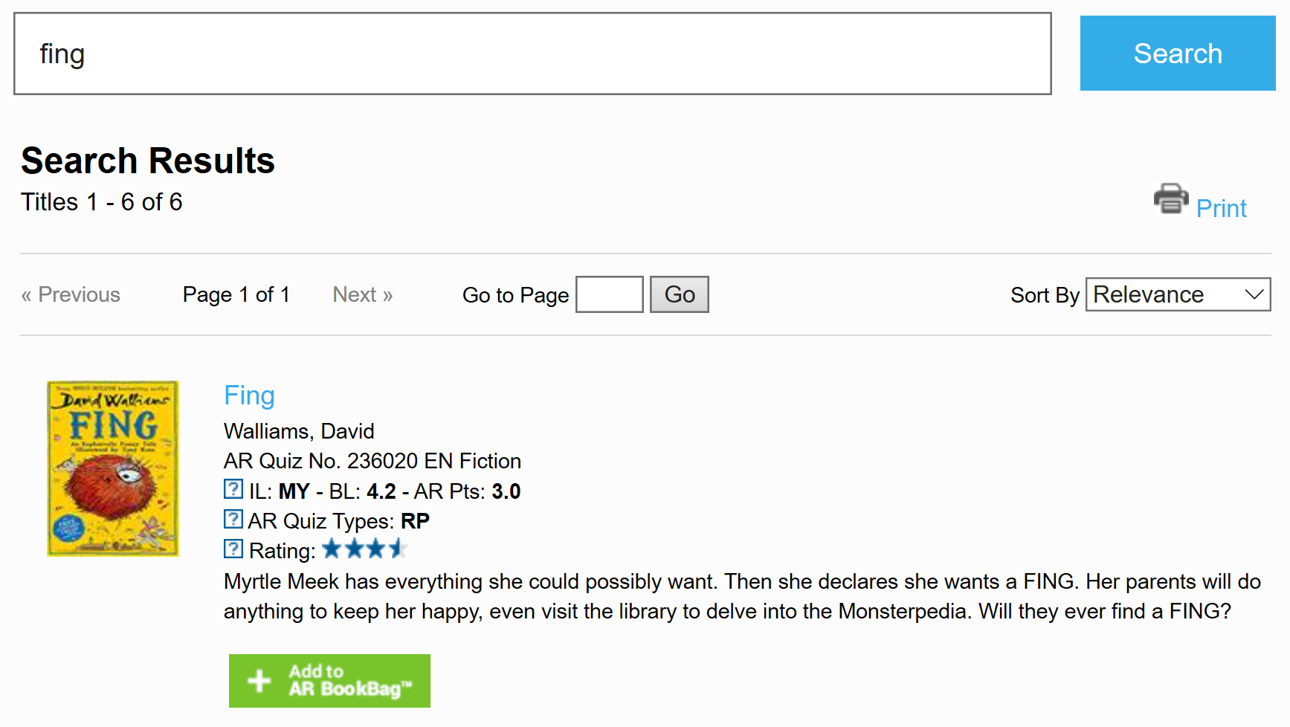

It is important to remember that children should be reading books appropriate for their level. To do this, check that the BL (Book Level) of the book correlates to the colour band of books your child reads at school (they will know which colour band they are in). An alternative method to check if a book is an appropriate level is to use the ‘Five Finger Rule’.
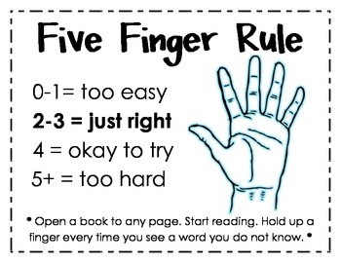
Gaelscoil Aodha Rua book bands
BL 0.1-1.9 : Yellow
BL 2.0-2.9 : Green
BL 3.0-3.9 : Blue
BL 4.0-4.9 : Red
BL 5.0-5.9 : Purple
BL 6.0+ : Black

Le gach deá-ghuí,
Meg

