Renaissance – myOn

https://readon.myon.co.uk/library/browse.html

MyOn is a site run by Renaissance, the same people that run the Accelerated Reader programme. Due to school closures it has been made freely available, without any need for login details. There are two aspects to this site, myOn Reader and myOn News.

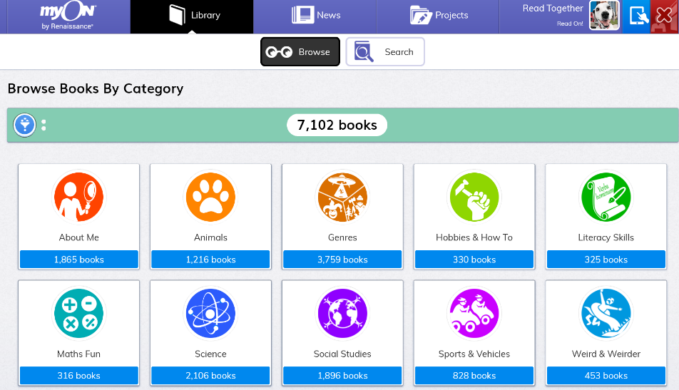
Renaissance myON® Reader is a student-centred, personalized literacy environment that gives students access to more than 7,000 enhanced digital books across a wide range of topics, both fiction and non-fiction.

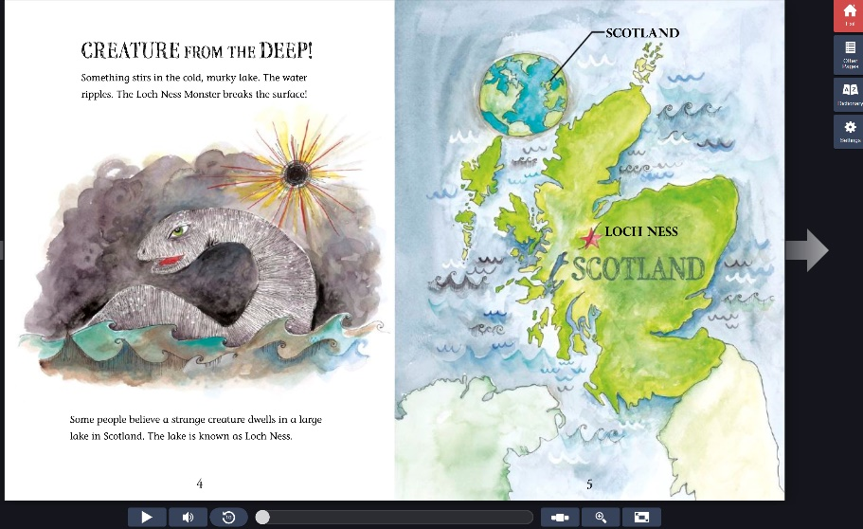
Children can read the books themselves or click the play button to listen. There is also a dictionary included to look up any new words.
Many of these eBooks are also quizzable on AR – use the www.arbookfind.co.uk site to check if the book is on the AR programme.

Renaissance myON® News, delivers age-appropriate digital news articles for students, reporting on timely topics and current events. Articles incorporate engaging multimedia – videos, slideshows and photo galleries – to help students better understand the news. Subjects cover everything from space science and endangered species to football and fashion, engaging even the most reluctant reader.
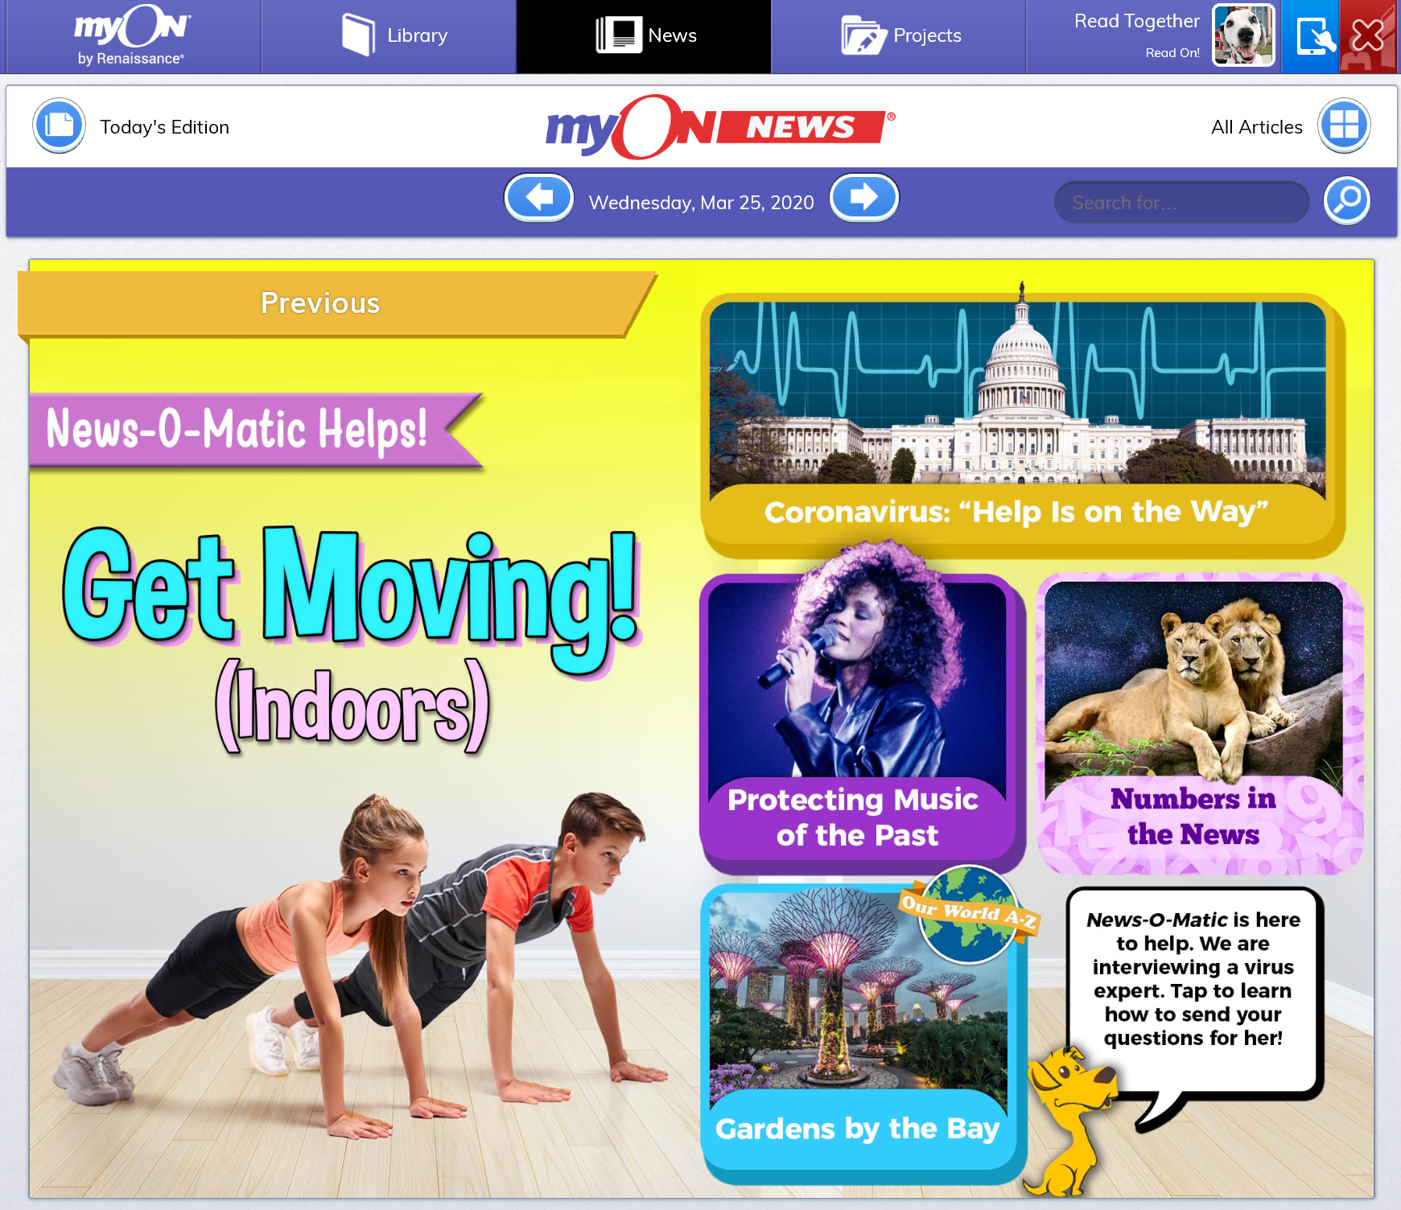

Happy reading!

Meg

