Taos
Rudaí atá de dhíth:
2 cups (approx. 500g) of Plain Flour
2 cups (approx. 475 ml) of Warm Water
1 cup (approx 250g) of Salt
2 tbsp of Oil · Food Colouring (optional)

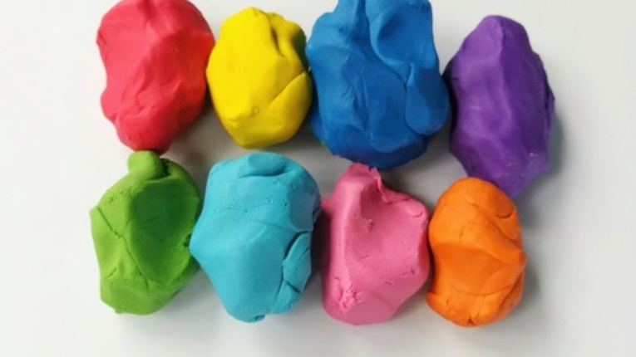

Plúr – ploor – flour
Uisce – ish/ka – water
Salann – sal/inn – salt
Dath – dah - colour

