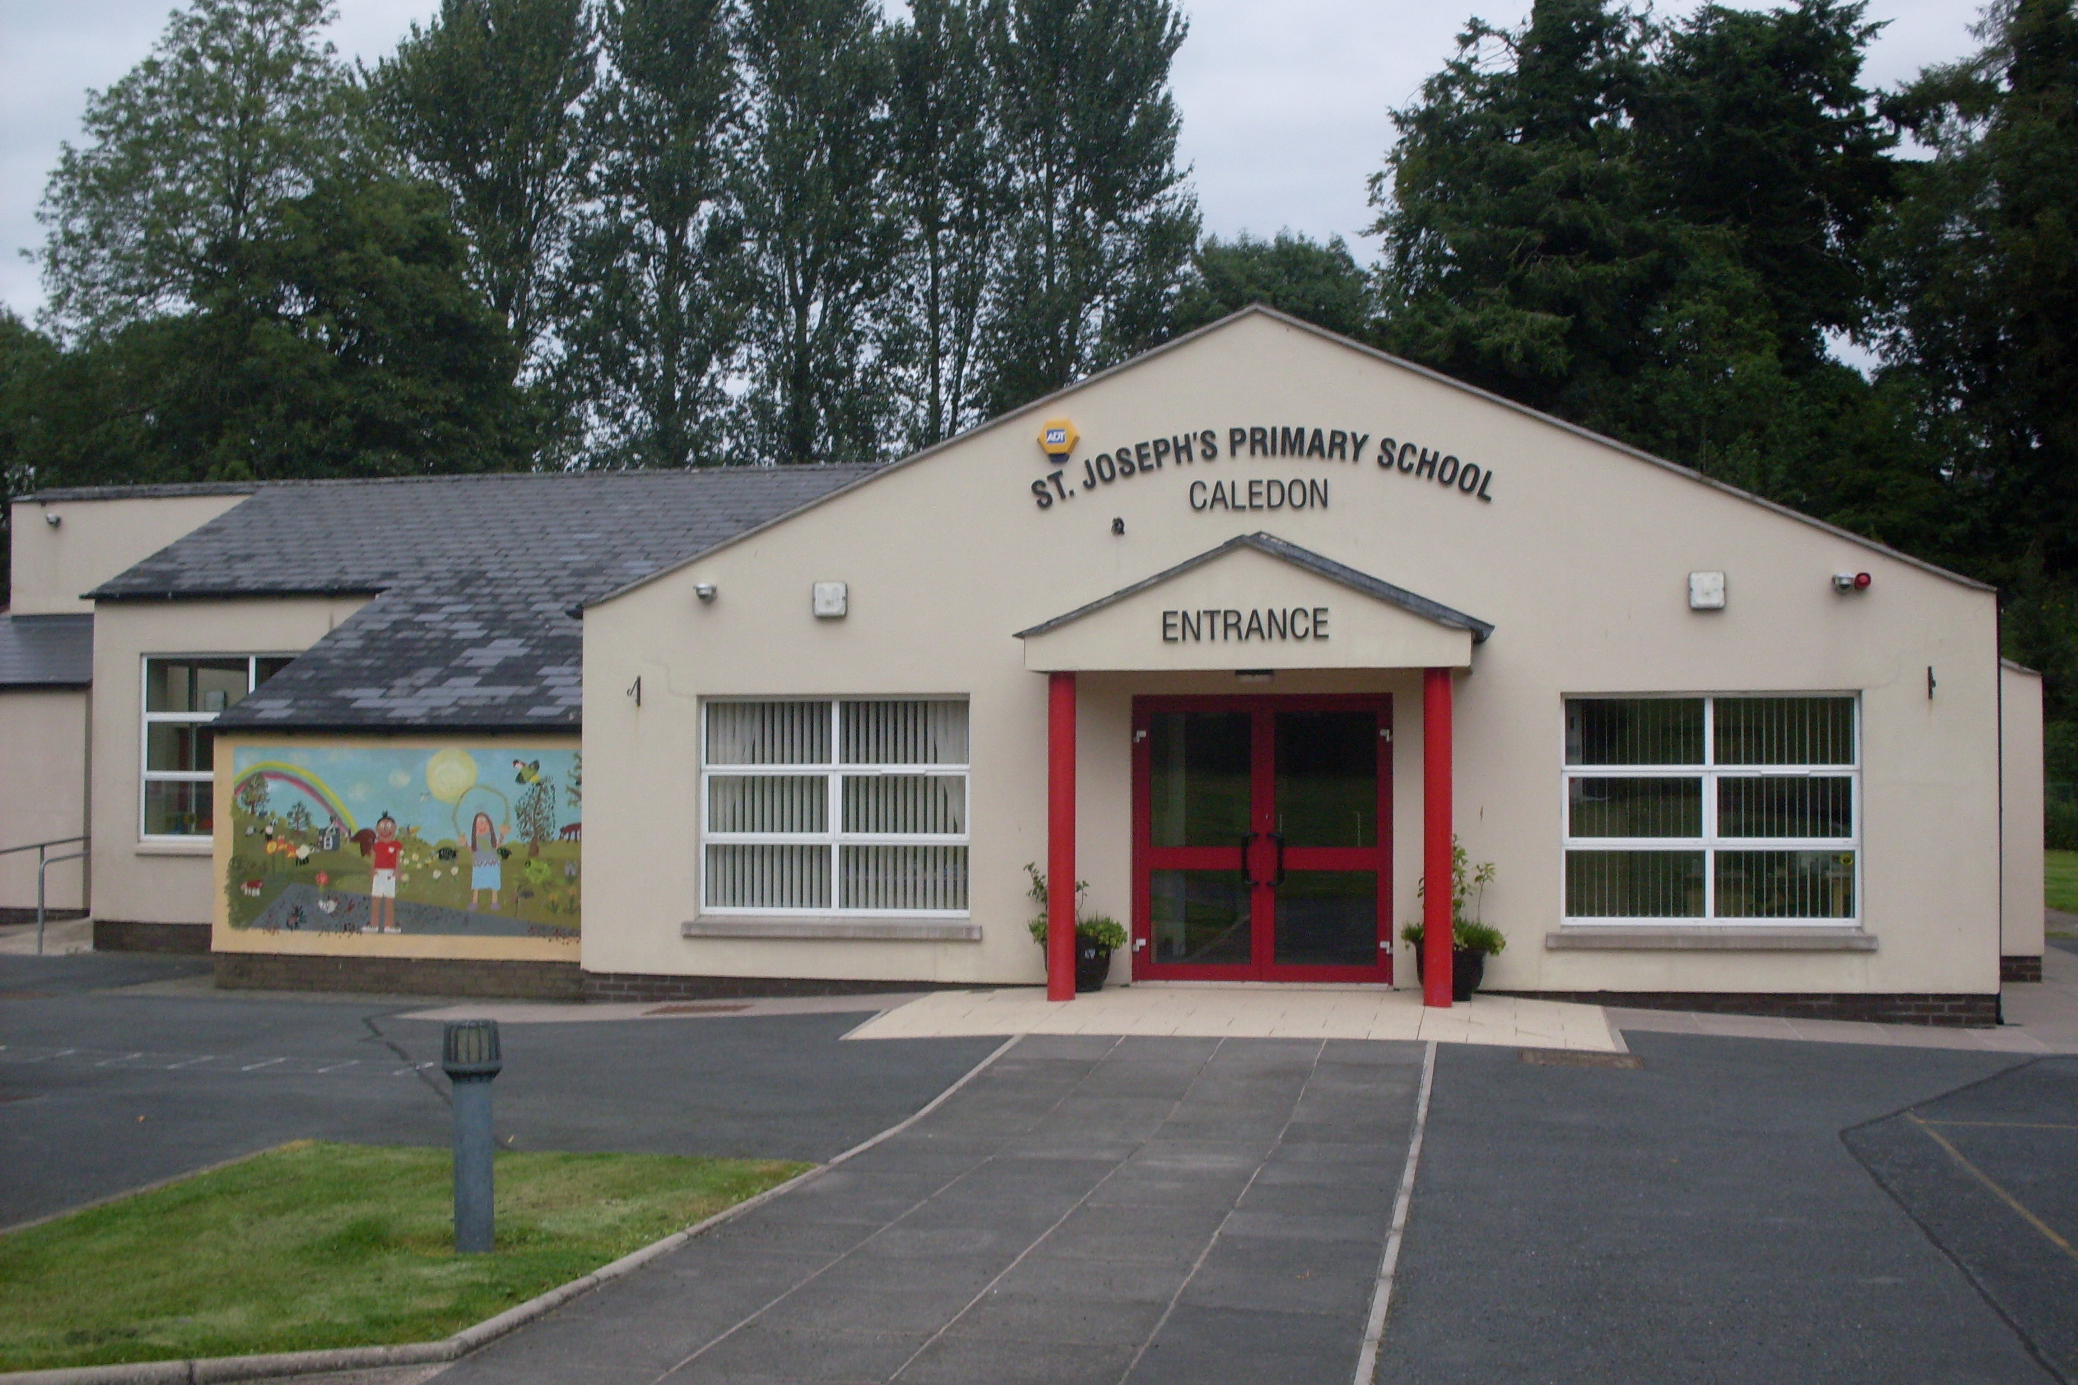

St. Joseph’s Primary School,
14, Derrycourtney Road,
Caledon,
Co. Tyrone
BT68 4UF
Tel: 37568537
Principal: Mrs Marie McKenna

St Joseph’s Primary School

Newsletter – December

Dear Parents

Dates for the Diary

Date | Event
3rd December  8th December  9th December  14th December  16th December  17th December  23rd December  6th January  3rd June | Whole school trip to Navan Fort (am)  Open Night for new prospective parents  Christmas Dinner  Christmas Raffle  Carol Service in St Joseph’s Church  Christmas Jumper Day- raising funds for Trocaire  School closes half day for Christmas break  School reopens for Spring Term for children  First Holy Communion & Confirmation @5pm

The Elf Who Stole Christmas (Trip to Navan Fort) - 3rd December
The whole school will visit Navan Fort on Friday 3rd December to see a production of ‘The Elf Who Stole Christmas’. ‘The Elf who stole Christmas’ is an enchanting Christmas experience, including a short stage show, craft making, a Christmas singalong and a visit to Santa’s house, where he has a gift of a selection box for all children attending. Light seasonal refreshments will also be served on arrival. The cost of the show is £8 per child. The Parent Support Group have kindly offered to pay for the transport.
Christmas Dinner 9th December
Christmas Diner will be available to all children (who wish to avail of it!) on Thursday 9th December. The cost is £2.60. Children can wear Christmas Jumpers if they wish!

Student Council- Christmas Appeal for Trocaire ( Christmas Jumper Day 17th December)
The Student Council are raising money for Trocaire to help those in need this Christmas. To help support this very worthy cause, the staff are respectively asking that a donation is made to their efforts in lieu of any presents. They are organising a
Christmas Jumper Day on Friday 17th December and are asking families to donate to their appeal on this occasion.

Christmas Raffle 14th December
We will have our Annual Christmas Raffle on Tuesday 14th December. We are sending home a raffle sheet to each family – £1/line or £10 per sheet. We hope you can support the effort to raise funds for the school. Prizes include a luxury food hamper and a Tyrone Fuel Voucher. We are also accepting any donations for prizes.

Carol Service- Thursday 16th December
We are hoping to have a Carol service in St Joseph’s Church on Thursday 16th December at 7pm– COVID restrictions permitting! All children will be involved. Each family will be assigned one row of seats and masks for over 12 should be worn inside.

Open Night for Prospective Parents of Children due to start school in September 2022 – Wednesday 8th December
In normal times we would invite all prospective parents over to meet our children & staff, to see around the school and to find out more about what we have to offer. Unfortunately, this year we will have to do things differently due to the COVID pandemic. Therefore, I would ask that any of you who know of any new parent who might wish to see around the school or who might wish to have a chat with me to find out more, to please ask them to make an appointment for the evening of Wednesday 8th December between 5 and 8.pm. I would be delighted to show individual families around and to answer any queries they might have. If this date does not suit then please don’t hesitate to tell them to make an appointment for another time.
First Holy Communion & Confirmation - Friday 3rd June 2022
We are delighted to announce that Archbishop Eamon Martin will celebrate the two sacraments with the children in St Joseph’s Church on Friday 3rd June @ 5pm. The P4 children will celebrate their First Holy Communion along with the children from the P6&7 class, who will receive the sacrament of Confirmation. This unique celebration has come about as the school is celebrating 40 years of successful education in St Joseph’s PS, on its present site on Derycourtney Road. Archbishop Eamon Martin was delighted to be asked to help mark the occasion in this very special way.

Health Check Update
We understand that children can become unwell for a variety of reasons that are not COVID related. This to clarify the procedures on what happens if your child is unwell. We are following guidance and direction from the Department of Education, the Education Authority and the Public Health Agency. Thus it is vital that we all are aware of the following:

If your child or children appear unwell or display any of the symptoms of Covid-19 they should not be sent to school. Symptoms of Covid-19 include:-
• a high temperature – this means you feel hot to touch on your chest or back (you do not need to measure your temperature), or;
• a new, continuous cough – this means coughing a lot for more than an hour, or 3 or more coughing episodes in 24 hours (if you usually have a cough, it may be worse than usual), or;
• anosmia - the loss or a change in your normal sense of smell (it can also affect your sense of taste)
Source: https://www.nidirect.gov.uk/articles/coronavirus-covid-19-overview-and-advice

If your child becomes unwell in school, we will isolate them in Mrs Mckenna’s office ( an adult will be in sight at all times) and contact you. If you wish, with your permission, we will take your child’s temperature at this point.
The children have been so good about abiding by the hand washing rules and keeping to their ‘bubble.’ Although ‘bubbles’ are no loger manadotory, we will keep to them at present and review them at half-term. Clearly you have all played your part in preparing them for back to school and for that we are very grateful.
The procedures for what happens if a case is reported in school are outlined on the flow chart published on our school Facebook page and website. However, this guidance may change and I will inform you as soon as I can of any updates.

Yours sincerely,
M Mckenna

