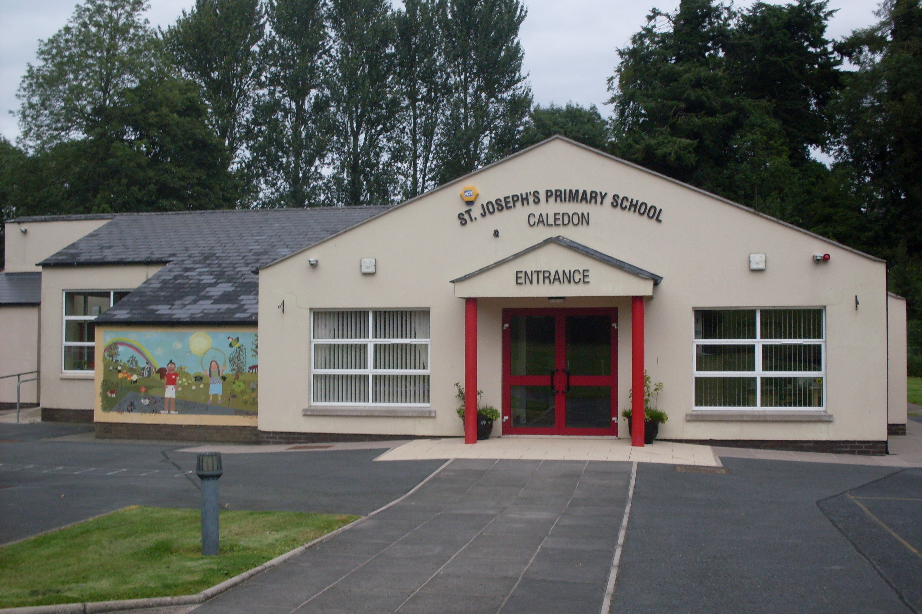

St. Joseph’s Primary School,
14, Derrycourtney Road,
Caledon,
Co. Tyrone
BT68 4UF
Tel: 37568537
Principal: Mrs Marie McKenna

St Joseph’s Primary School

Newsletter – December (2)

Dear Parents

Dates for the Diary

Date | Event
14th December  17th December  23rd December  6th January  3rd June | Christmas Raffle  Christmas Jumper Day- raising funds for Trocaire  School closes half day for Christmas break  School reopens for Spring Term for children  First Holy Communion & Confirmation @5pm
Student Council- Christmas Appeal for Trocaire ( Christmas Jumper Day 17th December)
The Student Council are raising money for Trocaire to help those in need this Christmas. To help support this very worthy cause, the staff are respectively asking that a donation is made to their efforts in lieu of any presents. They are organising a
Christmas Jumper Day on Friday 17th December and are asking families to donate to their appeal on this occasion.

Christmas Raffle 14th December
We will have our Annual Christmas Raffle on Tuesday 14th December. We are sending home a raffle sheet to each family – £1/line or £10 per sheet. We hope you can support the effort to raise funds for the school. Prizes include a luxury food hamper and a Tyrone Fuel Voucher. We are also accepting any donations for prizes.

Carol Service- Thursday 16th December – cancelled!
Unfortunately we have had to cancel our live Carol Service ude an outbreak of COVId 19 in the school. We will, instead, film the children in school and post a video of their performance on ouir school websoue in due course.

might have. If this date does not suit then please don’t hesitate to tell them to make an appointment for another time.

Health Check Update
We understand that children can become unwell for a variety of reasons that are not COVID related. This to clarify the procedures on what happens if your child is unwell. We are following guidance and direction from the Department of Education, the Education Authority and the Public Health Agency. Thus it is vital that we all are aware of the following:

If your child or children appear unwell or display any of the symptoms of Covid-19 they should not be sent to school. Symptoms of Covid-19 include:-
• a high temperature – this means you feel hot to touch on your chest or back (you do not need to measure your temperature), or;
• a new, continuous cough – this means coughing a lot for more than an hour, or 3 or more coughing episodes in 24 hours (if you usually have a cough, it may be worse than usual), or;
• anosmia - the loss or a change in your normal sense of smell (it can also affect your sense of taste)
Source: https://www.nidirect.gov.uk/articles/coronavirus-covid-19-overview-and-advice

If your child becomes unwell in school, we will isolate them in Mrs Mckenna’s office ( an adult will be in sight at all times) and contact you. If you wish, with your permission, we will take your child’s temperature at this point.
The children have been so good about abiding by the hand washing rules and keeping to their ‘bubble.’ Although ‘bubbles’ are no loger manadotory, we will keep to them at present and review them at half-term. Clearly you have all played your part in preparing them for back to school and for that we are very grateful.
The procedures for what happens if a case is reported in school are outlined on the flow chart published on our school Facebook page and website. However, this guidance may change and I will inform you as soon as I can of any updates.

Yours sincerely,
M Mckenna

